Welcome to the Vestry

As a vestry member you have the unique and awesome responsibility of casting the vision for our parish as we journey towards God’s future. Your unique gifts and talents are exactly what are needed at this time and in this community as we seek to follow Christ.

Serving on the vestry is a unique experience — similar to serving on secular, community boards in some ways, but different in other, important ways.

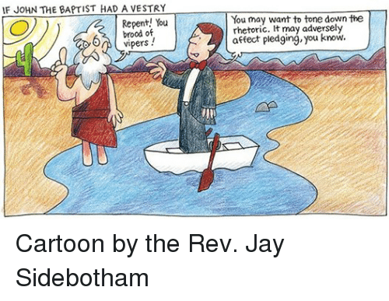
The most obvious difference is that vestry members are first called to follow Christ and to work together in God’s name. The vestry has a responsibility for ensuring that the spiritual mission of the church is maintained, as well as for carrying out the more secular duties related to church property, finances and personnel.

The vestry functions under the concept of “shared ministry,” in which the rector and the vestry are part of an interdependent team that involves many other parishioners in a variety of leadership and supportive roles. Ultimately, service on the vestry can be a joyful experience that enriches both one's spiritual life and one's feelings of connectedness with other vestry members, the rector and the entire church community.

Responsibilities of the Vestry

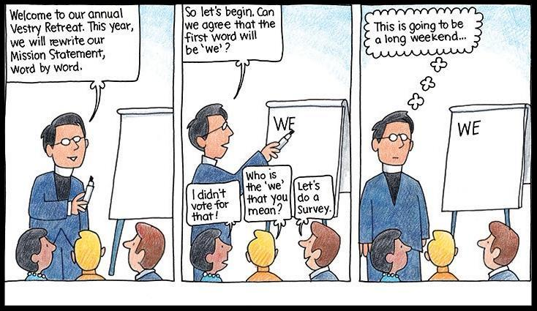

The vestry is the elected body of the parish that shares with the rector the responsibility for oversight of parish life and ministry.

Specific responsibilities include:
- Help define and articulate the mission of the congregation
- Support the mission by word and deed
- Ensure adequate resources in leadership and in financial stewardship
- Manage resources effectively
- Determine that appropriate programs, policies and procedures have been developed and are followed
- Oversee the upkeep of church property
- Oversee the business affairs of the parish
- Select parish representatives (e.g., for Diocesan Convention, community boards, etc.)
- Select a new rector, in the event of a vacancy
- Assess its own work and effectiveness

Responsibilities of Individual Vestry Members

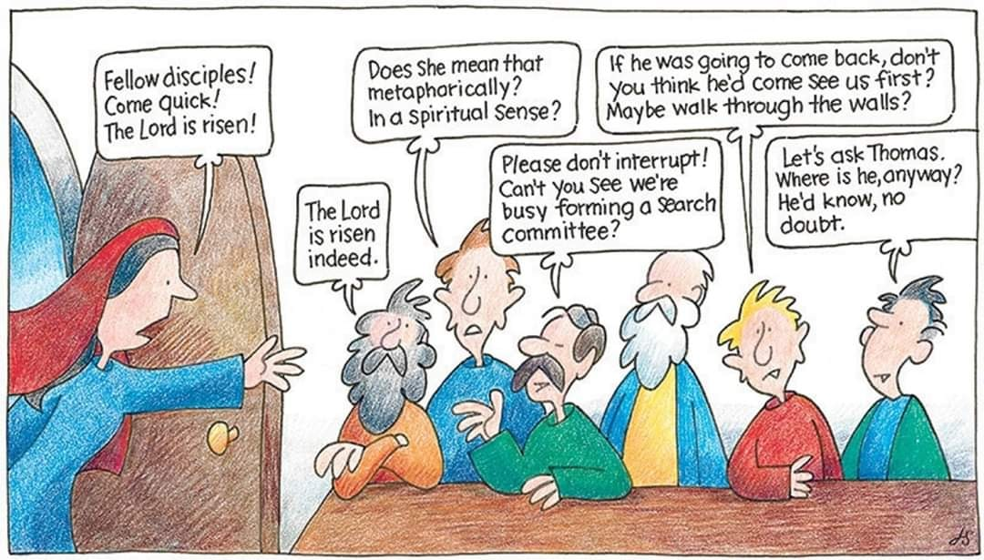In order for the vestry to function effectively, each vestry member must actively participate in vestry activities and in the life of the parish. Specific individual responsibilities include:
- Regularly prepare for, attend and participate in vestry meetings
- Be an active member of one of the parish’s ministries
- Assist in stewardship education
- Attend the annual vestry retreat
- Attend the orientation session at the beginning of each term of vestry service
- Interpret decisions of the vestry and the rector to other parishioners in a supportive way
- Maintain confidentiality on sensitive topics
- Support the mission of the church, putting overall interests of the church above personal or group interests
- Be receptive to individual parishioner's concerns and, if necessary, be willing to discuss these concerns with the rector, wardens and/or vestry.
- Learn about the mission, goals, programs, services, activities, strengths and needs of the congregation, diocese and the Episcopal Church

The above list presents duties that are specifically associated with vestry activities. In addition, vestry members are especially encouraged to participate in diverse aspects of parish life, in order to lead by example and to be visible as leaders:
- Regularly attend worship services
- Lead a life that includes personal disciplines of prayer and Bible study
- Faithfully contribute to the mission of the church through an annual pledge to the Church
- Serve in visible roles in parish worship (greeters, ushers, etc.)
- Take part in various ministries and missions of the church
- Share in the social activities of the church

Organization of the Vestry

Wardens:
Two wardens are elected each year from those elected to vestry. The method of selecting wardens is left up to the congregation’s bylaws. The senior warden is works closely with the rector and is sometimes referred to as the “rector’s warden.” The Senior Warden works with the diocesan office to provide for a priest when there is no rector. Also with a vacancy, the Senior Warden is responsible for keeping up the parish records, including the register and record of services. The junior warden is primarily responsible for the church buildings. Another special function of the junior warden is to serve as an ombudsman for members of the parish, and thus this position is sometimes called the “people’s warden.”

Clerk:
The clerk may or may not be a vestry member. The clerk, together with the parish administrator, is responsible for keeping minutes of vestry meetings and parish meetings, for correspondence related to vestry business and for maintaining vestry records.

Treasurer:
The treasurer, who may or may not be a vestry member, maintains the financial and business records of the parish, prepares monthly financial reports for the vestry, and prepares annual financial reports. Term of Office: 3 years, beginning with election at the annual meeting of the congregation

VESTRY MEETINGS ARE OPEN TO ALL PARISHIONERS.

