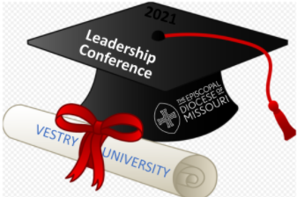
Jesus, Money, and Pandemic:
What You Need to Know About Changing Stewardship
A SPECIAL LEADERSHIP SUMMER-TIME WORKSHOP
Saturday, August 7 from 10 a.m. to Noon on Zoom

- Does your congregation dread pledge campaign season?
- Do you worry how to make ends meet in year 2 of the pandemic?
- Did you know that Jesus talks about money in the Bible more than he talks about sex, religion, or politics?
Join us as Vestry University presents a workshop led by Canon Whitney Rice on how to reinvent your congregation's stewardship out of your spiritual gifts, grounded in scripture and supported by innovative practices and methods. For more information and to Register, please go to: Stewardship Workshop: August 7
Registration deadline: Friday, Aug. 6 @ noon.
What to expect: Session 1: How to Get Your Congregation Excited About Giving.
Session 2: How Pandemic is Changing Stewardship and How to Help Your
Congregation Adapt.

- Choose from two Breakout Rooms after each Session to help process information

Who should attend: Vestry & Bishop’s Committee members, Stewardship Ministry members, Directors of Stewardship, Treasurers, Parish Leaders, and Clergy.

Don’t miss this FREE Stewardship-focused continuation of Diocesan Parish & Leadership training!

