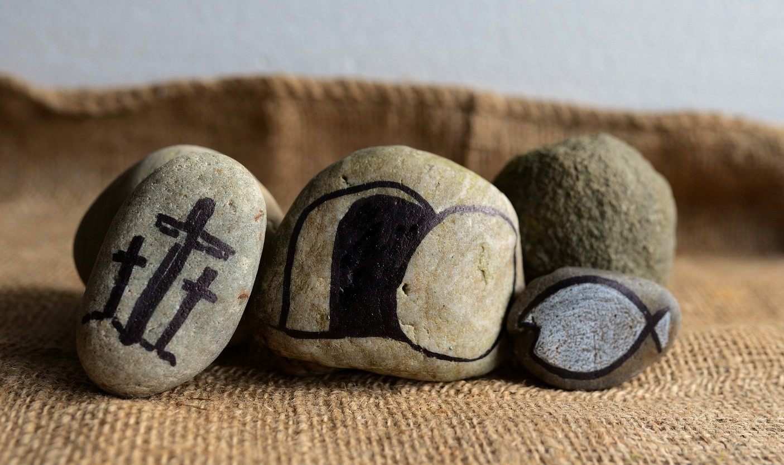

Holy Week & Easter Liturgical Resources

Good Friday
The Good Friday Liturgy is one of the earliest liturgies developed by the Early Church. The practice of following in the steps of Jesus during his final hours was the foundation for the practice known as Stations of the Cross. The dramatic reenactment of the suffering, death, and resurrection of Jesus form the central focus of the Church and is considered one extended liturgy, beginning with Maundy Thursday and concluding with the Easter Vigil (triduum).

The Episcopal Church has wrestled with the readings used on Good Friday, particularly the seemingly anti- Judaism nature of the Gospel of John in referencing, “the Jews” throughout the Gospel. General Convention of the Episcopal Church has invited Episcopalians to prayerfully and carefully express the theology of the Church without disparaging our Jewish siblings.

Guidance for the Good Friday Gospel
As you prepare for Good Friday the following guidance is issued in the Diocese of Missouri in proclaiming the Good Friday Gospel. On Good Friday permission is granted to:

- Read the Passion Narrative from one of the other three Gospels (Luke in the current Year C is recommended)
- When John’s Gospel is retained:
  - Preach specifically to address the problematic language of “the Jews” in the Gospel.
  - Replace “the Jews” with “Judeans,” “the crowd,” or “the leaders of the people” in the Gospel narrative.
  - Include a preamble that specifically addresses the language used in the gospel when substitutions of “the Jews” are not made:
    - Dear people of God, as we enter once more the contemplation of those mighty acts by which our Savior Jesus Christ redeemed the world, we are mindful of the Church’s historic role in the sin of Anti-Semitism. We repent of the many ways in which we have wounded our Jewish siblings across time. In the gospel according to John, which will be read shortly, the term “the Jews” applies to particular individuals, namely Judean leaders, and not to the whole Jewish people. Insofar as we ourselves turn against Christ, we are responsible for his death. I invite you therefore to enter Jerusalem once more with Jesus and the disciples. The regular introduction to the Passion Gospel follows.

Good Friday Alternative Collects & Prayers
The Proper Liturgy for Good Friday in the Book of Common Prayer often uses language that might be problematic in our current context. Language matters. As an alternative to the Solemn Collects and the prayers for Good Friday, below you will find a revised liturgy written by the Rev. Bosco Peters (https://liturgy.co.nz/) in the Anglican Church of New Zealand. The revised and edited collects, prayers, and prose are authorized for use in the Diocese of Missouri, provided that the source is sited in any print materials.

A Liturgy for Good Friday

The Celebration of Our Lord’s Passion

The service is normally without instrumental music except if needed to accompany congregational singing. The ministers enter in silence. All kneel for silent prayer. When all are standing the presider may greet the people with the following:

Presider Blessed be our God, for ever and ever.
People Amen. Presider Let us pray. Silence
Presider Look graciously on this your family for which our Savior Jesus Christ was willing to be betrayed,
and to suffer death upon the cross; and grant us to grow into the fullness of new life in Christ who now is alive and glorified with you and the Holy Spirit, one God, now and for ever. Amen.

The Readings.

Passion Gospel Preamble When John’s Gospel is used:
Dear people of God, as we enter once more the contemplation of those mighty acts by which our Savior Jesus Christ redeemed the world, we are mindful of the Church’s historic role in the sin of Anti-Semitism. We repent of the many ways in which we have wounded our Jewish siblings across time. In the gospel according to John, which will be read shortly, the term “the Jews” applies to particular individuals, namely Judean leaders, and not to the whole Jewish people. Insofar as we ourselves turn against Christ, we are responsible for his death. I invite you therefore to enter Jerusalem once more with Jesus and the disciples.

Or

Dear people of God, as we enter once more the contemplation of those mighty acts by which our Savior Jesus Christ redeemed the world, we are mindful of the Church’s historic role in the sin of Anti-Semitism. The term “the Jews” in John’s Gospel, whilst generally at that time a title for Judeans, applies in this context to particular individuals rather than the whole Jewish people. Insofar as we ourselves turn against Christ, we are responsible for his death.

The Passion Gospel is announced in the following manner.
The Passion of our Lord Jesus Christ according to [John | Luke] .
The customary Gospel responses are omitted at the reading of the Passion.

Roles may be assigned to different people and the congregation. The congregation may be seated until the verse which mentions the arrival at Golgotha (John 19:17) at which time all stand. A moment of silence is appropriately kept at Christ’s death (after John 19:30).

The Sermon

The Solemn Intercession
The biddings which follow may be adapted as appropriate. The people may be directed to stand or kneel. The biddings may be read by a deacon or other person appointed. The presider prays the collects. After each time of silence there may be a versicle and response such as, “God of love grant our prayer”.

Deacon Let us pray for the one holy catholic and apostolic Church of Christ throughout the world: for its unity in witness and service,
for all bishops and other ministers and the people whom they serve,
for N our bishop, and all the people of this diocese, for all Christians in this community,
for those about to be baptized (particularly…),
that God will confirm the Church in faith, increase it in love, and preserve it in peace.

Silence

Presider Faithful and compassionate God, your Spirit guides the Church and makes it holy; hear the prayers we offer, that in the particular ministry to which you have called us, we may serve you faithfully, through Jesus Christ our Savior. Amen.

Deacon Let us pray for all nations and peoples of the earth, and for those in authority among them: for N the President and for the government of this country,
for N our mayor and those who serve with him/her on the council, for all who serve the common good,
that by God’s help they may seek justice and truth, that all might live in peace and harmony.

Silence

Presider Faithful and compassionate God, kindle, we pray, in every heart the true love of peace, and guide with your wisdom those in authority, that justice, peace, and freedom may increase, until the earth is filled with the knowledge of your love; through Jesus Christ our Savior. Amen.

Deacon Let us pray for all who suffer:
for the hungry and the homeless, the deprived and the oppressed,
for the sick, the wounded, and the handicapped, for those in loneliness and in fear,
for those in confusion, doubt, and despair, for the sorrowful and bereaved,
for prisoners, and all at the point of death,
that God’s love will comfort and sustain them, and that we may be stirred up to minister to them.

Silence

Presider Faithful and compassionate God, the comfort of all who sorrow, the strength of all who suffer, hear the cry of all who call on you in any trouble, grant them the joy of receiving your help in their need, and give us, we pray, the strength to serve them, through Jesus Christ our Savior. Amen.

Deacon Let us pray for all who do not believe the gospel of Christ:
for those who have never heard the message of salvation, for those who have lost their faith,
for those who are indifferent to Christ,
for those who actively oppose Christ by word or deed,

and persecute Christ’s disciples,
for those who in the name of Christ have persecuted others,
that God will open their hearts to the truth, and lead them to faith and obedience.

Silence

Presider Faithful and compassionate God, you create and love all the peoples of the earth; may your good news be so lived and proclaimed, that all are brought home to your presence, through Jesus Christ our Saviour. Amen.

Deacon Let us commit ourselves to God, and pray for the grace of a holy life, that with all who have died in the peace of Christ, and with those whose faith is known to God alone, we may enter the fullness of life in the joy of Christ’s resurrection.

Silence

Presider God, our refuge and strength, accept the fervent prayers of your people, and bring to fulfillment your plan for all creation, through Jesus Christ your Firstborn, who is alive with you, in the unity of the Holy Spirit, one God, now and for ever. Amen.

The service may be concluded here with the singing of a hymn, the Lord’s Prayer, and the concluding prayer below.

The Meditation on the Cross of Jesus
If desired, a wooden cross may now be brought into the church and placed in the sight of the people. The following may be sung or said (three times if desired):

Presider Behold the cross, on which hung the Savior of the world.
People Come let us worship.

Appropriate devotions may follow, which may include suitable hymns, anthems, and the following:

Presider My people, what wrong have I done to you? How have I offended you? Answer me! Through baptism, I led you from slavery to freedom, but you lead your Savior to the cross.

People Holy God, holy and merciful, holy and just, have mercy upon us.

Presider I led you through the wilderness. I fed you with the bread of life, the manna from heaven, but you lead your Saviour to the cross.

People Holy God, holy and merciful, holy and just, have mercy upon us.

Presider I planted you as my fairest vineyard, I grafted you into the one true vine, I gave you the water of salvation, but you give me gall and vinegar to drink, and leave me thirsting upon a cross.

People Holy God, holy and merciful, holy and just, have mercy upon us.

Presider I gave you a royal scepter, but you give me a crown of thorns. I raised you up to newness of life, but you raise me high upon a cross.

People Holy God, holy and merciful, holy and just, have mercy upon us.

Presider What more could I have done for you? I gave you my peace and my truth, but you fight in my name, and divide my Church.

People Holy God, holy and merciful, holy and just, have mercy upon us.

Presider I come in your brother and sister, hungry, yet you give me no food, thirsty, yet you give me no drink, a stranger, and you do not welcome me, naked, and you do not clothe me, sick and in prison, and you do not visit me.

People Holy God, holy and merciful, holy and just, have mercy upon us.

A hymn extolling the cross is sung.

The service may be concluded here with the Lord’s Prayer, and the concluding prayer below.

The Ministry of the Sacrament
In places where the Eucharist is to be celebrated, the service continues with the Preparation of the Gifts from any of the Eucharistic Liturgies.

COMMUNION FROM THE RESERVED SACRAMENT: PASSIONTIDE.
In places where Holy Communion is to be administered from the reserved Sacrament, the holy table having been covered with a clean white cloth, and the Sacrament having been brought and placed on the altar, the service may continue at the Communion in any of the Eucharistic Liturgies.
The service may conclude with the following. No blessing or dismissal is added, and the ministers depart in silence.

Presider We adore you, O Christ, and we bless you.

People By your holy cross you have redeemed the world.
Presider God of our redemption, abundantly bless your people who have devoutly recalled the death of Christ; grant us forgiveness, renew us, strengthen our faith, and increase in us the fullness of life; we ask this through Christ our Savior. Amen.

Alternative introduction to the Lord’s Prayer:

Presider Let us pray for the forgiveness of our sins as Jesus taught us.
Or

Presider Let us ask God to forgive our sins and to help us forgive those who sin against us.

Good Friday Vesper Liturgy | Entombment
The Proper Liturgy of Good Friday is generally not repeated in the evening. In communities of faith where there is a desire to gather outside the traditional hours of noon and 3:00 p.m. the Vesper Liturgy may be used in the early afternoon or evening. This liturgy takes its themes from the entombment of Jesus following the crucifixion.

All stand as the ministers enter in silence.

The Prayer for Light
Presider Blessed are you, Sovereign God, gracious and merciful. You deal gently with those who go astray, and call those in darkness into the light of your presence. In the path of suffering, Jesus learned obedience; as our brother, he faced testing without sin; on the hill of darkness, he carried judgment for the world. As our merciful and faithful high priest in the realm of light, he is strong to save all who draw near to him through faith. Through the eternal Spirit he awakens us to serve you. Friend of sinners, healer of the nations; blessed are you Sovereign God, who scatters the darkness. Amen.

Candles are lit. The community then sings the Trisagion or other suitable anthem.
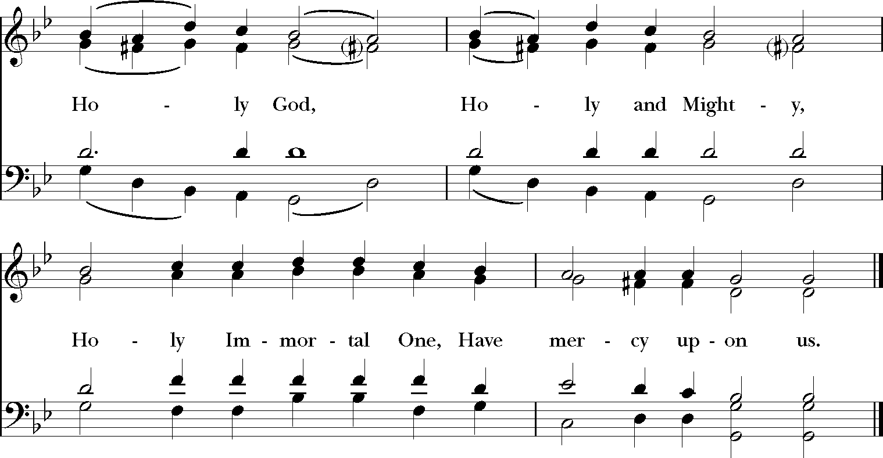

The Collect
Presider Let us pray.
Presider Almighty God, we pray you graciously to behold this your family, for whom our Lord Jesus Christ was willing to be betrayed, and given into the hands of sinners, and to suffer death upon the cross, and to be laid in a tomb in the garden; who now lives and reigns with you and the Holy Spirit, one God, for ever and ever. Amen.

The People are seated.

The Readings & Psalms

A reading from the book of Job 14:1-14
Silence follows the reading.

Psalm 24
V. If the Lord had not been on our side, let Israel now say;
R. If the Lord had not been on our side, when enemies rose up against us;

V.  R. | Then would they have swallowed us up alive in their fierce anger toward us;  Then would the waters have overwhelmed us and the torrent gone over us;
V.  R. | Then would the raging waters have gone right over us.  Blessed be the Lord! God has not given us over to be a prey for their teeth.
V.  R. | We have escaped like a bird from the snare of the fowler; the snare is broken, and we  Our help is in the Name of the Lord, the maker of heaven and earth. | have escaped.

A reading from the Letter of Paul to the Hebrews 4:14-16; 5:7-9
Silence follows the reading.

Psalm 90
V. Lord, you have been our refuge from one generation to another.
R. Before the mountains were brought forth, or the land and the earth were born, from age to age you are God.
V. You turn us back to the dust and say, “Go back, O child of earth.”
R. For a thousand years in your sight are like yesterday when it is past and like a watch in the night.
V. You sweep us away like a dream; we fade away suddenly like the grass.
R. In the morning it is green and flourishes; in the evening it is dried up and withered.
V. For we consume away in your displeasure; we are afraid because of your wrathful indignation.
R. Our iniquities you have set before you, and our secret sins in the light of your countenance.
V. When you are angry, all our days are gone; we bring our years to an end like a sigh.
R. The span of our life is seventy years, perhaps in strength even eighty; yet the sum of them is but labor and sorrow, for they pass away quickly and we are gone.
V. Who regards the power of your wrath? Who rightly fears your indignation?
R. So teach us to number our days that we may apply our hearts to wisdom.

A reading from the Gospel according to Luke 23:50-55
Silence follows the reading.

Meditation
Silence follows the mediation.

The Veneration of the Cross
Presider Be amazed, O heavens! Be shaken, O foundations of the earth! Behold, the One that dwells in the highest is numbered among the dead and sheltered in a lowly tomb. Today hell cries out groaning: “My dominion has shattered. I received a dead man as one of the dead, but against Him I could not prevail. From eternity I had ruled the dead, but behold, He raises all. Because of Him do I perish.” Glory to your Cross and Resurrection, O Lord!

Presider We adore you, O Christ, and we bless you.
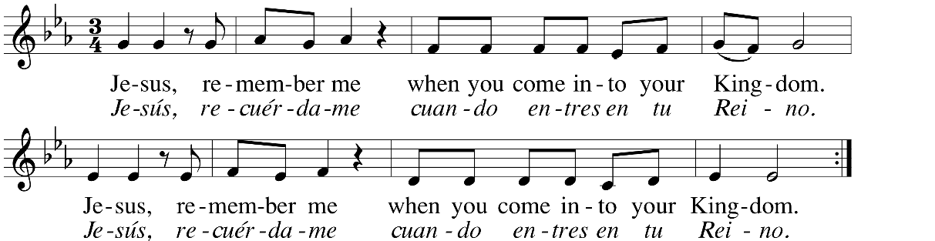
People Because by your holy cross and resurrection, you have redeemed the world.

After all, have returned to their seats, the cross is covered with a shroud or the funeral pall. The people may be invited to assist in the act of entombment. The Presider continues with the prayers.

The Prayers
Presider Into your hands, O Lord, I commend my spirit.
People For you have redeemed me, O Lord, O God of truth.

Presider As our Savior taught us we are bold to say.
People Our Father in heaven, hallowed be your Name, your kingdom come, your will be done, on earth as in heaven.
Give us today our daily bread. Forgive us our sins as we forgive those who sin against us. Save us from the time of trial, and deliver us from evil. For the kingdom, the power, and the glory are yours, now and for ever. Amen.

Presider Lord, hear our prayer.
People And let our cry come to you.
Presider Let us pray.

Silence

Presider O God, Creator of heaven and earth: as the crucified body of your dear Son was laid in the tomb and rested on this holy Sabbath, sanctifying the grave to be a bed of hope for your people, grant that we may await with him the coming of the third day, and rise with him to newness of life; who now lives and reigns with you and the Holy Spirit, one God, for ever and ever. Amen.

Presider In the midst of life we are in death;
People Of whom may we seek to be rescued, but by you, O Lord, who for our sins is justly displeased? Yet, O Lord God most holy, O Lord most mighty, O holy and most merciful Savior, deliver us not into the bitter pains of eternal death. You know, O Lord, the secrets of our hearts; Do not shut your merciful ears to our prayer; but spare us, Lord most holy, O God most mighty, O holy and merciful Savior, most worthy Judge eternal. Suffer us not, at our last hour, through any pains of death, to fall from you. Amen.

The Ministers depart in silence. The People are invited to remain in prayer.

Easter Day Liturgy
In communities of faith where the Great Vigil of Easter is not celebrated, the kindling of the new fire and the pass of the light of Christ, along with the renewal of Baptismal Vows may be added to the primary or principle liturgy of the day.

The Gathering of God's people
This is a day of remarkable surprise. It wasn’t supposed to happen like this. On that first Easter morning, what they expected was sadness and grief—what they found was more than they could pretend to dream. What are we expecting today?

Sharing Christ our Light
The church is in silence and darkness as we await the coming of Christ our Light. At the sound of a bell the Pascal Light (Christ Light) enters the church. The Presider greets the people.

Presider Dear friends in Christ, on this most holy morning, in which the Church gathers to celebrate and rejoice that our Lord Jesus Christ passed over from death to life, the Church invites her members, dispersed throughout the world, to gather in vigil and prayer. For this is the Passover of the Lord, in which, by hearing God’s Word and remembering our Baptism, we share in Christ’s victory over death.

Deacon The Holy Gospel of Our Savior Jesus Christ according to John 19:40 – 20:1
Deacon They took the body of Jesus and wrapped it with the spices in linen cloths, according to the burial custom of the Jews. Now there was a garden in the place where he was crucified, and in the garden there was a new tomb in which no one had ever been laid. And so, because it was the Jewish day of Preparation, and the tomb was nearby, they laid Jesus there. Early on the first day of the week, while it was still dark, Mary Magdalene came to the tomb and saw that the stone had been removed from the tomb.
A new fire may be kindled or the flame of the Pascal candle may be blessed in the sight of the people. Presider God is with you.
People And also with you.
Presider Let us give thanks to the Lord our God.
People It is right to give our thanks and praise.
Presider We thank you, Almighty God, for the gift of your light —shining on the first day of creation, guiding us through the wilderness, leading us to the land of promise. O God, through your Son you have bestowed upon your people the brightness of your light: Sanctify this new flame, and grant that in this Paschal feast we may so burn with heavenly desires, that with pure minds we may attain to the festival of everlasting light; through Jesus Christ our Lord. Alleluia! Amen!

Deacon The Light of Christ!
People Thanks be to God!

The Exultet
The Exultet or other hymn of praise may now be sung or said.
During the canticle, the congregation passes the Light of Christ to each other from the Paschal Candle. Deacon Rejoice! Let all the hosts of heaven, rejoice!

People Let the trumpet of salvation sound our mighty King’s triumph!
Deacon Be glad, let earth be glad, as glory floods her, ablaze with light from her eternal King,

People Let all corners of the earth be glad, knowing an end to gloom and sadness.
Deacon Rejoice, let Mother Church also rejoice, arrayed with the lightning of Christ’s glory,

People Let this holy building shake with joy, filled with the mighty voices of God’s peoples.
Deacon Therefore, O Lord, we pray you that this candle, hallowed to the honor of your name, may persevere undimmed, to overcome the dimness of our sight. May this flame be found still burning by the Morning Star: the one Morning Star who never sets, Christ your Son, who coming back from death’s dominion has shed his peaceful light on humankind, and lives and reigns for ever and ever.
People Alleluia! Amen!

The Liturgy continues with the Easter Greeting and Baptismal versicles.

Easter Greeting & Collect.
Presider Alleluia! Christ is Risen!
People Christ is Risen indeed! Alleluia! Presider There is one Body and one Spirit; People There is one hope in God’s call to us; Presider One Lord, one Faith, one Baptism; People One God and Creator of all.
Presider God is with you. People And also with you. Presider Let us pray.
The Presider continues with the Prayer of the Day.

The readings

The sermon

The Blessing of Water & the Renewal of Baptismal Vows
The Presider invites the congregation to gather at the font for the renewal of Baptismal Vows.

The Blessing of Water
The short form of the Thanksgiving over the Water may be used on Easter Day. The long form found in the Book of Common Prayer may also be used.

Presider God is with you
People And also with you.
Presider Let us give thanks to God.
People It is right to offer thanks and praise.
The Presider continues with the prayer of blessing.
We thank you O God for your love in all creation, especially for your gift of water to sustain, refresh and cleanse all life. We thank you that through the waters of baptism you cleanse us, renew us by your Spirit and raise us to new life. In the new covenant we are made members of your Church and share in your eternal kingdom. Now sanctify + this water we pray you, through the power of your Holy Spirit, that all who have passed through the waters of baptism may continue for ever in the risen life of Christ. Through Christ, in the unity of the Holy Spirit, all praise and thanks be yours, Redeemer God, now and for ever. Amen.

The Renewal of Baptismal Vows
The renewal of Baptismal Vows follows. At the conclusion of the Baptismal promises, the Presider offers the following prayer and invites the congregation to touch the waters of baptism or sprinkles the people as a reminder of their own baptism.
Presider Faithful God, by Water and Spirit you have bestowed on us the love of forgiveness, and you have raised us, with Jesus, to the new life of Grace. Sustain us, O Lord. Give us compassionate and discerning hearts,

the courage to will and to persevere, a spirit to know and to love you, and the gift of joy and wonder in all your works. Amen.

The liturgy continues with the Prayers of the People.

The prayers of the people
Leader We pray to Jesus who is present with us to eternity. Jesus, light of the world, bring the light and peace of your gospel to the nations. Jesus, Lord of life,
People In your mercy, hear us.

Leader Jesus, bread of life, give food to the hungry and nourish us all with your word. Jesus, Lord of life,
People In your mercy, hear us.

Leader Jesus, our way, our truth, our life, be with us and all who follow you in the way. Deepen our appreciation of your truth and fill us with your life. Jesus, Lord of life,
People In your mercy, hear us.

Leader Jesus, Good Shepherd, who gave your life for the sheep, recover the straggler, bind up the injured, strengthen the sick, especially those we name and lead the healthy and strong to new pastures. Jesus, Lord of life,
People In your mercy, hear us.

Leader Jesus, the resurrection and the life, we give you thanks for all who have lived and believed in you.
Raise us with them to eternal life. Jesus, Lord of life,
People In your mercy, hear us, accept our prayers, and be with us always. Amen.

The Presider adds a concluding prayer.
Presider Be present, O Risen Christ, in this your Church’s Easter praise. May we, like Mary Magdalene, the other Mary, and all witnesses to the resurrection see the tomb empty, and joyfully believing, walk in newness of life. Grant that our anthems of joy may give honor to the mystery of your redeeming love and that our proclamations of your victory over death may reflect the majesty of your eternal glory. In your most holy Name we pray. People Amen.

Post Communion Prayer
After all have received communion the Presider says Presider God is with you.
People And also with you.
Presider Let us pray.
People Holy and Eternal God, we give you thanks for this feast of your goodness and love. Send us out to share the bread of life with all who hunger for your love; through Jesus Christ our risen Savior. Alleluia! Amen!

Blessings & Sending
The Presider blesses the people as a reminder of God's extravagant love.

Presider Our worship is ended our service in the world to the risen Christ now begins. Go now to love and serve the Lord. Go in peace. Alleluia! Alleluia!
People Thanks be to God! Alleluia! Alleluia!

