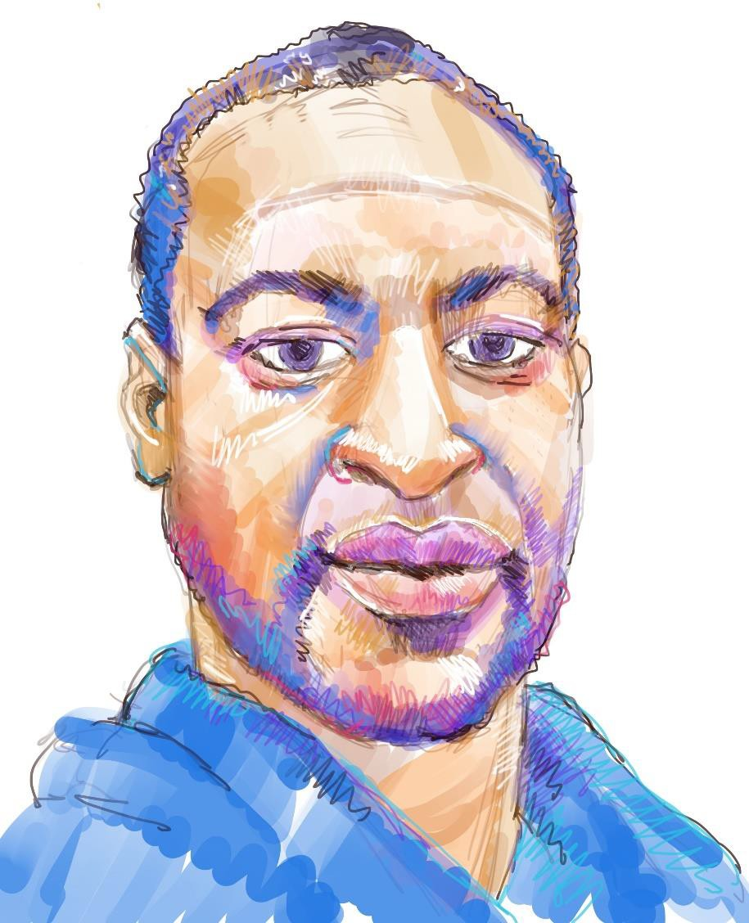

A Commemoration of the Life and Legacy of

George Perry Floyd Jr.
October 14, 1973 – May 25, 2020

The Episcopal Church

Intentionally Left Blank

A Commemoration of George Perry Floyd Junior

Prelude:

“GREAT IS THY FAITHFULNESS” ARRANGED BY DAN MILLER
Michael D. Boney, Organist Saint John’s Cathedral, Denver, CO

Introduction
The Presider begins with these or similar words.

The Rt. Rev. Jennifer Baskerville-Burrows, Diocese of Indianapolis
Presider A voice is heard in Ramah, lamentation and bitter weeping. Rachel is weeping for her children; she refuses to be comforted for her children, because they are no more.
- Jeremiah 31:15

Musical Offering:

“MOTHERLESS CHILD” ARRANGED BY HARRY T. BURLEIGH
Michael Walker, countertenor, Saint John’s Cathedral, Denver

The Rt. Rev. Dr. Bonnie Perry, Diocese of Michigan
Presider DEAR FRIENDS IN CHRIST, we gather on the anniversary of the death of George Floyd in homes across the church, across this nation and around the world. We gather with heavy hearts and raw emotions to pray, to reflect, to mourn, to question, to seek hope, to lament, to remember. Events like this ongoing viral pandemic and the pandemic of racism and violence which took the life of George Floyd and many others offer us more questions than answers, but we gather to be close to each other, to be in community, to remember. We stand with each other and with our siblings who tragically continue to lose their lives in our communities, our nation, and around the world.

The Rt. Rev. Kym Lucas, Diocese of Colorado
Presider TOGETHER WE STAND AGAINST THE TIDE. Because no matter what may come, no matter what the tide may bring we are here, and we are far stronger united as one; caring for our neighbors in Christ. Because together you and I in all our diversity and differences, our understandings and professions, our faith or lack of faith, we represent God’s radical and audacious vision for our world, a world transformed by love.

The Rt. Rev. Jennifer Baskerville-Burrows, Diocese of Indianapolis
Presider IT IS IN THAT LOVE THAT WE GATHER to commemorate and to commend to Almighty God the soul of George Floyd and all those who have died, to share in the grief of those who mourn, and to proclaim hope with those who persist. So together we lament, we remember, we hope.

Musical Selection:
“He’s got the whole world in his hand” arranged by Margaret Bonds
Everett McCorvey, tenor | Alicia McCorvey, soprano | Mattilda Middleton, organist
Church of the Good Shepherd, Lexington, KY

Scripture Reading:

JEREMIAH 31: 15-17, 23-24
Representative Steve Chisholm,
Diocese of Michigan

A reading from the Book of the Prophet Jeremiah

hus says the Lord: A voice is heard in Ramah, lamentation and bitter weeping. Rachel is weeping for her children; she refuses to be comforted for her children, because they are no more. Thus says the Lord: Keep your voice from weeping, and your eyes from tears; for there is
T
a reward for your work, says the Lord: they shall come back from the land of the enemy; there is hope for your future, says the Lord: your children shall come back to their own country. Thus says the Lord of hosts, the God of Israel: Once more they shall use these words in the land of Judah and in its towns when I restore their fortunes: “The Lord bless you, O abode of righteousness, O holy hill!” And Judah and all its towns shall live there together, and the farmers and those who wander with their flocks.

At the end of the reading the Reader says; Reader Hear ends the reading.

A psalm of Lament¹
The Rt. Rev. Craig, Loya, Diocese of Minnesota
V. How lonely sits our neighborhood O God! How we weep bitterly in the night!

R. Silent tears have become our song. “Gone too soon,” has become our lament.

V. Our hearts are heavy and our souls cry out.

R. Our elders and our children, our neighbors and our friends are gone.

V. Our ancestors weep at the legacy of injustice, inequity, inequality.

R. Our young men and young women cannot breathe.

V. How long O Lord will you keep silent?

R. How long O Lord will our loved ones die alone?

V. How long O Lord will deadly pestilence ravage our people?

R. For these things we weep; our eyes flow with tears.

V. Our elders sit in silence; our young bow their heads to the ground.

R. Weeping and wailing, despair and distress have become our companions.

V. We wait for a strong deliver, one to revive us in hope.

R. Look to God and consider! Give ear O my soul and hear.
V. The steadfast love of the Lord never ceases;

R. God’s mercies never come to an end.

¹ Written by the Rt. Rev. Deon K. Johnson, Diocese of Missouri

V. “I am your God and you are my people,” says our God,

R. “I will dry your tears and lift you up O my people.

V. I will turn your mourning in to dancing, and your lament into songs of joy.

R. Turn again to joy, and exchange mourning for a song.”

V. Be still then, O my soul, take courage,

R. The God of our Ancestors dwells with us, and in hope shall be our strength.

Music Selection:

“I WANT JESUS TO WALK WITH ME” ARRANGED BY CARL HAYWOOD
Yuri Rodriguez, vocalist | Kenneth Miller, D.M.A., organist, Assistant Professor of Church Music
Sewanee The University of the South

The Great Silence: 9 minute 26 sec
Please note that this is an intentional prolonged silence that will be broken by the tolling of a minute bell.

Reflection:

The Most Reverend Michael B. Curry,
Presiding Bishop and Primate of the Episcopal Church

Act of Remembrance
The Rt. Rev. Deon K. Johnson, Diocese of Missouri
Presider A single water drop has the power to shape even the hardest stone. A single act of hope has the power to inspire a world to be transformed. A single light has the power to dispel even the longest shadow.

Candles are now lit and the light shared. Individual candles at home may now be lit.

Presider As we share the light from these many flames, may these candles be symbols of our burning hope and our shining light. That we may act out of hope and compassion to mourn with those who grieve.

The Rt. Rev. Mariann Budde, Diocese of Washington
Presider O GOD WHO CREATED ALL PEOPLE IN YOUR HOLY IMAGE, who loves the stranger, who cares for the downtrodden: walk with those who face discrimination, protect them from harm, help them see Christ in our community. Guide those who fan the fires of discrimination to open their eyes to the beauty of all your creation and respect the human dignity of all people. Open our hearts to those who face hatred and injustice because of their race, their background, their ethnicity, that we might better help them belong; through Jesus Christ our Lord. Amen

Music selection:
”HOLD ON” ARRANGED BY MARGARET BONDS

Michael Walker, countertenor, Saint John’s Cathedral, Denver

Participants & Acknowledgements

Presiders
The Rt. Rev. Mariann E. Budde,
Diocese of Washington

The Rt. Rev. Jennifer Baskerville Burrows,
Diocese of Indianapolis

The Rt. Rev. Deon K. Johnson,
Diocese of Missouri

The Rt. Rev. Craig Loya,
Diocese of Minnesota

The Rt. Rev. Kimberly Lucas,
Diocese of Colorado

The Rt. Rev. Bonnie Perry,
Diocese of Michigan

Reader:
Representative Steven Chisholm,
Diocese of Michigan

Reflection
The Most Rev. Michael B. Curry,
Presiding Bishop & Primate of the Episcopal Church

The Great Silence 9 minutes 26 seconds Montage

The Rev. Kevin Goodman
Diocese of Chicago

The Rev. Sister Veronica Mary
Diocese of Michigan

Anna Stania
Diocese of Michigan

Musical Selections & Lead Musician

Dr. Michael Boney
Director of Music & Organist, St. John’s Cathedral Diocese of Colorado

Light Sharing Participating Dioceses
Diocese of Missouri Diocese of Central New York
Diocese of Chicago Diocese of Kansas
Diocese of Northern Michigan Diocese of Nova Scotia & PEI Diocese of Oregon
Diocese of Washington Diocese of West Tennessee The Territory of The People Seminary of The Southwest
Episcopal Divinity School at UTS

Liturgy
The Rt. Rev. Deon K. Johnson Diocese of Missouri

Permission to podcast/stream this music is obtained from OneLicense #A-713301

