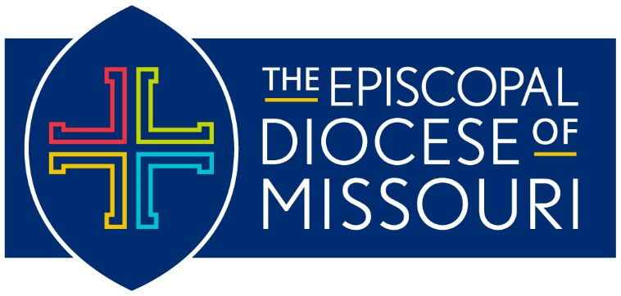
Budget Request – 2022 Operating Budget
Deadline: July 15, 2021

- Contact Information
Congregation Name and City:
OR
Organization/Ministry:
Contact Person:
Position:
Phone Number:
Email Address:

- Request Information (please attach additional pages as needed)
A. Amount Requested: | $
B. Description of need:

C. Breakdown of how funds will be used:
D. Specific measurable goals and outcomes of the request:
E. Any significant changes or trends affecting organization’s income:
F. Proposed time frame for your organization to assume full financial support if applicable:
G. Mission Statement:

Congregational Requests please also complete the following questions.
H. Pledging Units 2020:
2021:
I. Total pledges 2020:
2021:
J. Average Sunday Attendance 2020:
2021:
Organization/Ministry Requests please also complete the following questions.
K. Description of the program and how it fits the Diocesan vision:

L. Long range plans of your program:
M. Existing or anticipated funding sources/amounts:
N. Date organization was founded and its historic tie to the Diocese of Missouri:
O. Number of people served or other specific measure of outcome:

- Required Attachments:

- Financials for 2020 including all endowment and restricted funds
- Budget for 2021 (as adopted by the appropriate body)
- Proposed budget for 2022
- Strategic Plan (for Congregational Requests)

NOTE: Only completed applications with required documentation will be considered. Please provide one copy ready version with your submission (single sided, no staples, no paper clips). If sending via e-mail, which is preferred, please send in one PDF attachment. E-mail submissions with multiple attachments will not be accepted.

Mail, fax, or email your request by July 15, 2021 to:

Ms. Desirée Brattin
Diocese of Missouri
1210 Locust St., 3rd Floor
St. Louis, MO, 63103
Fax: 314‐231‐3373
Email: desiree@diocesemo.org

