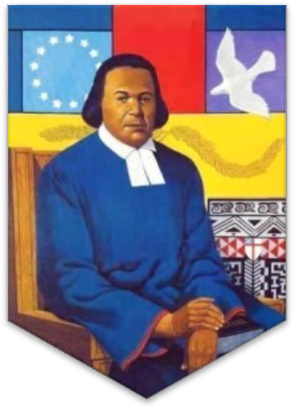
The Feast of

Blessed Absalom Jones,
Pioneer, Prophet, & Priest
Transferred

Saturday, February 27, 2021 The Right Reverend Deon K. Johnson,
The Eleventh Bishop of Missouri, Presider

The Right Reverend Gayle E. Harris

The Episcopal Diocese of Massachusetts,
Bishop Suffragan,
Preacher

Christ Church Cathedral
St. Louis, Missouri

Page 1

The Gathering of God’s People

Scattered into the world we gather together as God's people in worship. We bring the fragments of our lives to be healed and made whole in Christ as we gather in community.

Welcome to Christ Church Cathedral in the Episcopal Diocese of Missouri. We give thanks for the work and ministries of the Episcopal Church, and the Evangelical Lutheran Church as we worship “in the beauty of
holiness” together.

We gather from intimate rural parishes and sprawling urban ones, long time church members and those new to the faith to celebrate a new verse in a song that has been ringing through eternity. As we gather, we bring our diverse gifts: gifts of music, dance, prophecy, teaching, preaching, and friendship. We present these gifts in the form of our most precious offering to God, our very selves, that all that we do may be for God’s glory in the unity of Christ’s church.

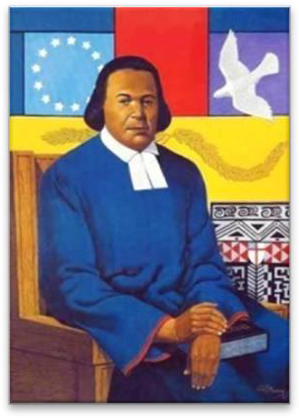
Absalom Jones (November 7, 1746 – February 13, 1818) was an African-American abolitionist and clergyman. After founding St. Thomas African Episcopal Church, a black congregation in 1794, he was the first African American ordained as a priest in the Episcopal Church of the United States in 1804.

Absalom Jones and Richard Allen founded the Free African Society, first conceived as a non-denominational mutual aid society, to help newly freed slaves in Philadelphia. Jones and Allen later separated, as their religious lives took different directions after 1794 as discussed below, but they remained lifelong friends and collaborators.
Absalom Jones is listed on the Episcopal calendar of saints and remembered liturgically on the date of his death, February 13, in the 1979 Book of Common Prayer.

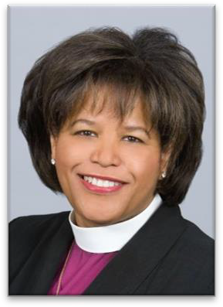
The Right Reverend Gayle Elizabeth Harris. Bishop Harris was ordained and consecrated a bishop in January 2003 in the Diocese of Massachusetts. Bishop Gayle serves as a suffragan (assisting) bishop alongside the diocesan bishop, the Rt. Rev. Alan M. Gates.

A native of Cleveland, she graduated from Lewis and Clark College and holds a Master of Divinity degree from the Church Divinity School of the Pacific, which awarded her an honorary Doctor of Divinity degree in 2002. She was ordained to the priesthood in 1982, and served parishes in the dioceses of Newark, Washington (D.C.) and Rochester (New York) prior to her consecration as bishop.

She currently chairs the House of Bishops Pastoral Development Committee and is the convenor of the Episcopal Bishops of African Descent. She is a member of the Board of Directors of the Episcopal Church Investment Group and is on the Task Force on the Theology of Money.

In the Diocese of Massachusetts she is on the board of the Old North Church Foundation and serves as vice president of Episcopal City Mission. She is the past president of the Massachusetts Council of Churches.

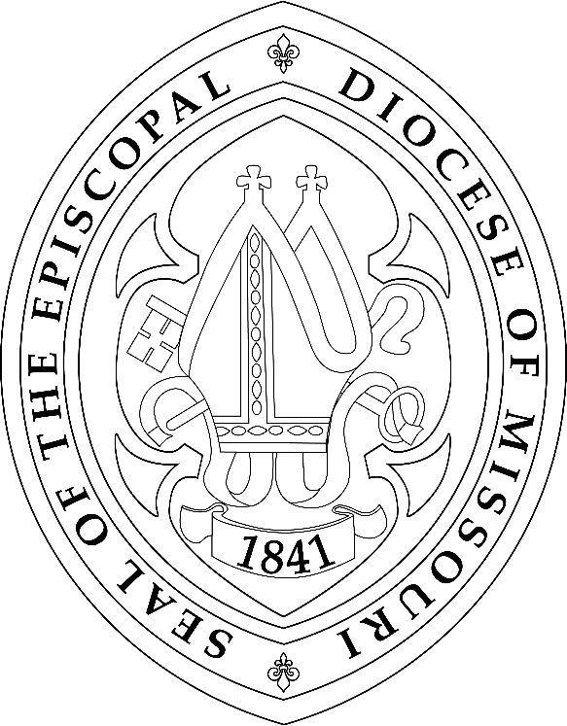

Visual Prelude: Absalom Jones Children’s Book Reading: Debbie Nelson Linck

Call to Worship

Musical Selection: African Drumming

Presider I was glad when they said unto me, let us go into the house of the Lord, our feet shall stand within your gates, O Jerusalem.
All For a day in thy courts is better than a thousand. I had rather be a doorkeeper in the house of my God than to dwell in the tents of wickedness.

Presider Because of the house of the Lord our God, I will seek to do you good.
All Those who are planted in the house of the Lord shall flourish in the courts of our God;

Presider Blessed are they who dwell in your house. Lord, I love the house in which you dwell and the place where your glory abides
All For the Lord is in the holy temple, let all the earth keep silence.

Presider Let the words of my mouth and the meditation of my heart be acceptable in thy sight, O Lord, my strength and my Redeemer.
All O sing a new song to the Lord, who has done marvelous things. Make a joyful noise unto the Lord, all the earth, and sing praises.

Welcome: The Very Rev. Kathie Adams-Shepherd, Dean of Christ Church Cathedral

OPENING HYMN: I WANT JESUS TO WALK WITH ME
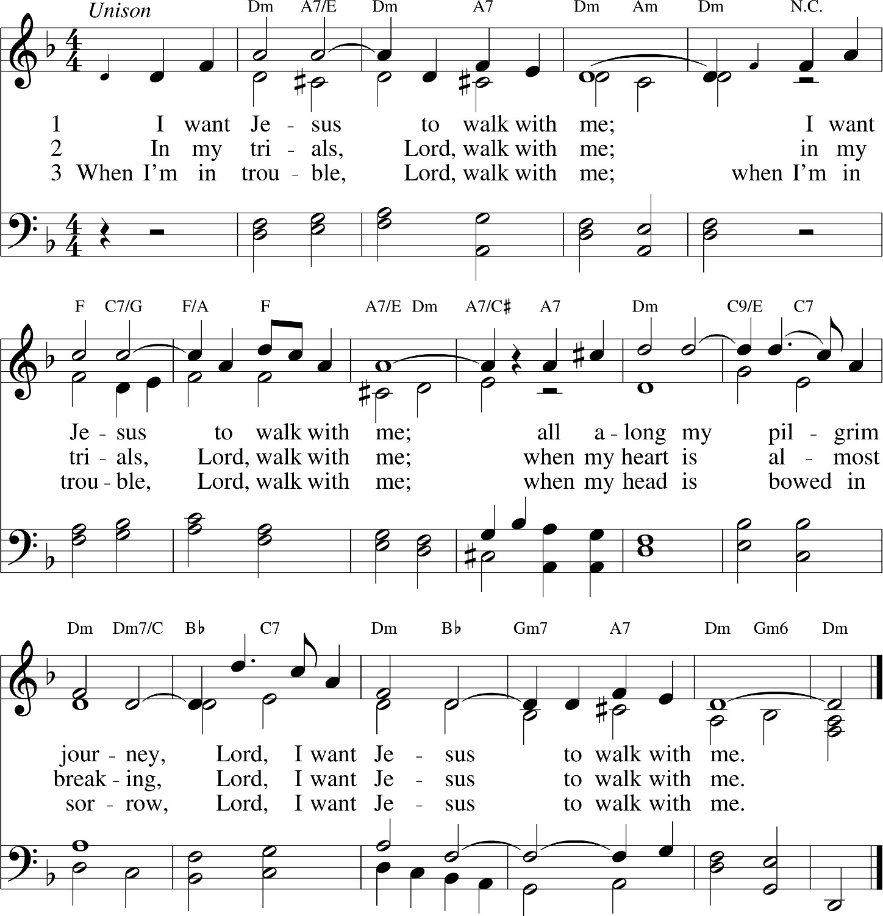

The Greeting

Presider Blessed be the Holy and Eternal God.
All From this time forth and for evermore!
Presider Blessed be the One whose justice rolls down like mighty waters.
All And whose righteousness is like an ever-flowing stream.

Song of Praise: Joyful, Joyful We Adore Thee (Diocesan Virtual Choir)
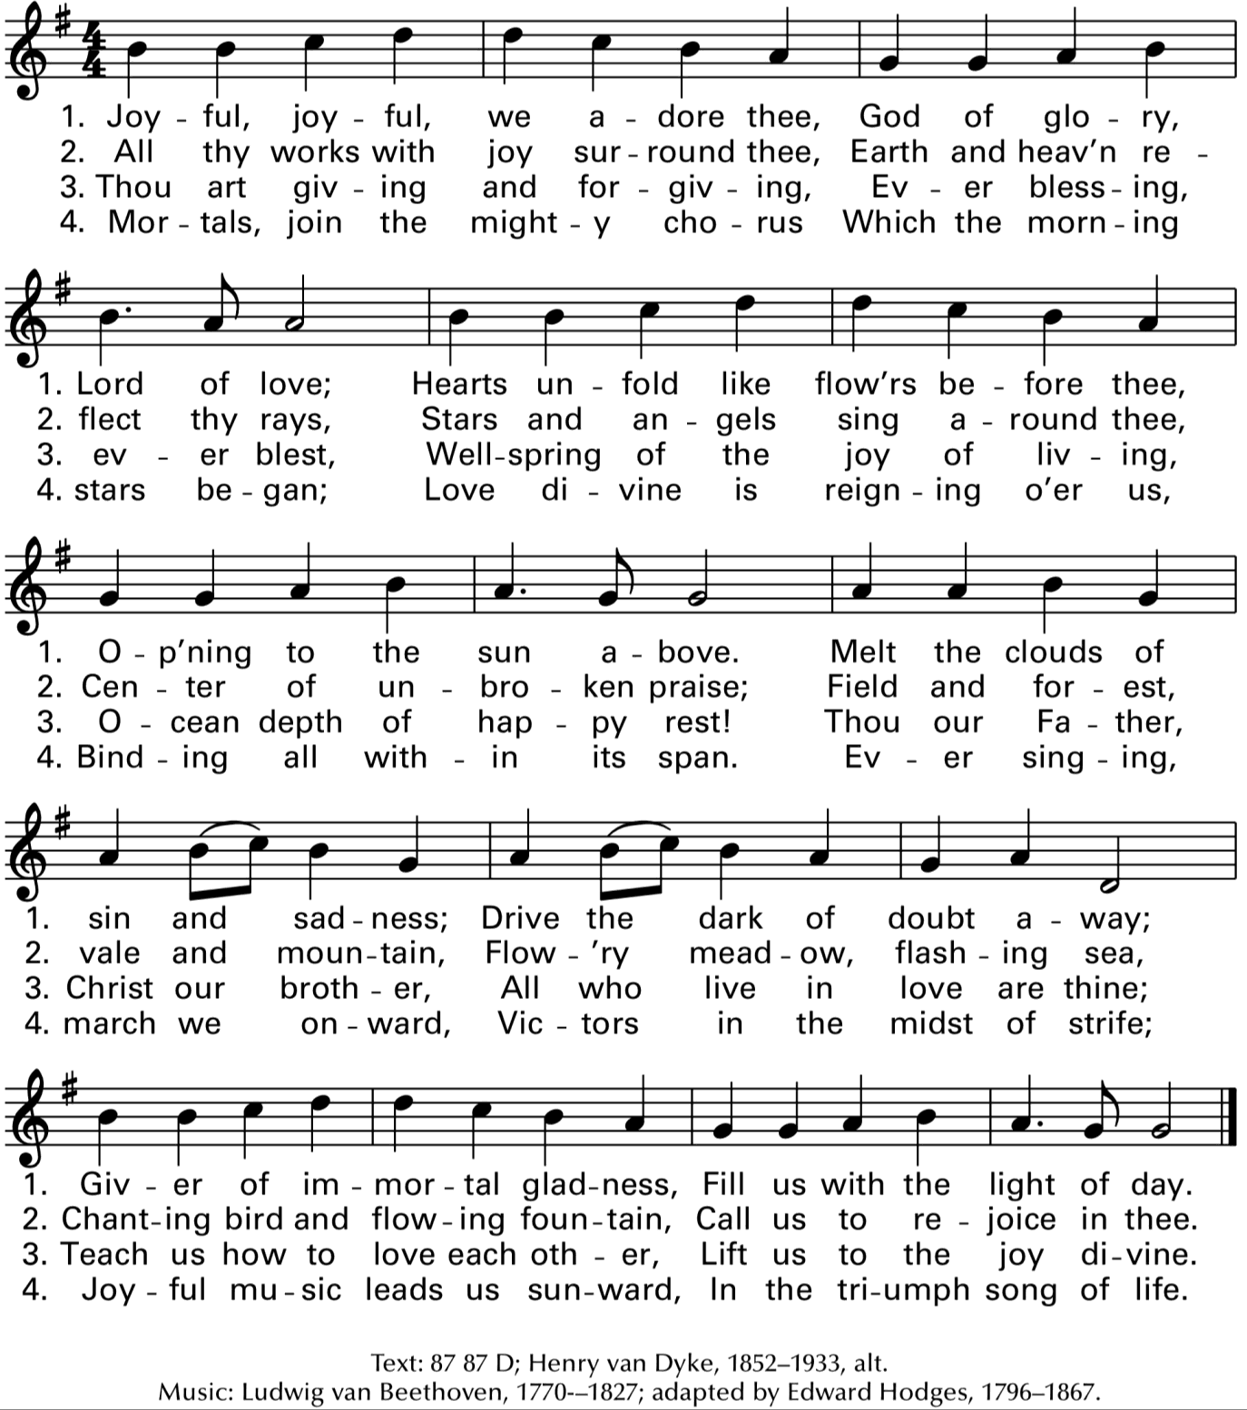

The Collect of the Day

Presider God is with you. All And also with you. Presider Let us pray.
Silence is kept for a time.

Presider Eternal One, who through the voices of the prophets call your people to hunger and thirst after righteousness and in our own time gave us the example of Absalom, Jehu and Richard, defenders of justice and truth. So guide and inspire our hearts as we seek your kingdom, that all your people may find their security in that love which casts out fear and in the fellowship revealed to us in Jesus Christ our Savior, who is alive and reigns with you, in the unity of the Holy Spirit, one God, now and for ever. Amen.

We hear the Sacred Stories

HEBREW SCRIPTURE: ISAIAH 11:1-5

A shoot shall come out from the stump of Jesse, and a branch shall grow out of his roots. The spirit of the LORD shall rest on him, the spirit of wisdom and understanding, the spirit of counsel and might, the spirit of knowledge and the fear of the LORD. His delight shall be in the fear of the LORD. He shall not judge by what his eyes see, or decide by what his ears hear; but with righteousness he shall judge the poor, and decide with equity for the meek of the earth; he shall strike the earth with the rod of his mouth, and with the breath of his lips he shall kill the wicked. Righteousness shall be the belt around his waist, and faithfulness the belt around his loins.

At the end of the reading the Reader says
Reader Hear what the Holy Spirit is telling God's people.
All Thanks be to God.

PSALM OF THE DAY: PSALM 137:1-6
The Psalm is prayed responsively.

V. By the waters of Babylon we sat down and wept, when we remembered you, O Zion.
R. As for our harps, we hung them up on the trees in the midst of that land.

V. For those who led us away captive asked us for a song, and our oppressors called for mirth: “Sing us one of the songs of Zion.”
R. How shall we sing the Lord’s song upon an alien soil?

V. If I forget you, O Jerusalem, let my strong hand forget its skill.
R. Let my tongue cleave to the roof of my mouth if I do not remember you, if I do not set Jerusalem above my highest joy.

NEW TESTAMENT: GALATIANS 5:1-5

For freedom Christ has set us free. Stand firm, therefore, and do not submit again to a yoke of slavery. Listen! I, Paul, am telling you that if you let yourselves be circumcised, Christ will be of no benefit to you. Once again I testify to every man who lets himself be circumcised that he is obliged to obey the entire law. You who want to be justified by the law have cut yourselves off from Christ; you have fallen away from grace. For through the Spirit, by faith, we eagerly wait for the hope of righteousness.

At the end of the reading the Reader says
Reader Hear what the Holy Spirit is telling God's people.
All Thanks be to God.

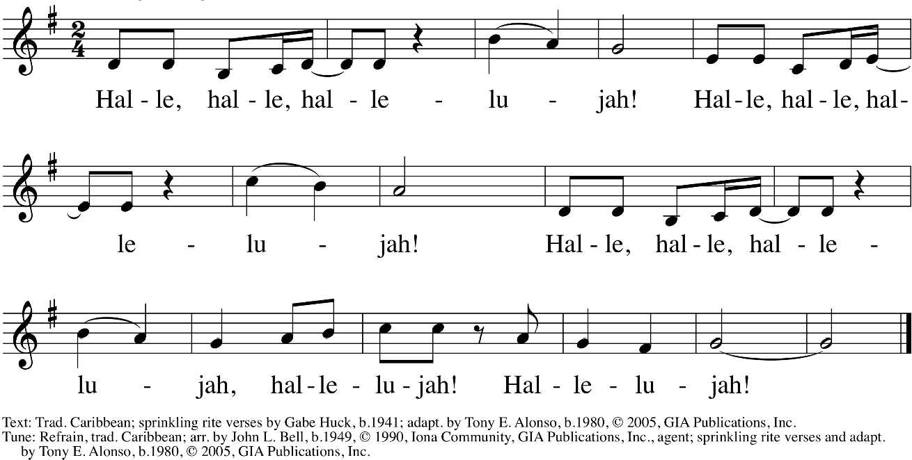
Caribbean Alleluia:

The Proclamation of the Gospel

Deacon God is with you.
All And also with you.
Deacon Hear the Good News of Christ according to John 15:12-15
All Amen. Praise to you O Christ.
The Deacon continues with the Gospel.

Jesus said, “This is my commandment, that you love one another as I have loved you. No one has greater love than this, to lay down one’s life for one’s friends. You are my friends if you do what I command you. I do not call you servants any longer, because the servant does not know what the master is doing; but I have called you friends, because I have made known to you everything that I have heard from my Father."

At the end of the proclamation the Deacon says:
Deacon The Gospel of Christ.
People Amen. Glory to you O Christ.

THE SERMON THE RIGHT REVEREND GAYLE HARRIS
Bishop Suffragan, The Episcopal Diocese of Massachusetts

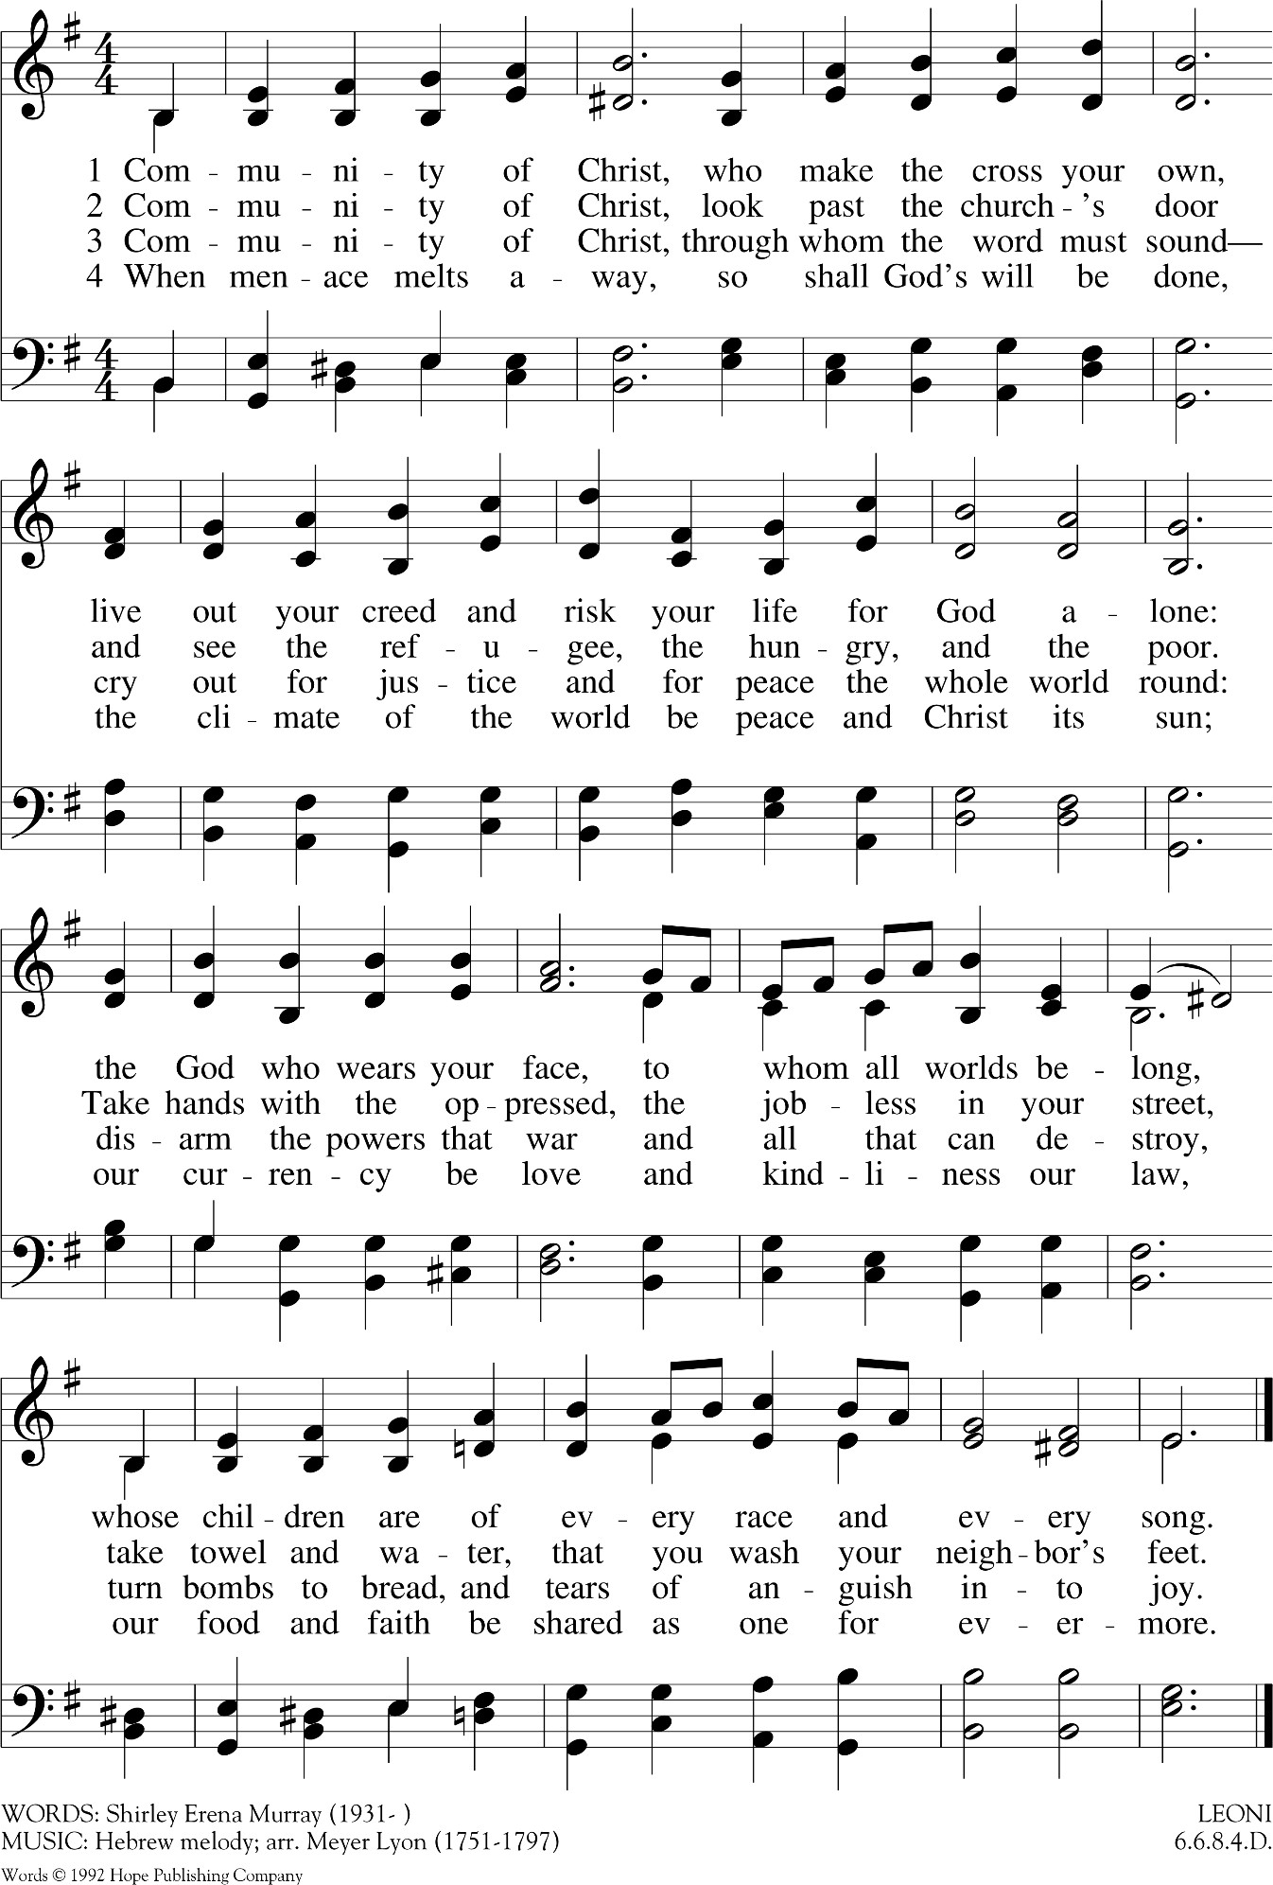
Hymn Selection: Community of Christ

Affirmation of Faith & the Renewal of Commitment for Social Justice
Presider Dear people of God, we are the body of Christ and the inheritors of the apostles teaching and fellowship. We stand in the shadow of the prophets crying out for justice and peace in our own time and place. God calls us to be a voice of generous-spirited Christianity, a people of reconciliation, serving a world in need. Throughout our history courageous women and men have taken the risk of standing up and speaking out for the least and the lowest. We now stand in their place seeking to create sacred communities of hope for generations to come. This work involves risking ourselves for the sake of God's love, moving beyond ourselves in order to seek and serve Christ and one another. I invite you therefore, following the example of the One who welcomed the outcaste and gave sight to the blind, to renew your commitment to the work and ministry of social justice.
Presider Do you believe in God the Almighty?
All I believe in God, the Almighty, creator of heaven and earth.
Presider Do you believe in Jesus Christ, the Son of God?
All I believe in Jesus Christ, God's only Son, our Lord. He was conceived by the power of the Holy Spirit and born of the Virgin Mary. He suffered under Pontius Pilate, was crucified, died, and was buried. He descended to the dead. On the third day he rose again. He ascended into heaven, and is seated at the right hand of God. He will come again to judge the living and the dead.
Presider Do you believe in God the Holy Spirit?
All I believe in the Holy Spirit, the holy catholic Church, the communion of saints, the forgiveness of sins, the resurrection of the body, and the life everlasting.

Presider Will you persevere in prayer and fellowship, seeking strength in our common life?
All I will, with God’s help.
Presider Will you proclaim the good news of the risen Christ, God’s word of hope and reconciliation in word and deed, to those to whom Christ will send you?
All I will, with God’s help.
Presider Will you care for God’s creation with wisdom and reverence, sharing freely of the gifts God has given?
All I will, with God’s help.
Presider Will you serve Christ in all persons, in those with whom you agree and disagree, loving your neighbor as yourself?
All I will, with God’s help.
Presider Will you strive to build God’s reign, the beloved community of justice and righteousness, working to bring peace to the human family?
All I will, with God’s help.
Presider Will you be the voice of those who have no voice, the spirit of those whose spirit is broken and the messenger of hope for those sitting in despair?
All I will, with God’s help.

Presider Will you seek to mend what is broken by human sin and greed, and look for Christ present in those who suffer at the hand of others?
All I will, with God’s help.
Presider May the God of Justice and Peace, who in love has called us to follow in the Way, pour out upon the blessings of the Holy Spirit to accomplish these things; May you go forth into the world to stand up, speak out and live into the reign of Christ our Savior. In peace let us pray to the Lord. Amen.

Still I Rise by Maya Angelou
(Read by Bishops of Color in the Episcopal Church)

THE PRAYERS OF THE PEOPLE: FOR SOCIAL JUSTICE

Lector 1 O God, we pray for the gifts of ministry; inspire our minds with a vision of your kingdom.
Lector 2 Come, Holy Spirit, touch our eyes, that we may see you at work in our community.

Lector 1 Come, Holy Spirit , touch our ears, that we may hear your voice calling us to new realities.
Lector 2 Come, Holy Spirit, touch our lips, that with fresh words we may tell of the works of God in every language and dialect.

Lector 1 Come, Holy Spirit, touch our hearts, that we may discern the mission to which you call us.
Lector 2 Come, Holy Spirit, touch our feet, that we may take your Good News into our neighborhoods, communities, and all parts of the world.

Lector 1 Come, Holy Spirit, touch our hands, that we may accomplish the work you give us to do.
Lector 2 Strengthen and encourage all who minister in your name in lonely, dangerous and unresponsive places.

Lector 1 Open the hearts and hands of many to support your Church in this and every place. Empower all who minister in your name especially...silence is kept for a time. Come, Holy Spirit. Renew your church.
Lector 2 Come, Holy Spirit. Fill those in need of healing...names may offered silently or aloud.

Lector 1 Come Holy Spirit. Surround those who have lived and died for the sake of justice... names may offered silently or aloud.
Lector 2 Open our lips that we may sing a new songs of freedom and peace in the places our feet trod and in the persons our eyes behold.

Presider Encircle us, O God. Circle this world with the joy of your Salvation; speak to us in our prayer. Where there is sickness and disease bring healing. Where there is inequity and discrimination bring justice. Where there is hunger and despair bring hope. Where there is torture and oppression bring release. Enable us to become that which you would desire. Amen.
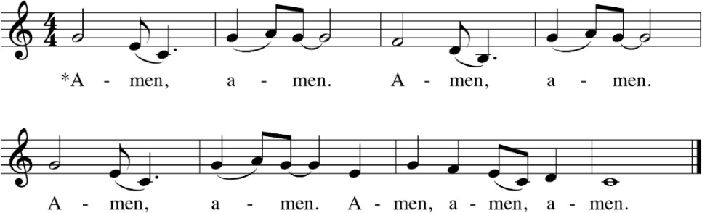

The Lord's Prayer
Presider Believing the promises of God, let us pray with confidence as our Savior has taught us:
All Our Father, who art in heaven, hallowed be thy name. Thy Kingdom come, thy will be done, on earth as it is in heaven. Give us this day our daily bread. And forgive us our trespasses, as we forgive those who trespass against us. And lead us not into temptation, but deliver us from evil.
For thine is the kingdom, the power and the glory, for ever and ever. Amen

Musical Selection: Lift Every Voice and Sing
Lift every voice and sing, Till earth and heaven ring,
Ring with the harmonies of Liberty; Let our rejoicing rise
High as the list'ning skies,
Let it resound loud as the rolling sea.
Sing a song full of the faith that the dark past has taught us, Sing a song full of the hope that the present has brought us; Facing the rising sun of our new day begun,
Let us march on till victory is won.

Stony the road we trod, Bitter the chast'ning rod,
Felt in the days when hope unborn had died; Yet with a steady beat,
Have not our weary feet
Come to the place for which our fathers sighed?
We have come over a way that with tears has been watered.
We have come, treading our path through the blood of the slaughtered, Out from the gloomy past,
Till now we stand at last
Where the white gleam of our bright star is cast.

God of our weary years, God of our silent tears,
Thou who hast brought us thus far on the way; Thou who hast by Thy might,
Led us into the light,
Keep us forever in the path, we pray.
Lest our feet stray from the places, our God, where we met Thee, Lest our hearts, drunk with the wine of the world, we forget Thee; Shadowed beneath Thy hand,
May we forever stand, True to our God,
True to our native land.

The General Thanksgiving

Presider Accept, O Lord, our thanks and praise for all that you have done for us. We thank you for the splendor of the whole creation, for the beauty of this world, for the wonder of life, and for the mystery of love.
All We thank you for the blessing of family and friends, and for the loving care which surrounds us on every side.

Presider We thank you for setting us at tasks, which demand our best efforts, and for leading us to accomplishments, which satisfy and delight us.
All We thank you also for those disappointments and failures that lead us to acknowledge our dependence on you alone.

Presider Above all, we thank you for your Son Jesus Christ; for the truth of his Word and the example of his life; for his steadfast obedience, by which he overcame temptation; for his dying, through which he overcame death; and for his rising to life again, in which we are raised to the life of your kingdom.
All Grant us the gift of your Spirit, that we may know Christ and make him known; and through him, at all times and in all places, may give thanks to you in all things. Amen.

The Blessing & Sending

Presider May God bless you with a restless discomfort about easy answers, half-truths and superficial relationships, so that you may seek truth boldly and love deep within your heart.

May God bless you with holy anger at injustice, oppression, and exploitation of people, so that you may tirelessly work for justice, freedom, and peace among all people.

May God bless you with the gift of tears to shed with those who suffer from pain, rejection, starvation, or the loss of all that they cherish, so that you may reach out your hand to comfort them and transform their pain into joy.

May God bless you with enough foolishness to believe that you really CAN make a difference in this world, so that you are able, with God’s grace, to do what others claim cannot be done.

And the blessing of God the Supreme Majesty and our Creator, Jesus Christ the Incarnate Word who is our brother and Savior, and the Holy Spirit, our Advocate and Guide, be with you and remain with you, this day and forevermore. Amen.

Deacon Let us go forth into the world, rejoicing in the power of the Spirit.
People Thanks be to God.

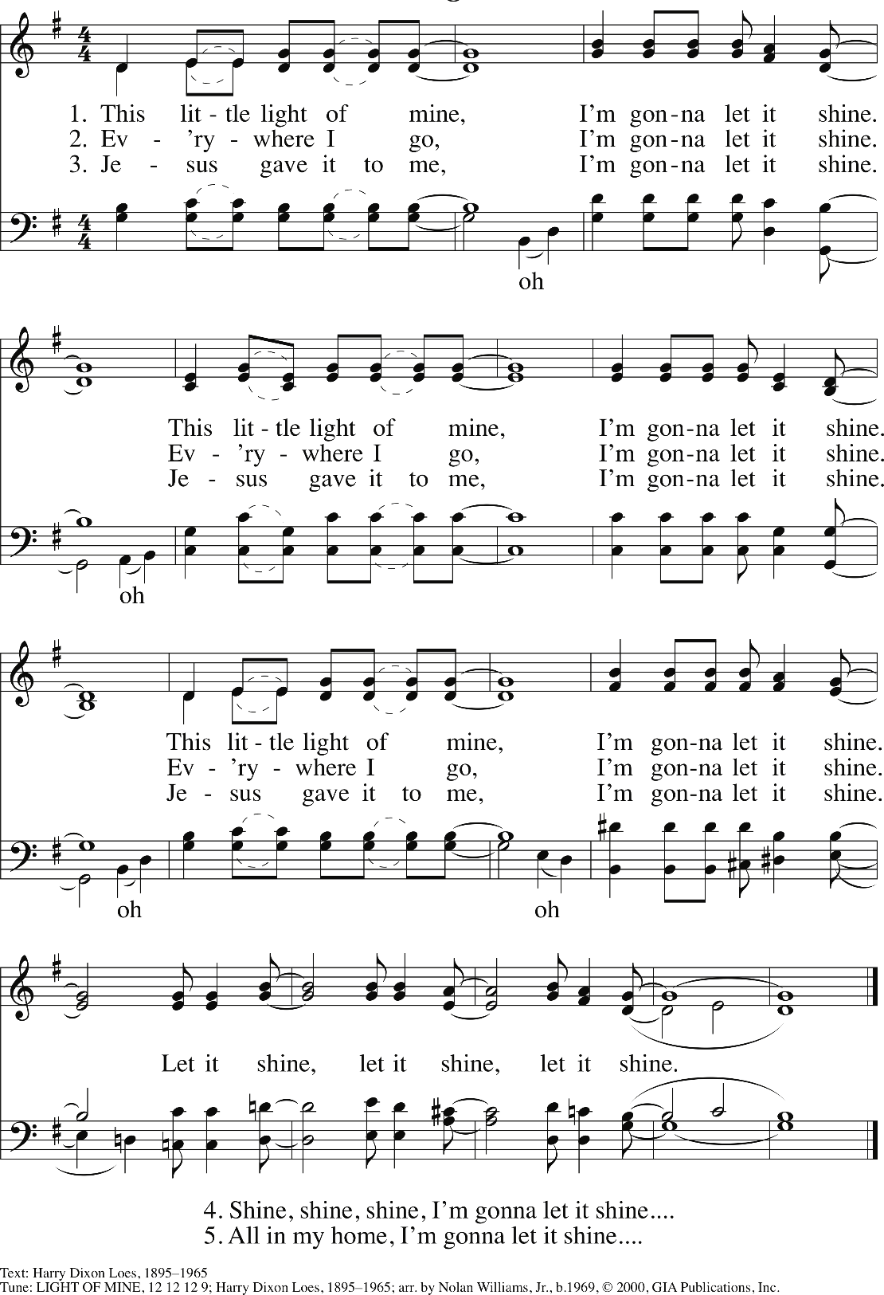
CLOSING HYMN: “THIS LITTLE LIGHT OF MINE”

Liturgy Participants

Presider
The Right Reverend Deon K. Johnson XI Bishop of Missouri

Preacher
The Right Reverend Gayle E. Harris Bishop Suffragan, Diocese of Massachusetts

Assisting Clergy
The Very Rev. Kathie Adams-Shepherd, Dean, Christ Church Cathedral, St. Louis The Rev. Renee Fenner, All Saints & Ascension, Northwood
The Rev. Shug Goodlow, St. Peter’s, Ladue
The Rev. Dn. Chester Hines, Holy Communion. University City The Venerable Rebecca Barger, Archdeacon, St. Francis, Eureka The Rev. Dn. Elizabeth Bowen, Trinity, St. Charles

Hebrew Scripture
Natalie Alexander, Trinity Episcopal Church, Kirksville

Psalm of the Day
Gordon Jones (reader) and Nancy Jones (response), St. Paul's, Sikeston

New Testament
Daive Dunkley, Calvary Episcopal Church, Columbia

Prayers of the People
Camryn, Camille and Cayleigh Moore, All Saints & Ascension, Northwoods

Caribbean Alleluia
Performed by the Holy Communion Choir Directed & Edited by Mary Chapman

Community of Christ
Performed by the Holy Communion Choir Directed by Mary Chapman

Poem: Still I Rise
The Most Rev. Michael B. Curry, Presiding Bishop of The Episcopal Church The Rt. Rev. Jennifer Baskerville-Burrows, Bishop of Indianapolis
The Rev. Cn. Paula Clark, Bishop-elect of Chicago The Rt. Rev. Carlye Hughes, Bishop of Newark The Rt. Rev. Deon K. Johnson, Bishop of Missouri
The Rt. Rev. Shannon MacVean-Brown, Bishop of Vermont The Rt. Rev. Phoebe Roaf, Bishop of West Tennessee
The Rt. Rev. Arthur Williams, Bishop of Ohio The Rt. Rev. Robert Wright, Bishop of Atlanta

edited by Hunter Johnson
"Still I Rise" by Maya Angelou, Used by permission of Caged Bird Legacy, LLC.

Call to Worship - African Drummers
led by David Jackson

Opening Hymn - I Want Jesus to Walk with Me
arranged by David M Cherwien
sung by Olivia Limbaugh, St Martin’s Episcopal and Senior at Parkway Central High School accompanied by Denise Marsh, Music Director at St Martin’s Episcopal Church
One License SKU# 50-3435

Song of Praise: Hymn to Joy
Sung by The Diocese of Missouri Virtual Choir Directed by Mary Chapman, Holy Communion, University City
Edited by Kyle Tallman, Church of St. Michael & St. George, Clayton

Virtual Choir: Amen
Performed by the Holy Communion Choir Directed & Edited by Mary Chapman

Musical Selection: Lift Every Voice and Sing
Arranged by Jae Park | Sung by Bria Jones

Closing Music: This Little Light of Mine
Harmonica performance by Gene Dobbs Bradford, Executive Director of Jazz St. Louis

Absalom Jones Commemoration Planning Team
The Rev. Dn. Chester Hines, Jr., Chair—Holy Communion, University City Adrienne Dillon—All Saints & Ascension, Northwoods
Alexia Dukes—All Saints & Ascension, Northwoods Rob Good—Christ Church Cathedral, St. Louis The Rev. Shug Goodlow—St. Peter’s, Ladue
Lisa Gould—Christ Church Cathedral, St. Louis Sherifa Hardware—Holy Communion, University City Doris Lucy-Goodlow—Christ Church Cathedral, St. Louis
Valerie Patton—All Saints & Ascension, Northwoods Margaret Rowe—Emmanuel, Webster Groves

This committee is part of the greater Dismantling Racism Commission, which meets on the first Saturday of every month. All are invited.
For more information, visit diocesemo.org/dismantling-racism-commission.

Music Permission
Music reprinted in this bulletin and streamed online under OneLicesnse.net #A-730970

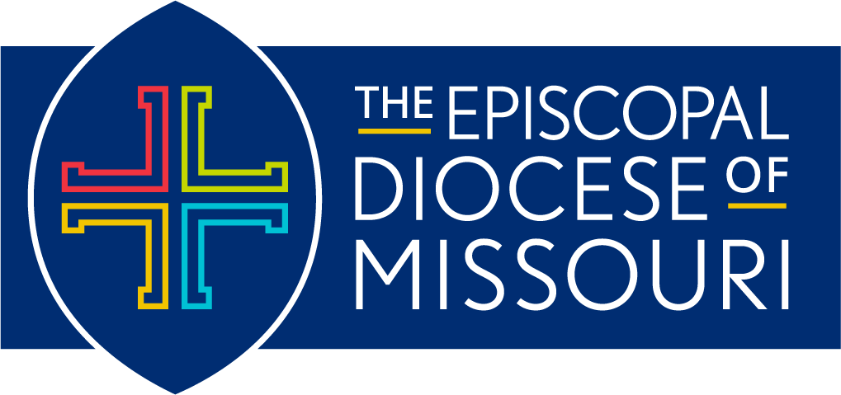

Page 16

