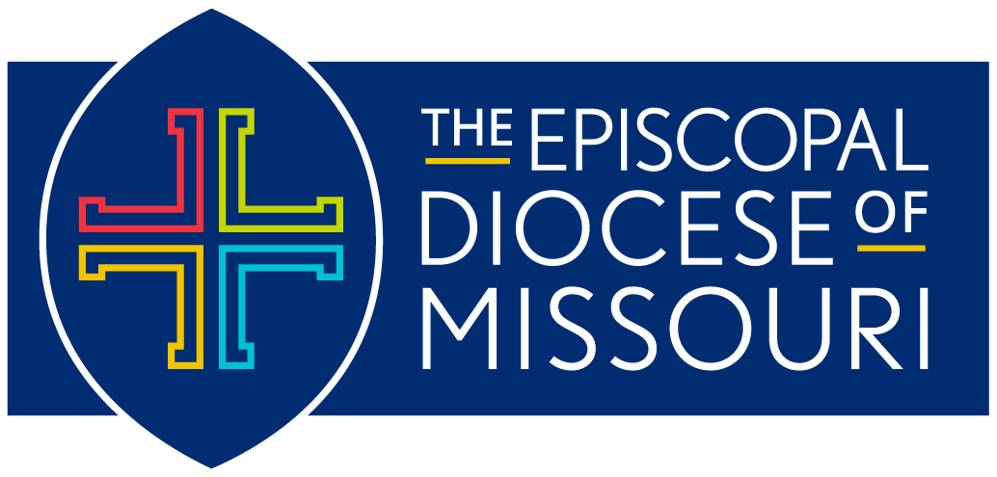
Diocese of Missouri Prayer Cycle
Second Quarter 2024:
April 2024 – June 2024

The Revised Common Lectionary: Year B
Office Lectionary: Year Two

The Daily Anglican Cycle of Prayer is available online at
https://www.anglicancommunion.org/resources/cycle-of-prayer/download-the-acp.aspx

*Please note:
In an effort to keep our diocesan list as current as possible, we will be distributing the prayer cycle by quarters this year:
- January, February, March (released January 2024)
- April, May, June (released March 2024)
- July, August, September (released June 2024)
- October, November December (released September 2024)

April 7: The Second Sunday of Easter
In our Diocese of Missouri, we pray for the people and ministry of Trinity Episcopal Church in St. James (1870). We pray for Kevin, their Priest-in-Charge; and Patricia, their Deacon.
- In our companion Diocese of Puerto Rico, we pray for the people and ministry of Misión San Bartolomé, Apóstol and Misión La Santa Cruz in Lares.
- In the Anglican Communion, we pray for the people and ministry of the Episcopal/Anglican Province of Alexandria.

April 14: The Third Sunday of Easter
In our Diocese of Missouri, we pray for the people and ministry of Trinity Episcopal Church in Kirksville (1871) and Carrol, their priest. We also pray for Trinity’s campus ministry at Truman State University.
- In our companion Diocese of Puerto Rico, we pray for the people and ministry of Misión San Matías, Apóstol in Lares.
- In the Anglican Communion, we pray for the people and ministry of The Anglican Church in Aotearoa, New Zealand and Polynesia.

April 21: The Fourth Sunday of Easter
In our Diocese of Missouri, we pray for our Diocesan Creation Care Ministry; our Missioner, Kevin; and all those working to protect and sustain our earth home.
- In our companion Diocese of Puerto Rico, we pray for the people and ministry of Misión San Felipe y Santiago, Apóstoles, in Loíza.
- In the Anglican Communion, we pray for the people and ministry of the Anglican Church of Australia.

April 28: The Fifth Sunday of Easter
In our Diocese of Missouri, we pray for the people and ministry of St. Peter’s Episcopal Church in Ladue (1872). We pray for David, their Rector; and Nathan, Luke, Jay, and Suzie, their Assisting Priests.
- In our companion Diocese of Puerto Rico, we pray for the people and ministry of Parroquia Ayudada La Resurrección in Manatí.
- In the Anglican Communion, we pray for the people and ministry of the Church of Bangladesh.

May 5: The Sixth Sunday of Easter
In our Diocese of Missouri, we pray for the people and ministry of the Episcopal Church of All Saints and Ascension in Northwoods and Renee, their Rector.
- In our companion Diocese of Puerto Rico, we pray for the people and ministry of Misión La Epifania in Maricao.
- In the Anglican Communion, we pray for the people and ministry of Igreja Episcopal Anglicana do Brasil.

May 12: The Seventh Sunday of Easter
In our Diocese of Missouri, we pray for all the people serving in and served by our Jubilee Ministries, including the JustFood Truck and the Diocesan Task Force on Hunger. We pray for Barbi, our Jubilee Missioner.
- In our companion Diocese of Puerto Rico, we pray for the people and ministry of Misión La Transiguración in Maricao.
- In the Anglican Communion, we pray for the people and ministry of The Anglican Church of Burundi.

May 19: The Day of Pentecost: Whitsunday
In our Diocese of Missouri, we pray for the people and ministry of the people and ministry of Christ Episcopal Church in Cape Girardeau (1876), and Ryan, their Priest-in-Charge.
- In our companion Diocese of Puerto Rico, we pray for the people and ministry of Parroquia San Andrés, Apóstol, in Mayagüez.
- In the Anglican Communion, we pray for the people and ministry of The Anglican Church of Canada.

May 26: The First Sunday after Pentecost: Trinity Sunday
In our Diocese of Missouri, we pray for the people and ministry of Christ Episcopal Church in Rolla (1877) and Shug, their Priest-in-Charge.
- In our companion Diocese of Puerto Rico, we pray for the people and ministry of Parroquia Ayudada La Ascensión in Morovis.
- In the Anglican Communion, we pray for the people and ministry of The Church of the Province of Central Africa.

June 2: The Second Sunday after Pentecost
In our Diocese of Missouri, we pray for the people and ministry of St. Stephen’s & the Vine Episcopal Church in Ferguson (1886), and Aaron, their Priest-in-Charge.
- In our companion Diocese of Puerto Rico, we pray for the people and ministry of Misión San Mateo, Apóstol, in Peñuelas.
- In the Anglican Communion, we pray for the people and ministry of Iglesia Anglicana de la Region Central de America.

June 9: The Third Sunday after Pentecost
In our Diocese of Missouri, we pray for the people and ministry of St. Mark’s Episcopal Church in Portland (1891) and Jessica, their priest. We also pray for our LGBTQIA+ Engagement Ministry, and DeWayne, our Diocesan Missioner.
- In our companion Diocese of Puerto Rico, we pray for the people and ministry of Misión Adscrita Príncipe de Paz, in Ponce.
- In the Anglican Communion, we pray for the people and ministry of Province de L’Eglise Anglicane Du Congo.

June 16: The Fourth Sunday After Pentecost
In our Diocese of Missouri, we pray for the people and ministry of St. Thomas Deaf Episcopal Church in Crestwood (1891) and Emily, their Vicar.
- In our companion Diocese of Puerto Rico, we pray for the people and ministry of Misión San Miguel Arcángel in Ponce.
- In the Anglican Communion, we pray for the people and ministry of Iglesia Anglicano de Chile.

June 23: The Fifth Sunday After Pentecost
In our Diocese of Missouri, we pray for the people and ministry of Holy Cross Episcopal Church in Poplar Bluff (1902) and Paul, their Priest-in-Charge.
- In our companion Diocese of Puerto Rico, we pray for the people and ministry of Parroquia Ayudada San Lucas Evangelista in Ponce.
- In the Anglican Communion, we pray for the people and ministry of The Church of England.

June 30: The Sixth Sunday After Pentecost
In our Diocese of Missouri, we pray for the people and ministry of the Episcopal Church of St. John & St. James in Sullivan (1904/1957). We pray for Sally, their priest, and Schelly, their deacon.
- In our companion Diocese of Puerto Rico, we pray for the people and ministry of Parroquia Ayudada La Santísima Trinidad in Ponce.
- In the Anglican Communion, we pray for the people and ministry of Hong Kong Sheng Kung Hui.

