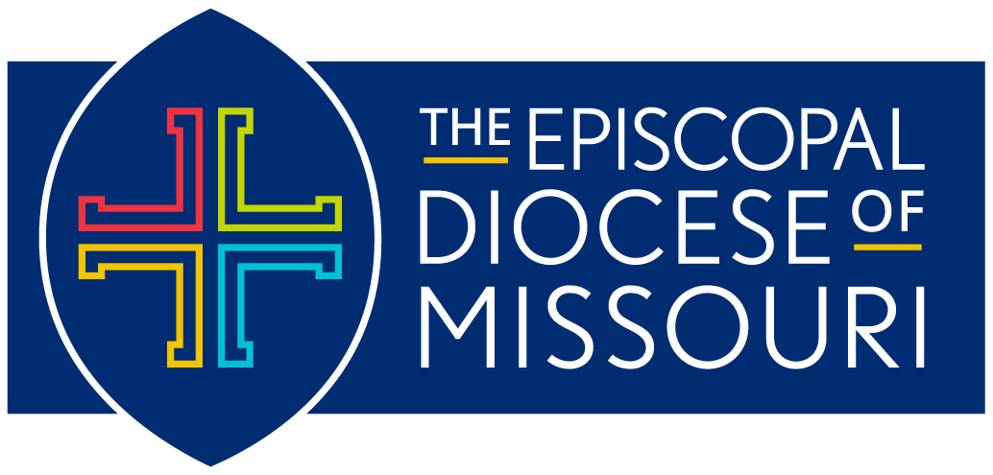
Diocese of Missouri Prayer Cycle
January 2024 – March 2024

The Revised Common Lectionary: Year B
Daily Office: Year Two

*Please note:
In an effort to keep our diocesan list as current as possible, we will be distributing the prayer cycle by quarters:
- January, February, March (released January, 2024)
- April, May, June (released March, 2024)
- July, August, September (released June 2024)
- October, November December (released September 2024)

January 7: The First Sunday after the Epiphany: The Baptism of Our Lord
In our Diocese of Missouri, we pray for the people and ministry of the Church of St. Michael & St. George (1848/1912) in Clayton. We pray for Andrew, their Rector; Peter and Tom, their Assistant Rectors; and Anne and Stewart, their Priest Associates.
- In our companion Diocese of Puerto Rico, we pray for the people and ministry of Misión San Bernabé in Bayamón.
- In the Anglican Communion, we pray for the people and ministry of The Scottish Episcopal Church.

January 14: The Second Sunday after the Epiphany
In our Diocese of Missouri, we pray for the people and ministry of St. John’s Episcopal Church (1853) in Eolia and Calvary Episcopal Church (1854) in Louisiana. We pray for Deborah, who serves as Deacon-in-Charge at both churches.
- In our companion Diocese of Puerto Rico, we pray for the people and ministry of Parraquia Ayudada San Pedro y San Pablo in Bayamón.
- In the Anglican Communion, we pray for the people and ministry of the Church of the Province of South East Asia.

January 21: The Third Sunday after the Epiphany
In our Diocese of Missouri, we pray for the people and ministry of Calvary Episcopal Church (1855) in Columbia. We pray for Ann, their Rector; Josh, their Curate; and Beth, their Deacon.
- In our companion Diocese of Puerto Rico, we pray for the people and ministry of Misión San Timoteo in Bayamón.
- In the Anglican Communion, we pray for the people and ministry of The Church of South India.

January 28: The Fourth Sunday after the Epiphany
In our Diocese of Missouri, we pray for the people and ministry of Trinity Episcopal Church (1855) in the Central West End neighborhood of St. Louis. We pray for Mary, their Interim Rector; Barbi, their Food Ministry Manager; and Harry and Bethann, their Deacons.
- In our companion Diocese of Puerto Rico, we pray for the people and ministry of Misión Nuestra Señora de Walsingham in Cabo Rojo.
- In the Anglican Communion, we pray for the people and ministry of The Anglican Church of Southern Africa.

February 4: The Fifth Sunday after the Epiphany
In our Diocese of Missouri, we pray for the people and ministry of Grace Episcopal Church (1859) in Kirkwood. We pray for Thomas, their Interim Priest.
- In our companion Diocese of Puerto Rico, we pray for the people and ministry of the Orden Franciscana Diocesana (Diocesan Franciscan Order).
- In the Anglican Communion, we pray for the people and ministry of The Anglican Church of South America.

February 11: The Last Sunday after the Epiphany
In our Diocese of Missouri, we pray for the children and youth in juvenile detention centers throughout our diocese. We give thanks for ministry of Episcopal City Mission and Nathan, their executive director, and the chaplains working to provide hope and healing to those young lives.
- In our companion Diocese of Puerto Rico, we pray for the people and ministry of Misión Cristo Rey in Caguas.
- In the Anglican Communion, we pray for the people and ministry of The Episcopal Church of South Sudan.

February 18: The First Sunday of Lent
In our Diocese of Missouri, we pray for all those suffering from addiction. We pray for the people and ministry of Episcopal Recovery Ministries and Loretta, their Missioner.
- In our companion Diocese of Puerto Rico, we pray for the people and ministry of Misión El Adviento in Carolina.
- In the Anglican Communion, we pray for the people and ministry of The Province of the Episcopal Church of Sudan.

February 25: The Second Sunday in Lent
In our Diocese of Missouri, we pray for the people and ministry of Emmanuel Episcopal Church (1866) in Webster Groves. We pray for Valori, their Priest-in-Charge; Sujanna, their Associate Priest, Jerre, their Deacon; and Warren and Paul, their Priests Affiliate.
- In our companion Diocese of Puerto Rico, we pray for the people and ministry of Misión Santo Tomás Apóstol in Carolina.
- In the Anglican Communion, we pray for the people and ministry of The Anglican Church of Tanzania.

March 3: The Third Sunday in Lent
In our Diocese of Missouri, we pray for the people and ministry of St. Paul’s Episcopal Church (1868) in the Carondelet neighborhood of St. Louis, and Rebecca, their Rector.
- In our companion Diocese of Puerto Rico, we pray for the people and ministry of the Orden de Predicadores (Dominicos).
- In the Anglican Communion, we pray for the people and ministry of The Church of the Province of Uganda.

March 10: The Fourth Sunday in Lent
In our Diocese of Missouri, we pray for our Diocesan Revival happening in Chesterfield on March 15 and for our Presiding Bishop Michael Curry, who inspires us to dream and do God’s work in the world.
- In our companion Diocese of Puerto Rico, we pray for the people and ministry of Misión San Simón Cirineo in Coamo.
- In the Anglican Communion, we pray for the people and ministry of our Episcopal Church.

March 17: The Fifth Sunday in Lent
In our Diocese of Missouri, we pray for the people and ministry of the Episcopal Church of the Holy Communion (1869) in University City. We pray for Earl, their Interim Rector; Julie, their Associate Rector; and Chester, their Deacon.
- In our companion Diocese of Puerto Rico, we pray for the people and ministry of Capilla L Natividad del Señor in Culebra.
- In the Anglican Communion, we pray for the people and ministry of The Church of Wales.

March 24: Sunday of the Passion: Palm Sunday
In our Diocese of Missouri, we pray for the people and ministry of Trinity Episcopal Church (1869) in
De Soto.
- In our companion Diocese of Puerto Rico, we pray for the people and ministry of Misión Emanuel in Dorado.
- In the Anglican Communion, we pray for the people and ministry of The Church of the Province of West Africa.

March 31: Easter Day
In our Diocese of Missouri, we pray for the people and ministry of St. Paul’s Episcopal Church (1870) in Ironton and Richard, their Vicar.
- In our companion Diocese of Puerto Rico, we pray for the Comunidad de Diáconos San Lorenzo (Community of Deacons).
- In the Anglican Communion, we pray for the people and ministry of The Church in the Province of the West Indies.

