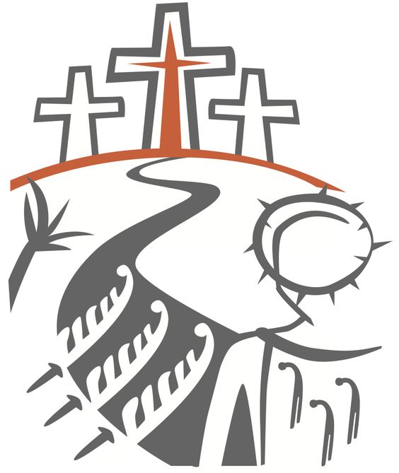

An Order for

**Morning Worship**

in the Absence of a Priest

the Season of Lent



Within The Episcopal

**Diocese of Missouri**

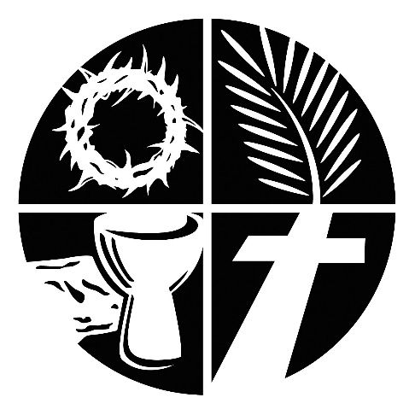

Welcome! Beinvenido! Karibu!

Scattered in the world we gather together as God's people in worship. We bring the fragments of our lives to be healed and made whole in Christ as we gather in community.

Worship lies at the heart of the Christian life. It is in worship that we express our theology and define our identity. It is through encountering God within worship that we are formed and transformed as God’s people. One of the glories of the Episcopal/Anglican Church is its liturgical worship. Liturgy refers to the patterns, forms, words and actions through which public worship is conducted.

As we gather, we bring our diverse gifts: gifts of music, dance, prophecy, teaching, preaching, and friendship. We present these gifts in the form of our most precious offering to God, our very selves, that all that we do may be for God’s glory in the unity of Christ’s church.

About Morning Worship

In many times and places, daybreak has been a time of prayer. Jews prayed in their synagogues at sunrise as well as at other times each day. This Jewish pattern of prayer formed the basis of the Christian monastic Daily Office, with its prayers or “hours” at seven times in each day. Thomas Cranmer’s revision of the Daily Office for the first English Prayer Book (1549) reduced the number of services to two-one for morning and one for evening. In the Second English Prayer Book (1552), the morning service was given its present name, Morning Prayer.

Many elements of Morning Prayer come from the seven monastic hours. Psalms were recited at every one of the offices, with the whole Psalter recited once a week. In the 1549 BCP, psalms were read at both Morning and Evening Prayer, with the whole Psalter read “in course” once each month. In subsequent Prayer Book revisions, psalms have come to be used more selectively, although a monthly cycle of psalms read “in course” is still provided as an option. In the 1549 Prayer Book, the very short monastic “chapters” were lengthened to full chapters of both the OT and NT at both Morning Prayer and Evening Prayer. In the 1979 BCP, only one lesson must be read, and the appointed lessons are not so long.

Morning Prayer once was the chief Sunday service in most Anglican/Episcopal churches on three out of four Sundays, the First Sunday usually being a celebration of Holy Communion. This practice has not continued because the eucharist has been recognized as the “principal act of Christian worship on the Lord’s Day” in most parishes (see BCP, p. 13). However, Morning Prayer is clearly designated as a daily service for the worship of the church. This usage reflects the ancient tradition of the Daily Office.

Gathering of God’s People

*Our worship today was modeled after a 4th Century service called Lauds, which means to praise, honor or glorify. This service is characterized by a series of prayers, readings and hymns that allow us to mark and offer our time of worship to God as both an act of stewardship and an act of praise.*

Gathering Song

*We begin by praising God through song and prayer.*

Greeting

*The Presider greets the community gathered.*

*Presider* The Lord is full of compassion and mercy,

*People*  **Slow to anger and of great kindness.** *-Psalm 103.8*

*Presider* O Lord, open now our lips.

*People*  **And our mouths shall proclaim your praise.**

*The Presider may add.*

*Presider* To you, O Lord, I lift up my soul;

*People*  **O my God, in you I trust.**

*Presider* You are the God of my salvation;

*People*  **To you, O Lord, I lift up my soul.**

*Presider* In you I hope all the day long.

*People* **O my God, in you I trust.**

*Presider* Remember, Lord, your compassion and love, for they are from everlasting.

*People* **To you, O Lord, I lift up my soul; O my God, in you I trust.**

*Presider* Friends in Christ, let us praise and worship God who has called us together. Let us celebrate God's majesty, and delight in the wonder of God's love. Together we shall confess our sins and receive assurance that we are forgiven. As the scriptures are read, we can allow the experiences of God from our Ancestors to speak to us, and ponder its meaning in our lives. In our prayers, we give thanks for God's goodness, we pray for others as well as for ourselves and we offer our lives anew in Christ's service. All this we do because we believe in the presence among us of our Savior Jesus Christ, and in the mighty power of the Holy Spirit.

The Confession

*As we enter in to worship we ask God’s forgiveness for things done and things left undone and things done on our behalf so that we may be reconciled to each other and to God.*

*Deacon* Let us confess our sins against God and our neighbor.

*Silence is kept for a time.*

*Deacon* Most holy and merciful God: We confess to you and to one another, and to the whole communion of saints in heaven and on earth, that we have sinned by our own fault in thought, word, and deed; by what we have done, and by what we have left undone.

*People* **We have not loved you with our whole heart, and mind, and strength. We have not loved our neighbors as ourselves. We have not forgiven others, as we have been forgiven.**

*Presider* Our past unfaithfulness: the pride, hypocrisy, and impatience of our lives,

*People* **We confess to you, O God.**

*Presider* Our self-indulgence, and our exploitation of other people, our anger at our own frustration, and our envy of those more fortunate than ourselves,

*People* **We confess to you, O God.**

*Presider* For all false judgments, for uncharitable thoughts toward our neighbors, and for our prejudice and contempt toward those who differ from us,

*People* **Accept our repentance, O God.**

*Presider* For our waste and pollution of your creation, and our lack of concern for those who come after us,

*People* **Accept our repentance, O God.**

*Presider* Restore us, good Lord, and let your anger depart from us;

*People* **Favorably hear us, for your mercy is great.**

declaration of pardon & forgiveness

*The Presider prays the declaration of forgiveness, and the people respond Amen.*

*Presider* May the Eternal God forgive us and free us from our sins, heal and strengthen us by the Holy Spirit, and raise us to new life in Christ Jesus our Lord. Amen.

Blessing of Light

*We give thanks to God for the gift of light that surrounds and infuses us.*

*One or more passages of scripture may be read.*

*Presider* The Holy One is full of compassion and mercy, slow to anger and of great kindness. -Psalm 103.8

*Or*

*Presider* Be alert at all times, praying that you may have the strength to escape all these things that will take place, and to stand before the Son of Man.

–Luke 21.36

*Or*

*Presider* For thus said the Lord God, the Holy One of Israel: In returning and rest you shall be saved; in quietness and in trust shall be your strength.

-Isaiah 30.15

*Silence is kept for a time.*

*Presider* Blessed are you, Lord God, creator of day and night:

*People* **to you be praise and glory for ever.**

*Presider* By the light of Christ, your living Word, dispel the gloom of our hearts  
that we may walk as children of light and sing your praise throughout the world.

*People* **Blessed be God, for ever and ever. Amen.**

*A hymn, song of praise, or instrumental music on the theme of light may be offered.*

*During the musical offering candles on the altar may be lit.*

**The Ministry of the Word**

*The Presider greets the community with these words.*

*Presider* May the Word of God always be heard in this place. May the experience of our spiritual ancestors be valued in this place. May the Good News of love be proclaimed in this place.

*People* May the mystery of Christ unfold before us and lead us to salvation. Let us hear once more the stories of our redemption.

*The community is seated.*

The First Reading

**A reading from Hebrew Scriptures.**

*At the end of the reading the Reader says.*

*Reader*Hear what the Holy Spirit is saying to God’s people.

*People*Thanks be to God.

**The Psalm of the Day**

*The psalms are a part of the poetry of the Hebrew people. They express joy and sadness, loneliness and thanksgiving as part of the human longing to be united with God.*

*The Psalm is prayed or sung by all standing.*

The Second Reading

**A reading from the New Testament Writings.**

*At the end of the reading the Reader says.*

*Reader*Hear what the Holy Spirit is saying to the church.

*People*Thanks be to God.

**Canticle, Hymn or Song**

*A canticle, hymn, or song may be sung that reflects the theme of the readings.*

*In the absence of a musical selection one or more of the following canticles may be prayed by the community.*

Canticle: The Song of Mary

*Leader* My heart praises you, O God,

*People* My spirit rejoices in you, my savior.

*Leader* You have remembered me in my lowliness,

*People* And now I will be called blessed.

*Leader* You have done great things for me,

*People* And shown mercy to all those who trust you.

*Leader* You have stretched out your arm,

*People* And scattered the proud with all their plans.

*Leader* You have brought down the mighty from their thrones,

*People* And lifted up the lowly.

*Leader* You have filled the hungry with good things,

*People* And sent the rich away with empty hands.

*Leader* You have kept your promise to our mothers and fathers,

*People* And come to the help of your people, to Abraham and Sarah, and to all generations for ever. Amen.

*Or*

Canticle: A Song of Christ the Servant 1 Peter 2.21b–25

*Leader* Christ suffered for you, leaving you an example, that you should follow in his steps.

*People* He committed no sin, no guile was found on his lips, when he was reviled, he did not revile in turn.

*Leader* When he suffered, he did not threaten, but he trusted himself to God who judges justly.

*People* Christ himself bore our sins in his body on the tree, that we might die to sin and live to righteousness.

*Leader* By his wounds, you have been healed, for you were straying like sheep,

*People* but have now returned to the shepherd and guardian of your souls.

*Or*

Canticle: A Song of God’s Love 1 John 4:7-11

*Leader* Beloved, let us love one another, for love is of God.

*People*Whoever does not love does not know God, for God is Love.

*Leader* In this the love of God was revealed among us,

*People*that God sent the only Son into the world, so that we might live through Jesus Christ.

*Leader* In this is love, not that we loved God but that God loved us

*People*and sent the Son that sins might be forgiven.

*Leader* Beloved, since God loved us so much,

*People*we ought also to love one another.

*Leader* For if we love one another, God abides in us,

*People*and God’s love will be perfected in us.

*Leader* Glory to the One, Holy and Living God.

*People*As it was in the beginning is now and shall be for ever. Amen.

The Gospel Reading

**A reading from the Gospels.**

*Reader* Alleluia! Blessing on the One, who comes in the name of the Lord!

*People*Peace in heaven and glory in the highest heavens. Alleluia!

*Reader* Let us open our hearts to hear the Good News of Christ. A reading from the Gospel of our Savior according to ___________.

*At the end of the reading the Reader says.*

*Reader*Hear the Good News of Jesus Christ.

*People*Thanks be to God.

The Sermon/reflection

*Having someone comment on the scriptures read goes back to the earliest days of Christianity and to the Jewish Synagogue worship which preceded it.*

*We remain seated for the sermon/reflection.*

*A Deacon, when present, offers a sermon on one or more of the readings.*

*A Lay Worship Leader offers a reflection on one of the readings.*

Hymn of the Day

*Following the sermon/reflection the community stands and sings a hymn that reflects the theme of the day.*

The Affirmation of Faith

*The Presider, priest or deacon, leads the assembly in an affirmation of faith. Originally the entire service was viewed as our confession of faith. But, since the Sixth Century, the Church has recited either the Nicene Creed or the Apostle’s Creed at the Eucharist. The word creed comes from the Latin credo for “I believe” or “I lend my heart to.” Creeds tell a deeper “truth” that goes beyond “facts.”*

*A Lenten Creed or the Nicene Creed or may be used. In the place of a Deacon, the Presider may lead the Creed.*

A Lenten Creed*

*Our Lenten Creed seeks to affirm our trust in God found in Jesus Christ.*

*Deacon* Let us affirm our faith.

*Deacon* We proclaim together in faith;

*People* **Holy, holy, holy, is the Lord God almighty, who was, and is, and is to come.**

*Deacon* We believe in God the Father, who created all things:

*People* **for by God’s will they were created and have their being.**

*Deacon* We believe in God the Son, who was slain:

*People* **for with his blood, he purchased us for God, from every tribe and language, from every people and nation.**

*Deacon* We believe in God the Holy Spirit:

*People* **the Spirit and the Bride say, ‘Come!’ Even so come, Lord Jesus! Amen.**

*\*Based on passages from the Book of Revelation*

The Nicene Creed

*Deacon* We affirm our faith in the One, Holy and Living God.

*People* **We believe in one God, the Father, the Almighty, maker of heaven and earth, of all that is, seen and unseen.**

*People* **We believe in one Lord, Jesus Christ, the only Son of God, eternally begotten of the Father, God from God, Light from Light, true God from true God, begotten, not made, of one Being with the Father. Through him all things were made. For us and for our salvation he came down from heaven: by the power of the Holy Spirit he became incarnate from the Virgin Mary, and was made man. For our sake he was crucified under Pontius Pilate; he suffered death and was buried. On the third day he rose again in accordance with the Scriptures; he ascended into heaven and is seated at the right hand of the Father. He will come again in glory to judge the living and the dead, and his kingdom will have no end.**

*People* **We believe in the Holy Spirit, the Lord, the giver of life, who proceeds from the Father and the Son. With the Father and the Son he is worshiped and glorified. He has spoken through the Prophets. We believe in one holy catholic and apostolic Church. We acknowledge one baptism for the forgiveness of sins. We look for the resurrection of the dead, and the life of the world to come. Amen.**

The Prayers of the People: Form A or B maybe used.

*Prayer changes people. Prayer is not about changing God but about changing us more into the likeness of God. Collectively and individually we offer the hopes and desires of our hearts to God.*

The Prayers of the People Form A

*Leader* We pray to the Eternal One for courage to give up other things and to give ourselves in service to Christ. *Silence is kept for a time.*

*Leader* Give your Church the courage to give up her preoccupation with herself and to give more time to your mission in the world. We pray for Justin, Archbishop of Canterbury, Michael, our Presiding Bishop, Deon, our Bishop, N. our clergy. For our companion Diocese of Puerto Rico. May the wounds of Jesus bring forgiveness to your people and help us to face the cost of proclaiming salvation. Lord, meet us in the silence;

*People* **Give us strength and hear our prayer.**

*Leader* Give your world the courage to give up war, bitterness and hatred, and to seek peace. We pray for those in authority, particularly_____. May the shoulders of the risen Jesus, once scourged by soldiers, bear the burden of political and military conflict in our world. Lord, meet us in the silence,

*People* **Give us strength and hear our prayer.**

*Leader* Give us the courage to give up quarrels, strife and jealousy in our families, neighborhoods and communities. We pray for_____. May the presence of the risen Jesus, his body once broken and now made whole, bring peace and direction as we live with one another. Lord, meet us in the silence,

*People* **Give us strength and hear our prayer.**

*Leader* Give us the courage to give up our selfishness as we live for others, and to give time, care and comfort to the sick. We pray for____. May the wounded hands of Jesus bring his healing touch, and the light of his presence fill their rooms. Lord, meet us in the silence,

*People* **Give us strength and hear our prayer.**

*Leader* Give us the courage to give up our fear of death and to rejoice with those who have died in faith. Especially we hold in our minds___. May the feet of the risen Lord Jesus, once nailed to the cross, walk alongside the dying and bereaved in their agony, and walk with us and all your Church through death to the gate of glory. Lord, meet us in the silence,

*People* **Give us strength and hear our prayer, here and in eternity. Amen.**

The Prayers of the People Form B

*Prayer changes people. Prayer is not about changing God, but about changing us more into the likeness of God. Collectively and individually we offer the hopes and desires of our hearts to God. The Deacon, when present in the liturgy, offers the prayers for those who are sick or have asked our prayers.*

*Leader* We pray for the whole church, all leaders and ministers, and all the holy people of God. *Silence.* Wash us through and through,

*People* **And cleanse us from our sin.**

*Leader* We pray for our nation, for all the nations of the earth, and for all who govern and judge. *Silence.* Purge us from our sin,

*People*  **And we shall be pure.**

*Leader* We pray for those who hunger, those who thirst, those who cry out for justice, those who live under the threat of terror, and those without a place to lay their head. *Silence.* Make them hear of joy and gladness,

*People* **that those who are broken may rejoice.**

*Leader* We pray for those who are ill, those in pain, those under stress, and those who are lonely. *Silence.* Give them the joy of your saving help,

*People* **and sustain them with your bountiful Spirit.**

*Leader* In this season of Lent we pray for those who prepare for baptism, and we pray that we all might be given the grace and strength to repent and grow closer to you, O God. *Silence.* Create in us clean hearts, O God,

*People* **and renew a right spirit within us.**

*Leader* We pray for those who have died, (especially _____ ) and who have entered into the land of eternal Light and your abiding peace. *Silence.* Cast them not away from your presence,

*People* **and take not your Holy Spirit from them.**

*Leader* We especially pray for…

*Concluding prayer led by the Presider:*

*Presider* Artist of souls, you sculpted a people for yourself out of the rocks of wilderness and fasting. Help us as we take up your invitation to prayer and simplicity, that the discipline of these forty days may sharpen our hunger for the feast of your holy friendship, and whet our thirst for the living water you offer through Jesus Christ. **Amen.**

The Lord’s Prayer (Traditional)

*The Lord’s Prayer follows in either traditional or contemporary language. The link between our daily bread and the spiritual food we receive in the Eucharist is an ancient connection. In the Lord’s Prayer we ask for daily bread, meaning the things we need to get through each day. But as a part of that, the bread also symbolizes God’s presence.*

*Presider* As our Savior has taught us, we are bold to pray.

*People* **Our Father, who art in heaven, hallowed be thy name. Thy Kingdom come, thy will be done, on earth as it is in heaven. Give us this day our daily bread. And forgive us our trespasses, as we forgive those who trespass against us. And lead us not into temptation, but deliver us from evil. For thine is the kingdom, the power and the glory, for ever and ever. Amen.**

The Lord’s Prayer (Contemporary)

*Presider* Let us pray in the way that our Savior has taught us.

*People* Our Father in heaven, hallowed be your name, your kingdom come, your will be done, on earth as in heaven. Give us today our daily bread. Forgive us our sins as we forgive those who sin against us. Lead us not into temptation but deliver us from evil. For the kingdom, the power, and the glory are yours now and for ever. Amen.

Collect of the Day

*Presider* God is with you. *or* The Lord be with you.

*People* And also with you.

*Presider* Let us pray.

*The collect is written to go along with both the season of the church year and the readings for the day. It summarizes the attributes of God as revealed in the scripture for the day.*

*The Presider continues with the collect appointed for the day.*

*The Presider then prays;*

*Presider* O God, the author of peace and lover of concord, to know you is eternal life and to serve you is perfect freedom: Defend us, your humble servants, in all assaults of our enemies; that we, surely trusting in your defense, may not fear the power of any adversaries; through the might of Jesus Christ our Lord. Amen.

The Exchange of the Peace

*As we enter the most sacred portion of our worship we exchange a sign of God’s promised peace. There are no set words to use in greeting each other, but “Peace be with you” “God’s peace” and “Shalom” are all commonly used.*

*The Presider offers one or more passages of scripture.*

*Presider* Since we are justified by faith, we have peace with God through our Lord Jesus Christ, who has given us access to his grace. –Romans 5:1-2

*Presider* Let the peace of Christ rule in your hearts, since as members of one body you are called to peace. *-Colossians 3.15*

*Presider* Jesus says to his disciples, ‘Peace I leave with you; my peace I give you. Not as the world gives do I give to you. Let not your hearts be troubled or afraid.’ *-John 14.27*

*Presider* The Peace of Christ be always with you.

*People* And also with you.

*Presider* Let us offer each other a sign of Christ's peace.

*We are a community of reconciliation and peace; therefore, we greet each other with a sign of our desire for peace.*

Welcome & Announcements

*Community announcements, notices, prayers, and celebrations may be offered at this time.*

The Offertory

*The gifts of money and other gifts are brought to the Presider as an offering to God and placed on or near the Holy Table. The Presider and people give thanks to God for the many gifts we have been given.*

Offertory Music:

*An anthem, hymn or instrumental music may be offered.*

Doxology

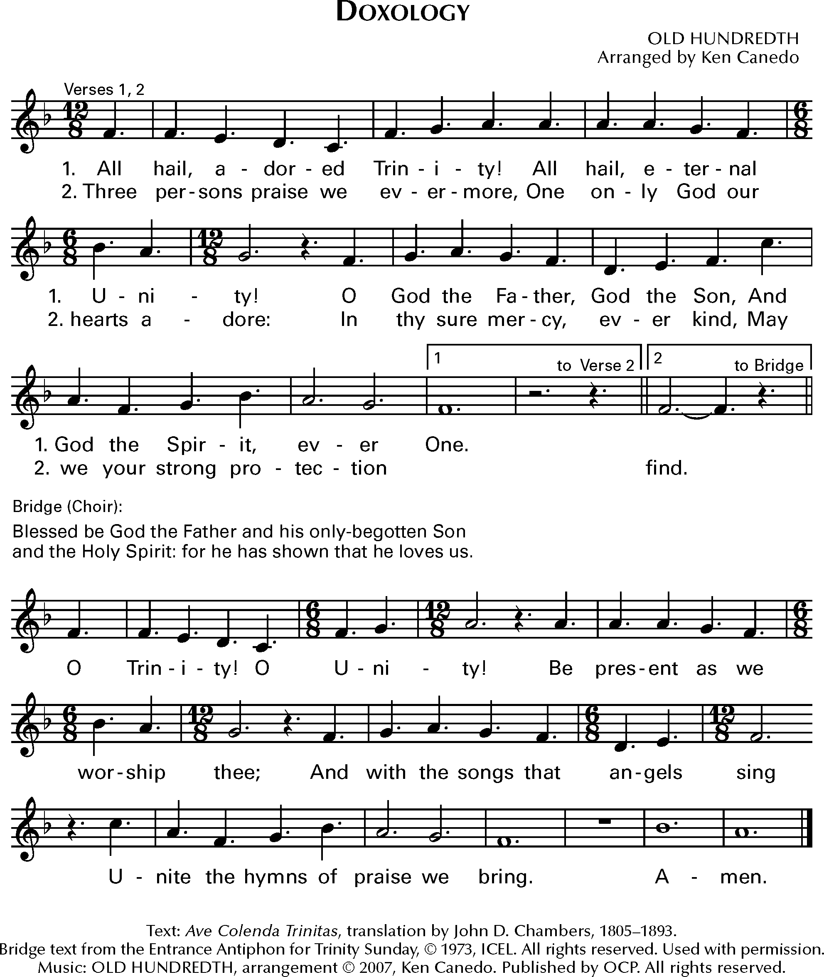

*Music: OLD HUNDREDTH*

The General Thanksgiving

*The Presider and people give thanks for the many blessings of this life and the many ways in which God continues to shower blessing upon blessing in our lives and on our world.*

*Presider* Accept, O Lord, our thanks and praise for all that you have done for us.

*People* We thank you for the splendor of the whole creation, for the beauty of this world, for the wonder of life, and for the mystery of love.

*Presider* We thank you for the blessing of family and friends, and for the loving care which surrounds us on every side.

*People* We thank you for setting us at tasks which demand our best efforts, and for leading us to accomplishments which satisfy and delight us.

*Presider* We thank you also for those disappointments and failures that lead us to acknowledge our dependence on you alone.

*People* Above all, we thank you for your Son Jesus Christ; for the truth of his Word and the example of his life; for his steadfast obedience, by which he overcame temptation; for his dying, through which he overcame death; and for his rising to life again, in which we are raised to the life of your kingdom.

*Presider* Grant us the gift of your Spirit, that we may know Christ and  
make him known; and through him, at all times and in all  
places, may give thanks to you in all things. Amen.

The Great Silence

*The silence is begun and ended with the sound of a bell.*

*Presider* Jesus said to his disciples, “Come away to a quiet place and rest for a while.” Therefore, let us now rest in Christ’s presence in the silence.

*A prolonged silence is kept for a time. At a signal from the Presider, the silence is broken.*



Christ has no body but yours,

No hands, no feet on earth but yours,  
Yours are the eyes with which He looks  
Compassion on this world,  
Yours are the feet with which He walks to do good,  
Yours are the hands, with which He blesses all the world.  
Yours are the hands, yours are the feet,  
Yours are the eyes, you are His body.  
Christ has no body now but yours,  
No hands, no feet on earth but yours,  
Yours are the eyes with which he looks  
compassion on this world.  
Christ has no body now on earth but yours.

*— St. Teresa of Ávila (attributed)*

A Prayer of St. Chrysostom

*Presider* Almighty God, you have given us grace at this time with one accord to make our common supplication to you;

*People* And you have promised through your well-beloved Son that when two or three are gathered together in his Name you will be in the midst of them: Fulfill now, O Lord, our desires and petitions as may be best for us; granting us in this world knowledge of your truth, and in the age to come life everlasting. Amen.

Closing Song

*We begin and end our time of worship by praising God through song and prayer.*

*Presider* Let us bless the Lord.

*People* Thanks be to God.

*The Presider may then conclude with one of the following*

*Presider* The grace of our Lord Jesus Christ, and the love of God, and the fellowship of the Holy Spirit, be with us all evermore. Amen.

-*2 Corinthians 13:14*

*Presider* May the God of hope fill us with all joy and peace in believing through the power of the Holy Spirit. Amen. *-Romans 15:13*

*Presider* Glory to God whose power, working in us, can do infinitely more than we can ask or imagine: Glory to him from generation to generation in the Church, and in Christ Jesus for ever and ever. Amen.  *-Ephesians 3:20,21*



**Please return your bulletin for reuse.**

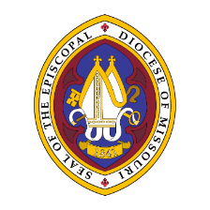

**The Episcopal Diocese of Missouri Land Acknowledgement**

In humility, we recognize and acknowledge that we in the Diocese of Missouri worship and live on the traditional ancestral lands of the Osage Nation, the Illiniwek/Peoria Tribe, the O-Gah-Pah (Quapaw) Tribe, the Otoe-Missouria Tribe, and other First Peoples. We recognize our mutual dependence upon and benefit from this land; we proclaim our solidarity with and our debt to the Peoples who first claimed and improved this land as their home. We acknowledge our complicity in the process of colonization that dispossessed the First Peoples from their ancestral lands. We affirm our commitment to stand with indigenous communities today and henceforth as they seek justice and resist continued threats to their sovereignty and humanity.

We are also cognizant that the history of The Episcopal Church is intertwined with the history of colonialism and slavery in the United States. More than four centuries ago, the first Africans were brought to the Americas and enslaved. Two centuries ago, enslaved and indigenous persons contributed to the exploration of this state by Lewis and Clark. Our state’s history is entangled with both the Missouri Compromise making this state officially a slave state, and the cases of Scott v. Emerson that petitioned for Dred and Harriet Scott’s emancipation. We acknowledge the tragic legacy of slavery in our diocese, and the blood, sweat, and tears of enslaved people that soak the earth beneath our feet in Missouri. This legacy persists today as we continue to work towards racial justice, equity, liberation, and community, here in Missouri and across The Episcopal Church.