

An Order for

the Celebration of

**The Holy Eucharist**

For the Season of Lent



Within The Episcopal

**Diocese of Missouri**

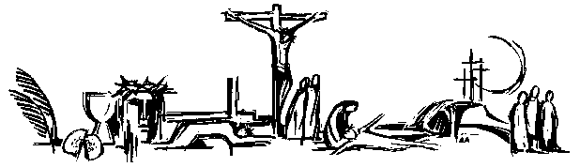

Welcome! Beinvenido! Karibu!

Scattered in the world we gather together as God's people in worship. We bring the fragments of our lives to be healed and made whole in Christ as we gather in community.

Worship lies at the heart of the Christian life. It is in worship that we express our theology and define our identity. It is through encountering God within worship that we are formed and transformed as God’s people. One of the glories of the Episcopal/Anglican Church is its liturgical worship. Liturgy refers to the patterns, forms, words and actions through which public worship is conducted.

As we gather, we bring our diverse gifts: gifts of music, dance, prophecy, teaching, preaching, and friendship. We present these gifts in the form of our most precious offering to God, our very selves, that all that we do may be for God’s glory in the unity of Christ’s church.

**About the Season of Lent**

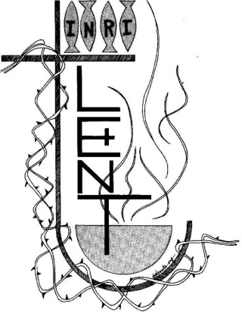

Early Christians observed “a season of penitence and fasting” in preparation for the Paschal feast, or Pascha (Easter). The season now known as Lent, from an Old English word meaning “spring,” the time of lengthening days, has a long history. Lent was especially important for converts to the faith who were preparing for baptism, and for those guilty of notorious sins who were being restored to the Christian assembly.

In the western church, the forty days of Lent extend from Ash Wednesday through Holy Saturday, omitting Sundays. The last three days of Lent are the sacred Triduum of Maundy Thursday, Good Friday, and Holy Saturday. Today, Lent has reacquired its significance as the final preparation of adult candidates for baptism. Joining with them, all Christians are invited “to the observance of a holy Lent, by self-examination and repentance; by prayer, fasting, and self-denial; and by reading and meditating on God’s holy Word.”



About the

**Holy Eucharist**

*“When God finds us, there is always a celebration. In the Eucharist, we gather to celebrate God finding us in Jesus Christ. If you’re feeling lost, when you come to receive Jesus in bread and wine, ask to be found. If you know what it is to have been found by God, when you come to receive Jesus in bread and wine, give thanks – thanks to the one who came looking for you, and found you.”*

-Br. Geoffrey Tristram

Society of Saint John the Evangelist

In the Episcopal Church the Holy Eucharist is the sacrament of Christ's body and blood, and the principal act of Christian worship. The term is from the Greek, "thanksgiving." Jesus instituted the Eucharist "on the night when he was betrayed." At the Last Supper he shared the Bread and cup of Wine at a sacred meal with his disciples. He identified the Bread with his body and the Wine with his blood of the new covenant. Jesus commanded his disciples to "do this" in remembrance of Jesus.

For Episcopalians, the Holy Eucharist becomes the very Real Presence of Christ, his Body and Blood, the ordinary made also extraordinary, sacred by Jesus' own words and by the Holy Spirit.

In the Episcopal Church, we seek to adapt ancient liturgy for today. If you grew up in a less formal church, worship may feel pretty traditional. If you grew up in a formal church, our worship may deconstruct that formality, and ask you to pray using more modern words, or sing new songs. We seek to balance tradition and culture in our worship. When we hold the tension well between the ancient and the modern, the Holy Eucharist comes alive.

Gathering

*We begin by praising God through song and prayer. During the Season of Lent, in some communities,* **the****Great Litany** *is sung or said in place of the normal gathering song. When the Great Litany is used, the customary Prayers of the People are omitted and the liturgy then continues with the Collect of the Day.*

The Penitential Rite

*Our worship begins with the Acclamation and Penitential Rite.*

*Presider* Blessed be the God of our salvation.

*People* **Who bears our burdens and forgives our sin.**

*Presider* Jesus said, "The first commandment is this: Hear, O Israel: The Lord our God is the only Lord. Love the Lord your God with all your heart, with all your soul, with all your mind, and with all your strength. The second is this: Love your neighbor as yourself. There is no other commandment greater than these." -Mark 12:29-31

*Or*

*Presider* “If we say that we have no sin, we deceive ourselves, and the truth is not in us. But if we confess our sins, God, who is faithful and just, will forgive our sins and cleanse us from all unrighteousness.” 1 John 1:8,9

The Confession

*As we enter in to worship we ask God’s forgiveness for things done and things left undone and things done on our behalf so that we may be reconciled to each other and to God.*

*Deacon* Let us confess our sins against God and our neighbor.

*Silence is kept for a time.*

*Deacon* Most holy and merciful God: We confess to you and to one another, and to the whole communion of saints in heaven and on earth, that we have sinned by our own fault in thought, word, and deed; by what we have done, and by what we have left undone.

*People* **We have not loved you with our whole heart, and mind, and strength. We have not loved our neighbors as ourselves. We have not forgiven others, as we have been forgiven.**

*Deacon* Our past unfaithfulness: the pride, hypocrisy, and impatience of our lives,

*People* **We confess to you, O God.**

*Presider* Our self-indulgence, and our exploitation of other people, our anger at our own frustration, and our envy of those more fortunate than ourselves,

*People* **We confess to you, O God.**

*Deacon* For all false judgments, for uncharitable thoughts toward our neighbors, and for our prejudice and contempt toward those who differ from us,

*People* **Accept our repentance, O God.**

*Presider* For our waste and pollution of your creation, and our lack of concern for those who come after us,

*People* **Accept our repentance, O God.**

*Deacon* Restore us, good Lord, and let your anger depart from us;

*People* **Favorably hear us, for your mercy is great.**

declaration of pardon & forgiveness

*The Presider prays the declaration of forgiveness, and the people respond Amen.*

*Presider* May the Eternal God forgive you and free you from your sins, heal and strengthen you by the Holy Spirit, and raise you to new life in Christ Jesus our Lord. Amen.

Song of Penance: Kyrie (spoken)

*The Song of Penance maybe said or sung.*

*Presider* Wash me thoroughly from my wickedness and cleanse me from my sin: Lord, have mercy.

*People* **Lord, have mercy.**

*Presider* Make me a clean heart, O God, and renew a right spirit within me: Christ, have mercy.

*People* **Christ, have mercy.**

*Presider* Cast me not away from your presence and take not your holy spirit from me: Lord, have mercy.

*People* **Lord, have mercy.**

Song of Penance: Trisagion (Sung)

*When the Trisagion is sung, it is repeated three times.*

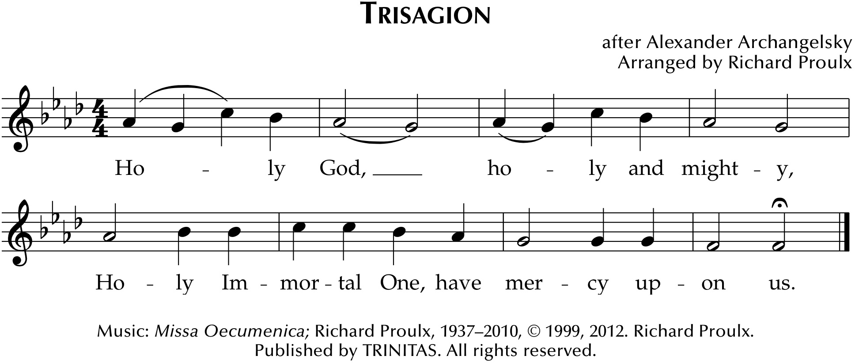

Collect of the Day

*Presider* God is with you. *or* The Lord be with you.

*People* **And also with you.**

*Presider* Let us pray.

*The Presider continues with the prayer appointed for the day, called the collect.*

*The collect is written to go along with both the season of the church year and the readings for the day. It summarizes the attributes of God as revealed in the scripture for the day.*

We hear the sacred stories

*We hear the stories of the experience of God from our spiritual ancestors. Reading and commenting on scripture goes back to the earliest services of Christianity. Following the pattern of Jewish synagogue worship, readings follow a set pattern for what will be read when.*

The First Reading

**A reading from Hebrew Scriptures.**

*At the end of the reading the Reader says:*

*Reader*Hear what the Holy Spirit is saying to God’s people.

*People* **Thanks be to God.**

The Psalm of the Day

*The psalms are a part of the poetry of the Hebrew people. They express joy and sadness, loneliness and thanksgiving as part of the human longing to be united with God.*

The Second Reading

**A reading from the New Testament.**

*At the end of the reading the Reader says:*

*Reader*Hear what the Holy Spirit is saying to the church.

*People* **Thanks be to God.**

Preparing to Hear the Gospel

*We rise in body or in spirit for the Gospel reading to show the particular importance we place on Jesus’ words and actions.*

*A hymn, Verse, or other music may be sung.*

The Proclamation of the Gospel

*Presider* God is with you.

*People* **And also with you.**

*Presider* The Holy Gospel of our Savior Jesus Christ according to _______.

*People* **Glory to you, O Christ.**

*At the end of the Gospel the Presider says:*

*Presider* The Gospel of the Lord.

*People* **Praise to you, O Christ.**

The Sermon

*We remain seated for the sermon. Having someone comment on the scriptures read goes back to the earliest days of Christianity and to the Jewish Synagogue worship which preceded it.*

The Affirmation of Faith

*The Presider, priest or deacon, leads the assembly in an affirmation of faith. Originally the entire service was viewed as our confession of faith. But, since the Sixth Century, the Church has recited either the Nicene Creed or the Apostle’s Creed at the Eucharist. The word creed comes from the Latin credo for “I believe” or “I lend my heart to.” Creeds tell a deeper “truth” that goes beyond “facts.”*

*A Lenten Creed or the Nicene Creed or may be used. In the place of a Deacon, the Presider may lead the Creed.*

A Lenten Creed*

*Our Lenten Creed seeks to affirm our trust in God found in Jesus Christ.*

*Deacon* Let us affirm our faith.

*Deacon* We proclaim together in faith;

*People* **Holy, holy, holy, is the Lord God almighty, who was, and is, and is to come.**

*Deacon* We believe in God the Father, who created all things:

*People* **for by God’s will they were created and have their being.**

*Deacon* We believe in God the Son, who was slain:

*People* **for with his blood, he purchased us for God, from every tribe and language, from every people and nation.**

*Deacon* We believe in God the Holy Spirit:

*People* **the Spirit and the Bride say, ‘Come!’ Even so come, Lord Jesus! Amen.**

*\*Based on passages from the Book of Revelation*

The Nicene Creed

*Deacon* We affirm our faith in the One, Holy and Living God.

*People* **We believe in one God, the Father, the Almighty, maker of heaven and earth, of all that is, seen and unseen.**

*People* **We believe in one Lord, Jesus Christ, the only Son of God, eternally begotten of the Father, God from God, Light from Light, true God from true God, begotten, not made, of one Being with the Father. Through him all things were made. For us and for our salvation he came down from heaven: by the power of the Holy Spirit he became incarnate from the Virgin Mary, and was made man. For our sake he was crucified under Pontius Pilate; he suffered death and was buried. On the third day he rose again in accordance with the Scriptures; he ascended into heaven and is seated at the right hand of the Father. He will come again in glory to judge the living and the dead, and his kingdom will have no end.**

*People* **We believe in the Holy Spirit, the Lord, the giver of life, who proceeds from the Father and the Son. With the Father and the Son he is worshiped and glorified. He has spoken through the Prophets. We believe in one holy catholic and apostolic Church. We acknowledge one baptism for the forgiveness of sins. We look for the resurrection of the dead, and the life of the world to come. Amen.**

The Prayers of the People Form A

*Prayer changes people. Prayer is not about changing God, but about changing us more into the likeness of God. Collectively and individually we offer the hopes and desires of our hearts to God. The Deacon, when present in the liturgy, offers the prayers for those who are sick or have asked our prayers.*

*When a Deacon is present the Presider addresses the Deacon saying;*

*Presider* N., Deacon in the Church of God, what cares and concerns of the world do you bring before us to be held up in prayer?

*Deacon* People of God, I bid your prayers for…

*The concerns of the community and wider world, including those who are sick, in need, or in want are named by the Deacon.*

*Deacon* We pray to the Eternal One for courage to give up other things and to give ourselves in service to Christ. *Silence is kept for a time.*

*Leader* Give your Church the courage to give up her preoccupation with herself and to give more time to your mission in the world. We pray for Justin, Archbishop of Canterbury, Michael, our Presiding Bishop, Deon, our Bishop, N. our clergy. For our companion Diocese of Puerto Rico. May the wounds of Jesus bring forgiveness to your people and help us to face the cost of proclaiming salvation. Lord, meet us in the silence;

*People* **Give us strength and hear our prayer.**

*Leader* Give your world the courage to give up war, bitterness and hatred, and to seek peace. We pray for those in authority, particularly_____. May the shoulders of the risen Jesus, once scourged by soldiers, bear the burden of political and military conflict in our world. Lord, meet us in the silence,

*People* **Give us strength and hear our prayer.**

*Leader* Give us the courage to give up quarrels, strife and jealousy in our families, neighborhoods and communities. We pray for_____. May the presence of the risen Jesus, his body once broken and now made whole, bring peace and direction as we live with one another. Lord, meet us in the silence,

*People* **Give us strength and hear our prayer.**

*Leader* Give us the courage to give up our selfishness as we live for others, and to give time, care and comfort to the sick. We pray for____. May the wounded hands of Jesus bring his healing touch, and the light of his presence fill their rooms. Lord, meet us in the silence,

*People* **Give us strength and hear our prayer.**

*Leader* Give us the courage to give up our fear of death and to rejoice with those who have died in faith. Especially we hold in our minds___. May the feet of the risen Lord Jesus, once nailed to the cross, walk alongside the dying and bereaved in their agony, and walk with us and all your Church through death to the gate of glory. Lord, meet us in the silence,

*People* **Give us strength and hear our prayer, here and in eternity. Amen.**

The Prayers of the People Form B

*Prayer changes people. Prayer is not about changing God, but about changing us more into the likeness of God. Collectively and individually we offer the hopes and desires of our hearts to God. The Deacon, when present in the liturgy, offers the prayers for those who are sick or have asked our prayers.*

*When a Deacon is present the Presider addresses the Deacon saying;*

*Presider* N., Deacon in the Church of God, what cares and concerns of the world do you bring before us to be held up in prayer?

*Deacon* People of God, I bid your prayers for…

*The concerns of the community and wider world, including those who are sick, in need, or in want are named by the Deacon.*

*Leader* We pray for the whole church, all leaders and ministers, and all the holy people of God. *Silence.* Wash us through and through,

*People* **And cleanse us from our sin.**

*Leader* We pray for our nation, for all the nations of the earth, and for all who govern and judge. *Silence.* Purge us from our sin,

*People*  **And we shall be pure.**

*Leader* We pray for those who hunger, those who thirst, those who cry out for justice, those who live under the threat of terror, and those without a place to lay their head. *Silence.* Make them hear of joy and gladness,

*People* **that those who are broken may rejoice.**

*Leader* We pray for those who are ill, those in pain, those under stress, and those who are lonely. *Silence.* Give them the joy of your saving help,

*People* **and sustain them with your bountiful Spirit.**

*Leader* In this season of Lent we pray for those who prepare for baptism, and we pray that we all might be given the grace and strength to repent and grow closer to you, O God. *Silence.* Create in us clean hearts, O God,

*People* **and renew a right spirit within us.**

*Leader* We pray for those who have died, (especially _____ ) and who have entered into the land of eternal Light and your abiding peace. *Silence.* Cast them not away from your presence,

*People* **and take not your Holy Spirit from them.**

*Leader* We especially pray for…

*Concluding prayer led by the Presider:*

Lent 1 Lord Jesus, you proclaimed the Good News in Galilee, saying that the time is fulfilled and the kingdom of God has come near; grant us the strength and wisdom to repent and believe in the Good News, this day and always. **Amen.**

Lent 2 Lord Jesus, you taught your disciples that you must undergo great suffering and be killed before rising again; grant us the strength and wisdom to be your followers and to take up our cross to follow you, this day and always. **Amen.**

Lent 3 Lord Jesus, it was your will that your Father’s House would be a place of prayer for all people; grant us the strength and wisdom to be a people consumed with prayer and zeal for you, this day and always. **Amen.**

Lent 4 Gracious God, because of your great love for the world you gave us your son; grant us the strength and wisdom believe in him that we would not perish but have eternal life. **Amen.**

Lent 5 Lord Jesus, you taught your disciples that unless a grain of wheat falls into the earth and dies it remains just a single grain, but if it dies it bears much fruit; as we prepare our hearts to remember your death and resurrection, grant us the strength and wisdom to serve and follow you, this day and always. **Amen.**

The Exchange of the Peace

*As we enter the most sacred portion of our worship, we exchange a sign of God’s promised peace. There are no set words to use in greeting each other, but “Peace be with you,” “God’s peace,” and “Shalom” are all commonly used.*

*Presider* The Peace of Christ be always with you.

*People* **And also with you.**

*Presider* Let us offer each other a sign of Christ's peace.

*We are a community of reconciliation and peace; therefore, we greet each other with a sign of our desire for peace.*

Welcome & Announcements

*Community announcements, notices, prayers, and celebrations may be offered at this time.*

Gathering at Christ's Table

*Having been nourished from the richness of God's love in sacred story and reconciled to each other through prayer and peace, we gather at Christ's table to offer ourselves to be transformed for service in the world.*

The Offertory

*The gifts of bread, wine, money and other gifts are brought to the Presider as an offering to God as a reminder of Christ's sacrificial love and life. Once the Holy Table or Altar is prepared the Presider and people give thanks to God for the many gifts we have been given.*

Offertory Music:

*An anthem, hymn or instrumental music may be offered.*

Doxology

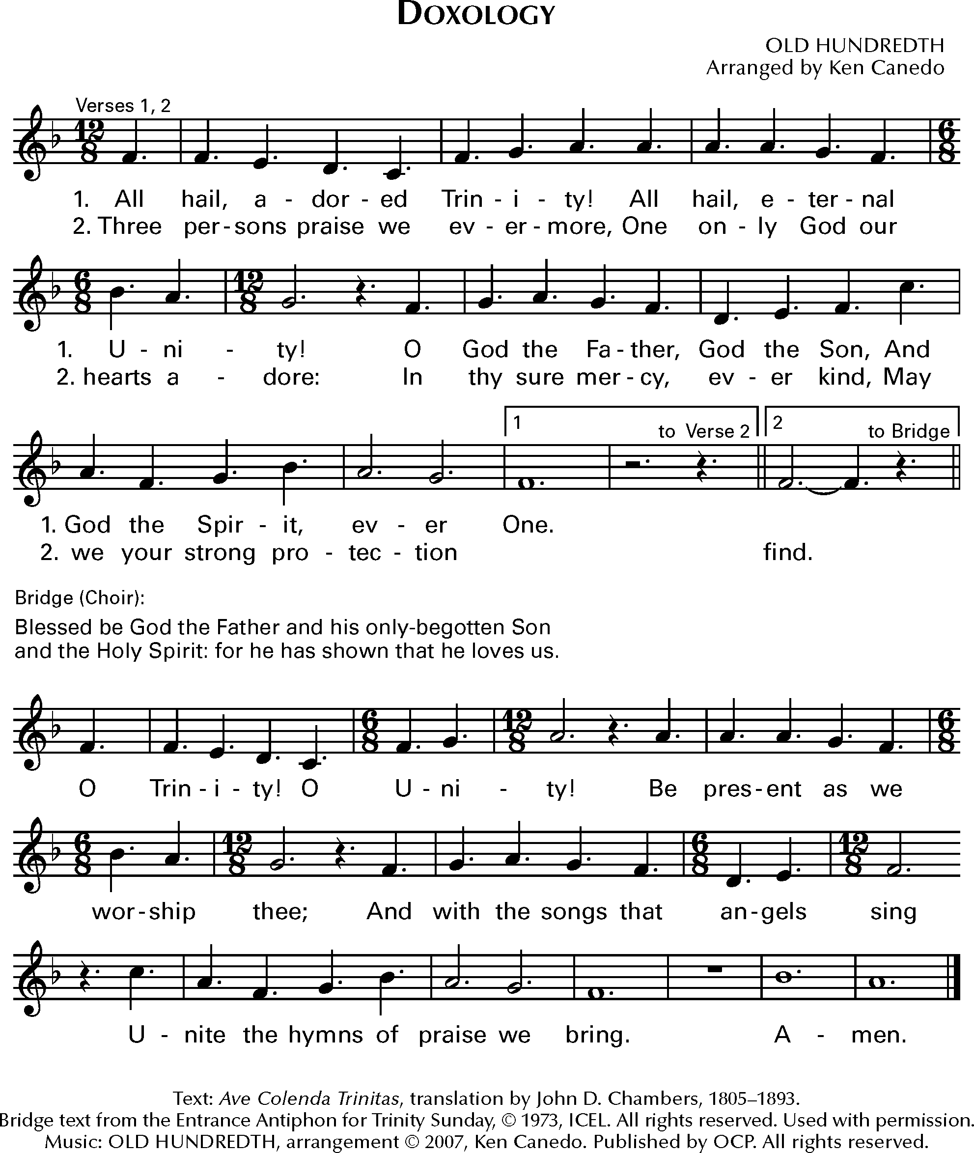

*Music: OLD HUNDREDTH*

The Great Thanksgiving

*The Eucharistic Prayer, or Great Thanksgiving, is the prayer of the Church to invite Christ to be present in the elements of bread and wine. Now we come to the second act in the drama with the Liturgy of the Table. It is based on Jewish Fellowship meals, particularly the Passover observance. But this second half of the service is not communion in and of itself. It is the whole service, both acts of the drama, that make up the Eucharist.*

Eucharistic Prayer A: The Book of Common Prayer

*Presider* God is with you. *or* The Lord be with you.

*People***And also with you.**

*Presider* Lift up your hearts.

*People***We lift them to the Lord.**

*Presider* Let us give thanks to the Lord our God.

*People***It is right to give thanks and praise.**

*Then, facing the Holy Table, the Presider proceeds.*

*Presider* It is right, and a good and joyful thing, always and everywhere to give thanks to you, Almighty God, Creator of heaven and earth. You bid your faithful people cleanse their hearts, and prepare with joy for the Paschal feast; that, fervent in prayer and in works of mercy, and renewed by your Word and Sacraments, they may come to the fullness of grace which you have prepared for those who love you.

*Presider* Therefore we praise you, joining our voices with Angels and Archangels and with all the company of heaven, who for ever sing this hymn to proclaim the glory of your Name:

Spoken: Holy, holy, holy

**Holy, holy, holy Lord, God of power and might,**

**heaven and earth are full of your glory. Hosanna in the highest.**

**Blessed is the one who comes in the name of the Lord. Hosanna in the highest.**

Sung: Holy, holy, holy

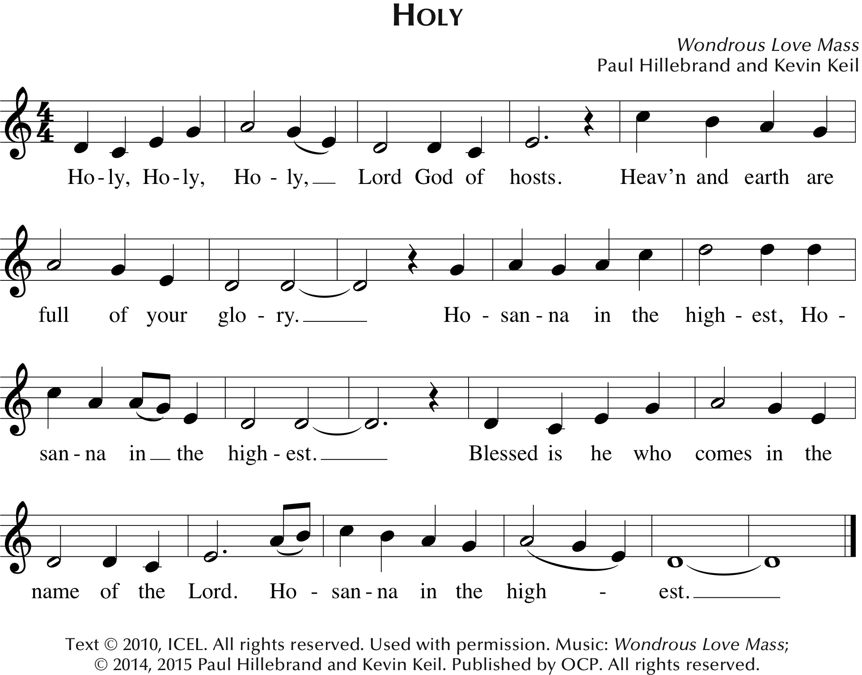

**

*Presider* Holy and gracious God: In your infinite love you made us for yourself; and, when we had fallen into sin and become subject to evil and death, you, in your mercy, sent Jesus Christ, your only and eternal Son, to share our human nature, to live and die as one of us, to reconcile us to you, the God and maker of all.

*Presider* Jesus stretched out his arms upon the cross, and offered himself in obedience to your will, a perfect sacrifice for the whole world.

*Presider* On the night he was handed over to suffering and death, our Savior Jesus Christ took bread; and when he had given thanks to you, he broke it, and gave it to his disciples, and said, “Take, eat: This is my Body, which is given for you. Do this for the remembrance of me.”

*Presider* After supper Jesus took the cup of wine; and when he had given thanks, he gave it to them, and said, “Drink this, all of you: This is my Blood of the new Covenant, which is shed for you and for many for the forgiveness of sins. Whenever you drink it, do this for the remembrance of me.”

*Presider* Therefore we proclaim the mystery of faith:

*People* **Christ has died. Christ is risen. Christ will come again.**

*Presider* We celebrate the memorial of our redemption, Almighty God, in this sacrifice of praise and thanksgiving. Recalling Christ’s death, resurrection, and ascension, we offer you these gifts.

*Presider* Sanctify them by your Holy Spirit to be for your people the Body and Blood of your Son, the holy food and drink of new and unending life in Christ. Sanctify us also that we may faithfully receive this holy Sacrament, and serve you in unity, constancy, and peace; and at the last day bring us with all your saints into the joy of your eternal kingdom.

*Presider* All this we ask through Jesus Christ our Savior. By Christ, and with Christ, and in Christ, in the unity of the Holy Spirit all honor and glory is yours, Almighty God, now and for ever. **AMEN.**

Eucharistic Prayer for Lent

*Presider* God is with you. *or* The Lord be with you.

*People***And also with you.**

*Presider* Lift up your hearts.

*People***We lift them to the Lord.**

*Presider* Let us give thanks to the Lord our God.

*People***It is right to give thanks and praise.**

*Then, facing the Holy Table, the Presider proceeds.*

*Presider* Blessed are you, God of everlasting covenant, for your promises are steadfast and your provision is sure. Through the forty years of your people’s desert wanderings you were constant in fire and cloud; with manna and mercy you sustained every step. You made Jesus’ temptation of forty days a theater of truth where your Word stood strong.

*Presider* In every age you have shaped your people through times of wilderness and wandering, of temptation and trial, and brought them into the land of promise and the life of covenant.

*Presider* And so we give you humble thanks for your forgiveness and our new life, with angels and archangels and the company of heaven, singing your unending praise.

Spoken: Holy, holy, holy

**Holy, holy, holy Lord, God of power and might,**

**heaven and earth are full of your glory.**

**Hosanna in the highest.**

**Blessed is the one who comes in the name of the Lord.**

**Hosanna in the highest.**

Sung: Holy, holy, holy

**

**

*Presider* Enduring God, as you sustained Jesus in hunger and thirst, through this meal strengthen us to keep our Lenten fast. Send your Holy Spirit upon us as we remember Jesus’ saving passion; transform our insatiable desires into hunger for the feast of this table. Send your Holy Spirit upon this bread and wine that they may be for us the body and blood of Christ;

*Presider* Who at supper with his disciples, took bread, gave you thanks, broke the bread, and gave it to them, saying “Take, eat: this is my body which is given for you; do this in remembrance of me.”

*Presider* After supper he took the cup of wine. Again he gave you thanks, and gave it to this disciples, saying, “Drink this, all of you: this is my blood of the new covenant which is shed for you and for many for the forgiveness of sins. Do this, as often as you drink it, in remembrance of me.”

*Presider* Great is the mystery of faith.

*People***Christ has died; Christ is risen; Christ will come again.**

*Presider* Forgiving God, in this season of repentance, make your mercy sufficient for every need. Come to your children who are in their own wilderness and make their wanderings holy paths of learning your truth. Strengthen all who face the threshold of temptation or the tumult of trial. Seek those whose hearts are contrite and meet them with grace.

*Presider* Come alongside your children who suffer under the sin of another and give them the power to live as your beloved sons and daughters. Renew your church form the depths of your heart, where justice and mercy meet. Bring us, with blessed Mary, blessed Paul and all your saints to the day when all who watch and pray for your kingdom behold your salvation and meet you in your resurrection.

*Presider* Infuse your church with Spirit and truth, walk with your beloved people as they seek security, companionship and freedom in your world, and fill your saints with the hope of eternal life, that all may come to praise your name, and every grain of sand and star in the sky be stirred with the wonders of your grace.

*Presider* Through Christ, with Christ, in Christ, in the unity of the Holy Spirit, all glory and honor are yours, almighty God, now and forever. **AMEN**.

The Lord’s Prayer (Traditional)

*The Lord’s Prayer follows in either traditional or contemporary language. The link between our daily bread and the spiritual food we receive in the Eucharist is an ancient connection. In the Lord’s Prayer we ask for daily bread, meaning the things we need to get through each day. But as a part of that, the bread also symbolizes God’s presence.*

*Presider* As our Savior has taught us, we are bold to pray.

*People* **Our Father, who art in heaven, hallowed be thy name. Thy Kingdom come, thy will be done, on earth as it is in heaven. Give us this day our daily bread. And forgive us our trespasses, as we forgive those who trespass against us. And lead us not into temptation, but deliver us from evil. For thine is the kingdom, the power and the glory, for ever and ever. Amen.**

The Lord’s Prayer (Contemporary)

*Presider* Let us pray in the way that our Savior has taught us.

*People* **Our Father in heaven, hallowed be your name, your kingdom come, your will be done, on earth as in heaven. Give us today our daily bread. Forgive us our sins as we forgive those who sin against us. Lead us not into temptation but deliver us from evil. For the kingdom, the power, and the glory are yours now and for ever. Amen.**

The Breaking of the Bread

*The Presider breaks the consecrated bread in view of the assembly.*

*Presider* Christ our Passover is sacrificed for us.

*People* **Therefore let us keep the feast.**

*And may add.*

*Presider* Lamb of God, you take away the sin of the world.

*People* **Have mercy upon us.**

*Presider* Lamb of God, you take away the sin of the world.

*People* **Have mercy upon us.**

*Presider* Lamb of God, you take away the sin of the world.

*People* **Grant us your peace. Grant us your peace.**

Invitation to Communion

*We partake in the Eucharist and are spiritually nourished, but it is not for our benefit alone. Communion enables us to return to the world with renewed vigor for proclaiming the Gospel in our words and in our lives. In the Eucharist, Christ’s presence both nourishes us and challenges us.*

*Presider* The gifts of God for the people of God. *Then may be added:* Take them in remembrance that Christ died for you, and feed on him in your hearts by faith, with thanksgiving.

*Or*

*The Presider may add*

*Presider* These are God’s holy gifts, for you, God’s holy people. *Then may be added:* So come to this table you who have been here often and you who have not been here in a long time. You who have tried to follow Jesus and you who have failed. You who are full of faith and full of doubt. Come, it is Christ himself who invites you to meet him here.

Sharing the Sacred Meal

*This is Christ’s table and all are welcome and all are fed. All the baptized are invited to partake in the sacred meal. Please follow the movement to the altar.*

Communion Hymns:

*Hymns, anthems, or instrumental music may be played.*

The Great Silence

*Once all have received communion and the Holy Table has been cleared, the community observes a moment of silent reflection and prayer. The silence is begun and ended with the sound of a bell.*

*Presider* Jesus said to his disciples, “Come away to a quiet place and rest for a while.” Therefore, let us now rest in Christ’s presence in the silence.

*A prolonged silence is kept. At a signal from the Presider, the silence is broken.*

Post Communion Prayer

*After the Silence the Presider invites the congregation to stand and pray saying:*

*Presider* God is with you.

*People* **And also with you.**

*Presider* Together, let us pray.

*People* **Eternal God, you have renewed us with the living bread from heaven; by it you nourish our faith, increase our hope, and strengthen our love: teach us always to hunger for him who is the true and living bread, and enable us to live lives grounded in service to you and to one another; through Jesus Christ our Lord. Amen.**

The Lenten Prayers over the People

*The Presider prays over the people as a reminder of God’s extravagant love and invites us to go into the world to be God’s blessing.*

*Deacon* Bow down your hearts before the Lord our God.

*The Presider offers the prayer over the people.*

Lent 1 Grant, most merciful Lord, to your faithful people pardon and peace, that they may be cleansed from all their sins, and serve you with a quiet mind; through Christ our Lord. A- men.

Lent 2 Grant, Almighty God, that your people may recognize their weakness and put their trust in your strength, so that they may rejoice in the protection of your loving providence; through Christ our Lord. A- men.

Lent 3 Keep this your family, Lord, with your never-failing mercy, that relying solely on the help of your heavenly grace, they may be upheld by your divine protection; through Christ our Lord. A- men.

Lent 4 Look mercifully on this your family, Almighty God, that by your great good they may be preserved ever-more; through Christ our Lord. A- men.

Lent 5 Look down in mercy, Lord, on your people who kneel before you; and, grant that those whom you have nourished by your Word and Sacraments may bring forth fruit worthy of repentance; through Christ our Lord. Amen.

Closing Song

*We begin and end our time of worship by praising God through song and prayer.*

Dismissal

*As the celebration ends, we are charged to “Go in Peace to love and serve the Lord.” The Eucharist is therefore not an exclusive gathering that separates us from the world, but a challenge to reach out beyond our own church to the world around us.*

*Deacon* Our worship is ended. Our service in the world begins. Go into the world to love what God loves. Go in Peace to love and serve the Lord.

*People* **Thanks be to God.**



Please return your bulletin for reuse next week.

**Thank you for worshiping with us today.**

**We hope to see you again soon**

**as we offer Christ’s unfenced love to the world.**

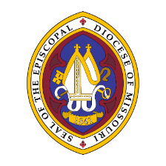

**The Episcopal Diocese of Missouri Land Acknowledgement**

In humility, we recognize and acknowledge that we in the Diocese of Missouri worship and live on the traditional ancestral lands of the Osage Nation, the Illiniwek/Peoria Tribe, the O-Gah-Pah (Quapaw) Tribe, the Otoe-Missouria Tribe, and other First Peoples. We recognize our mutual dependence upon and benefit from this land; we proclaim our solidarity with and our debt to the Peoples who first claimed and improved this land as their home. We acknowledge our complicity in the process of colonization that dispossessed the First Peoples from their ancestral lands. We affirm our commitment to stand with indigenous communities today and henceforth as they seek justice and resist continued threats to their sovereignty and humanity.

We are also cognizant that the history of The Episcopal Church is intertwined with the history of colonialism and slavery in the United States. More than four centuries ago, the first Africans were brought to the Americas and enslaved. Two centuries ago, enslaved and indigenous persons contributed to the exploration of this state by Lewis and Clark. Our state’s history is entangled with both the Missouri Compromise making this state officially a slave state, and the cases of Scott v. Emerson that petitioned for Dred and Harriet Scott’s emancipation. We acknowledge the tragic legacy of slavery in our diocese, and the blood, sweat, and tears of enslaved people that soak the earth beneath our feet in Missouri. This legacy persists today as we continue to work towards racial justice, equity, liberation, and community, here in Missouri and across The Episcopal Church.