

An Order for

the Celebration of

**The Holy Eucharist**

The Season of Advent



Within The Episcopal

**Diocese of Missouri**



Welcome! Beinvenido! Karibu!

Scattered in the world we gather together as God's people in worship. We bring the fragments of our lives to be healed and made whole in Christ as we gather in community.

Worship lies at the heart of the Christian life. It is in worship that we express our theology and define our identity. It is through encountering God within worship that we are formed and transformed as God’s people. One of the glories of the Episcopal/Anglican Church is its liturgical worship. Liturgy refers to the patterns, forms, words and actions through which public worship is conducted.

As we gather, we bring our diverse gifts: gifts of music, dance, prophecy, teaching, preaching, and friendship. We present these gifts in the form of our most precious offering to God, our very selves, that all that we do may be for God’s glory in the unity of Christ’s church.



About the

**Holy Eucharist**

*“When God finds us, there is always a celebration. In the Eucharist, we gather to celebrate God finding us in Jesus Christ. If you’re feeling lost, when you come to receive Jesus in bread and wine, ask to be found. If you know what it is to have been found by God, when you come to receive Jesus in bread and wine, give thanks – thanks to the one who came looking for you, and found you.”*

-Br. Geoffrey Tristram

Society of Saint John the Evangelist

In the Episcopal Church the Holy Eucharist is the sacrament of Christ's body and blood, and the principal act of Christian worship. The term is from the Greek, "thanksgiving." Jesus instituted the Eucharist "on the night when he was betrayed." At the Last Supper he shared the Bread and cup of Wine at a sacred meal with his disciples. He identified the Bread with his body and the Wine with his blood of the new covenant. Jesus commanded his disciples to "do this" in remembrance of Jesus.

The Holy Eucharist, for Episcopalians becomes the very Real Presence of Christ, his Body and Blood, the ordinary made also extraordinary, sacred by Jesus' own words and by the Holy Spirit.

In the Episcopal Church, we seek to adapt ancient liturgy for today. If you grew up in a less formal church, worship may feel pretty traditional. If you grew up in a formal church, our worship may deconstruct that formality, and ask you to pray using more modern words, or sing new songs. We seek to balance tradition and culture in our worship. When we hold the tension well between the ancient and the modern, the Holy Eucharist comes alive.

Gathering Song

*We begin by praising God through song and prayer.*

The Bidding & Lighting of the Advent Candles

*The Season of Advent takes its name from the Latin word* adventus*, meaning “coming” or “visit.” Advent begins four Sundays before Christmas and ends on Christmas Eve. For Christians Advent is the beginning of the liturgical year. During Advent we prepare for and anticipate the coming of Christ. We remember the longing of our Jewish ancestors for a Messiah and our own longing for, and need of, forgiveness, salvation, and new beginning.*

The Bidding for Advent

*A hymn may be sung. Once the community has gathered the Presider greets the assembly.*

*Presider* Light and peace in Jesus Christ our Lord.

*People* **Thanks be to God!**

*Presider* Dear friends in Christ, as we travel towards Bethlehem in this journey of Advent, we come together in the midst of a busy season to take a breath. To slow down as we anticipate Jesus’ coming once more into the world. We are invited for a time to breathe in together the life that God gives us; to listen for the beating of God’s heart and the blessings and lessons this season brings.  As we gather for this time of worshipful anticipation let us in the silence rest in God’s presence.

*A prolonged silence is kept.*

Lighting of the Advent Wreath

*Presider* May Christ, the One whose coming we await, fill our homes and hearts with joyful anticipation as we journey to the manger. Amen.

*Presider* Each week we light an Advent candle as a symbol of our journey. With its light comes our prayers and our stories.

**Advent Week One**

*Presider* The candle of this first week of Advent is a candle of **hope**. Today the flame of this candle reminds us of the hope that came to this world when Jesus was born. Jesus said, “I came so that everyone would have life, life in all its fullness.”

*Once the candle is lit, the Presider continues*

*Presider* You called the patriarchs and matriarchs to live by the light of faith and to journey in the hope of your promised fulfillment.

*People* **May we be obedient to your call and be ready and watchful to receive your Christ, a lamp to our feet and a light to our path. Amen.**

**Advent Week Two**

*Presider* The candle of this second week of Advent is a candle of **peace**. Today the flame of this candle reminds us of the peace that Jesus brings into this world. Jesus said, “I give you peace, the kind of peace that only I can give. It isn’t like the peace that this world can give. So don’t be worried or afraid.”

*Once the candles are lit, the Presider continues*

*Presider* Of old you spoke by the mouth of your prophets, but in our days you speak through your Son, whom you have appointed the heir of all things.

*People* **Grant us, your people, to walk in his light, that we may be found ready and watching when he comes again in glory and judgment. Amen.**

**Advent Week Three**

*Presider* The candle of this third week of Advent is a candle of **joy**. Today the flame of this candle reminds us of the joy that Jesus brings into this world. Jesus said, “Until now you have not asked for anything in my name. Ask and you will receive, so that your joy may be complete.”

*Once the candles are lit, the Presider continues*

*Presider* Your prophet John the Baptist was witness to the truth as a burning and shining light.

*People* **May we your servants rejoice in his light, and so be led to witness to him who is the Lord of our coming kingdom, Jesus our Savior and Sovereign of the ages. Amen.**

**Advent Week Four**

*Presider* The candle of this fourth week of Advent is a candle of **love**. Today the flame of this candle reminds us of the love that came to this world when Jesus was born. Jesus said, “As God has loved me, so I have loved you; remain in my love.”

*Once the candles are lit, the Presider continues*

*Presider* Your light has shone in our shadowed world through the child-bearing of blessed Mary;

*People* **Grant that we who have seen your glory may daily be renewed in your image and prepared like her for the coming of your Son, who is the Lord and Savior of all. Amen.**

Greeting

*Standing before the assembly the Presider welcomes the community to worship.*

*Presider* Blessed are you, Sovereign God, just and true:

*People* **To you be praise and glory for ever and ever. Amen.**

*Or*

*Presider* Blessed be the Holy One whose coming we await,

*People* **And blessed be the One who comes to set all people free. Amen.**

*Then may be added*

*Presider* In the tender compassion of our God

*People* **The dawn from on high shall break upon us,**

*Presider* To shine on those who dwell in the shadow of death,

*People* **To guide our feet into the way of peace.**

*Presider* Almighty God, to you all hearts are open,

*People* **All desires known, and from whom no secrets are hid. Cleanse the thoughts of our hearts by the inspiration of your Holy Spirit, that we may perfectly love you, and worthily magnify your holy Name; through Christ our Lord. Amen.**

Confession & Absolution

*As we enter in to worship we ask God’s forgiveness for things done and things left undone and things done on our behalf so that we may be reconciled to each other and to God.*

*Presider* Holy God, we have fallen short in loving you and loving our neighbors; we stand beside each other and ask for the forgiveness of our sins.

*Silence is kept for a time.*

*Presider* Most Holy God, in the midst of this season of expectation and new life, we confess:

*People*  **We have resisted the light of your love; we have not fully shared the gifts entrusted to us; and we have not treasured the gifts of others around us. Holy Trinity, make us holy. Holy God, make us whole. Amen.**

*The Presider offers assurance of God's forgiveness.*

*Presider* May the Trinity of Love bring you back to God and forgive you all your sins; be assured of God's eternal love in Jesus Christ our Lord. Amen.

Song of Praise: Spoken

*The Song of Praise maybe said or sung.*

*Presider* Let us glorify the Holy One as we proclaim.

*People* **O Light of the world, first born of creation, radiance of glory, light from light begotten. God self-revealing, holy, bright and blessed, you shine upon us.**

**Day’s light is fleeting, your light is eternal and we look to you, our light within the shadow. We sing to you O Creator, Christ and Spirit, you shine before us.**

**Light of our world, O Jesus Christ we bless you; giver of life and Child of God we praise you. Here with us the universe proclaims your glory, as you shine among us. Amen.**

Song of Praise: Based on Veni Veni Emmanuel

*Presider* Let us glorify the Holy One as we sing.

*The Presider and community join in singing.*



Collect of the Day

*Presider* God is with you. *or* The Lord be with you.

*People* **And also with you.**

*Presider* Let us pray.

*The Presider continues with the prayer appointed for the day, called the collect.*

*The collect is written to go along with both the season of the church year and the readings for the day. It summarizes the attributes of God as revealed in the scripture for the day.*

We hear the sacred stories

*We hear the stories of the experience of God from our spiritual ancestors. Reading and commenting on scripture goes back to the earliest services of Christianity. Following the pattern of Jewish synagogue worship, readings follow a set pattern for what will be read when.*

The First Reading

**A reading from Hebrew Scriptures.**

*At the end of the reading the Reader says:*

*Reader*Hear what the Holy Spirit is saying to God’s people.

*People* **Thanks be to God.**

The Psalm of the Day

*The psalms are a part of the poetry of the Hebrew people. They express joy and sadness, loneliness and thanksgiving as part of the human longing to be united with God.*

The Second Reading

**A reading from the New Testament.**

*At the end of the reading the Reader says:*

*Reader*Hear what the Holy Spirit is saying to the church.

*People* **Thanks be to God.**

Preparing to Hear the Gospel

*We stand, as we are able, for the Gospel reading to show the particular importance we place on Jesus’ words and actions.*

*A hymn, Verse, or other music may be sung.*

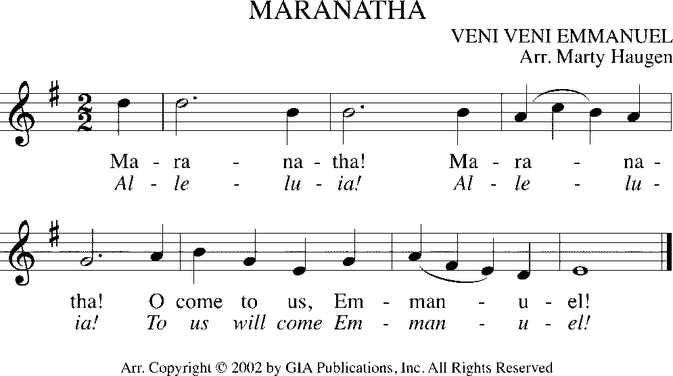

**

The Proclamation of the Gospel

*Presider* God is with you.

*People* **And also with you.**

*Presider* The Holy Gospel of our Savior Jesus Christ according to _______.

*People* **Glory to you, O Christ.**

*At the end of the Gospel the Presider says:*

*Presider* The Gospel of the Lord.

*People* **Praise to you, O Christ.**

The Sermon

*We remain seated for the sermon. Having someone comment on the scriptures read goes back to the earliest days of Christianity and to the Jewish Synagogue worship which preceded it.*

The Affirmation of Faith

*The Presider, priest or deacon, leads the assembly in an affirmation of faith. Originally the entire service was viewed as our confession of faith. But, since the Sixth Century, the Church has recited either the Nicene Creed or the Apostle’s Creed at the Eucharist. The word creed comes from the Latin credo for “I believe” or “I lend my heart to.” Creeds tell a deeper “truth” that goes beyond “facts.”*

*The Nicene Creed or An Advent Creed may be used. In the place of a Deacon, the Presider may lead the Creed.*

The Nicene Creed

*Deacon* We affirm our faith in the One, Holy and Living God.

*People* **We believe in one God, the Father, the Almighty, maker of heaven and earth, of all that is, seen and unseen.**

*People* **We believe in one Lord, Jesus Christ, the only Son of God, eternally begotten of the Father, God from God, Light from Light, true God from true God, begotten, not made, of one Being with the Father. Through him all things were made. For us and for our salvation he came down from heaven: by the power of the Holy Spirit he became incarnate from the Virgin Mary, and was made man. For our sake he was crucified under Pontius Pilate; he suffered death and was buried. On the third day he rose again in accordance with the Scriptures; he ascended into heaven and is seated at the right hand of the Father. He will come again in glory to judge the living and the dead, and his kingdom will have no end.**

*People* **We believe in the Holy Spirit, the Lord, the giver of life, who proceeds from the Father and the Son. With the Father and the Son he is worshiped and glorified. He has spoken through the Prophets. We believe in one holy catholic and apostolic Church. We acknowledge one baptism for the forgiveness of sins. We look for the resurrection of the dead, and the life of the world to come. Amen.**

An Advent Creed

*Our Advent Creed seeks to affirm our trust in God found in Jesus Christ.*

*Deacon* Let us stand and affirm our hope in the light of Christ.

*Deacon* Do you believe and trust in God?

*People* **We believe in God, eternal, almighty, creator of heaven and earth.**

*Deacon* Do you believe and trust in Jesus the Christ?

*People* **We believe in Jesus Christ, the Redeemer of all, the Only Begotten One; who was conceived by the Holy Spirit, born of the Virgin Mary, lived and loved among us, suffered under Pontius Pilate, was crucified, died and was buried; who descended to the dead, and on the third day rose again; Jesus, Our Savior, ascended into heaven, sits at the right hand of the loving God, and will come again to judge the living and the dead.**

*Deacon* Do you believe and trust in the Holy Spirit?

*People* **We believe in the Holy Spirit, the holy catholic and apostolic Church, the communion of saints, the forgiveness of sins, the resurrection of the dead, and life everlasting. Amen.**

The Prayers of the People

*Prayer changes people. Prayer is not about changing God, but about changing us more into the likeness of God. Collectively and individually we offer the hopes and desires of our hearts to God. The Deacon, when present in the liturgy, offers the prayers for those who are sick or have asked our prayers.*

*When a Deacon is present the Presider addresses the Deacon saying;*

*Presider* N., Deacon in the Church of God, what cares and concerns of the world do you bring before us to be held up in prayer?

*Deacon* People of God, I bid your prayers for…

*The concerns of the community and wider world, including those who are sick, in need, or in want are named by the Deacon.*

*Deacon* “The people who walked in darkness have seen a great light; those who lived in a land of deep darkness—on them light has shined.” In this season of anticipation and hope, let us be seekers of the light and peddlers of hope found in Christ Jesus our Savior.

*Leader* You who dwell in the darkness and the light, in the silence and in the sound; dwell in the hearts of your people that in hope, peace, joy and love, we may be agents of your heavenly reign and await with anticipation the coming of Christ, the Morning Star. Christ be our light.

*People* **Shine in our hearts.**

*Leader* You who framed the brightness of the first light in creation; dispel the arrogance, animosity, and anger that shatters the unity of your holy Church. Fill your faithful people with the radiant light of truth, that we may be made one in faith, hope, and love. Christ be our light.

*People* **Shine in our hearts.**

*Leader* You who delivered your people from the misery of bondage in slavery to the land of promise; set us free from enslavement to division, disunity, and distrust in our public life and labor. Illumine those in authority with the light of vision, that they may lead the peoples of the nations to greater unity and concord. Christ be our light.

*People* **Shine in our hearts.**

*Leader* You who patterned the stars and called the sun in to being, who appointed the moon and chartered the cosmos. Pattern the hearts of people everywhere to see in each other the beauty of the universe and the splendor of creation, that divisions of race, class, gender, and ethnicity may dissolve into one common humanity. Christ be our light.

*People* **Shine in our hearts.**

*Leader* You who shower comfort and hope to the lowest, the lost, and the least, shower the light of compassion on the sick, the sorrowful and the suffering especially those we name [______]. Help us to be your compassion and hope in the world. Christ be our light.

*People* **Shine in our hearts.**

*Leader* You who welcome into the brilliant light of eternity the souls of those who have died; welcome those whose lives have been cut short by violence, warfare, and strife. Shine the light of hope on our faithful dead, especially those we now name [______]. Christ be our light.

*People* **Shine in our hearts.**

*Leader* You who delight in the complexity of creation and the splendor of each creature; help us to delight in the diversity of the earth, our island home. Inspire your people to care for the earth and its creatures and repent and return when we abuse, misuse, and neglect our fellow creatures. Christ be our light.

*People* **Shine in our hearts.**

*Presider* May Christ, the Morning Star who knows no setting, find us ever burning with the light of love, the spirit of truth, and the wellspring of hope; that following the way of Jesus and filled with the flame of the Holy Spirit, we may be a holy people whose lives and living inspire, incite, and inflame your world with compassion and care. Through Jesus the Christ, the light of the world. Amen.

*Or*

*Presider* Almighty and eternal God, ruler of all things in heaven and earth: Mercifully accept the prayers of your people, and strengthen us to do your will; through Jesus Christ our Lord. Amen.

The Exchange of the Peace

*As we enter the most sacred portion of our worship, we exchange a sign of God’s promised peace. There are no set words to use in greeting each other, but “Peace be with you,” “God’s peace,” and “Shalom” are all commonly used.*

*Presider* The Peace of Christ be always with you.

*People* **And also with you.**

*Presider* Let us offer each other a sign of Christ's peace.

*We are a community of reconciliation and peace; therefore, we greet each other with a sign of our desire for peace.*

Welcome & Announcements

*Community announcements, notices, prayers, and celebrations may be offered at this time.*

Gathering at Christ's Table

*Having been nourished from the richness of God's love in sacred story and reconciled to each other through prayer and peace, we gather at Christ's table to offer ourselves to be transformed for service in the world.*

The Offertory

*The gifts of bread, wine, money and other gifts are brought to the Presider as an offering to God as a reminder of Christ's sacrificial love and life. Once the Holy Table or Altar is prepared the Presider and people give thanks to God for the many gifts we have been given.*

Offertory Music:

*An anthem, hymn or instrumental music may be offered.*

Doxology

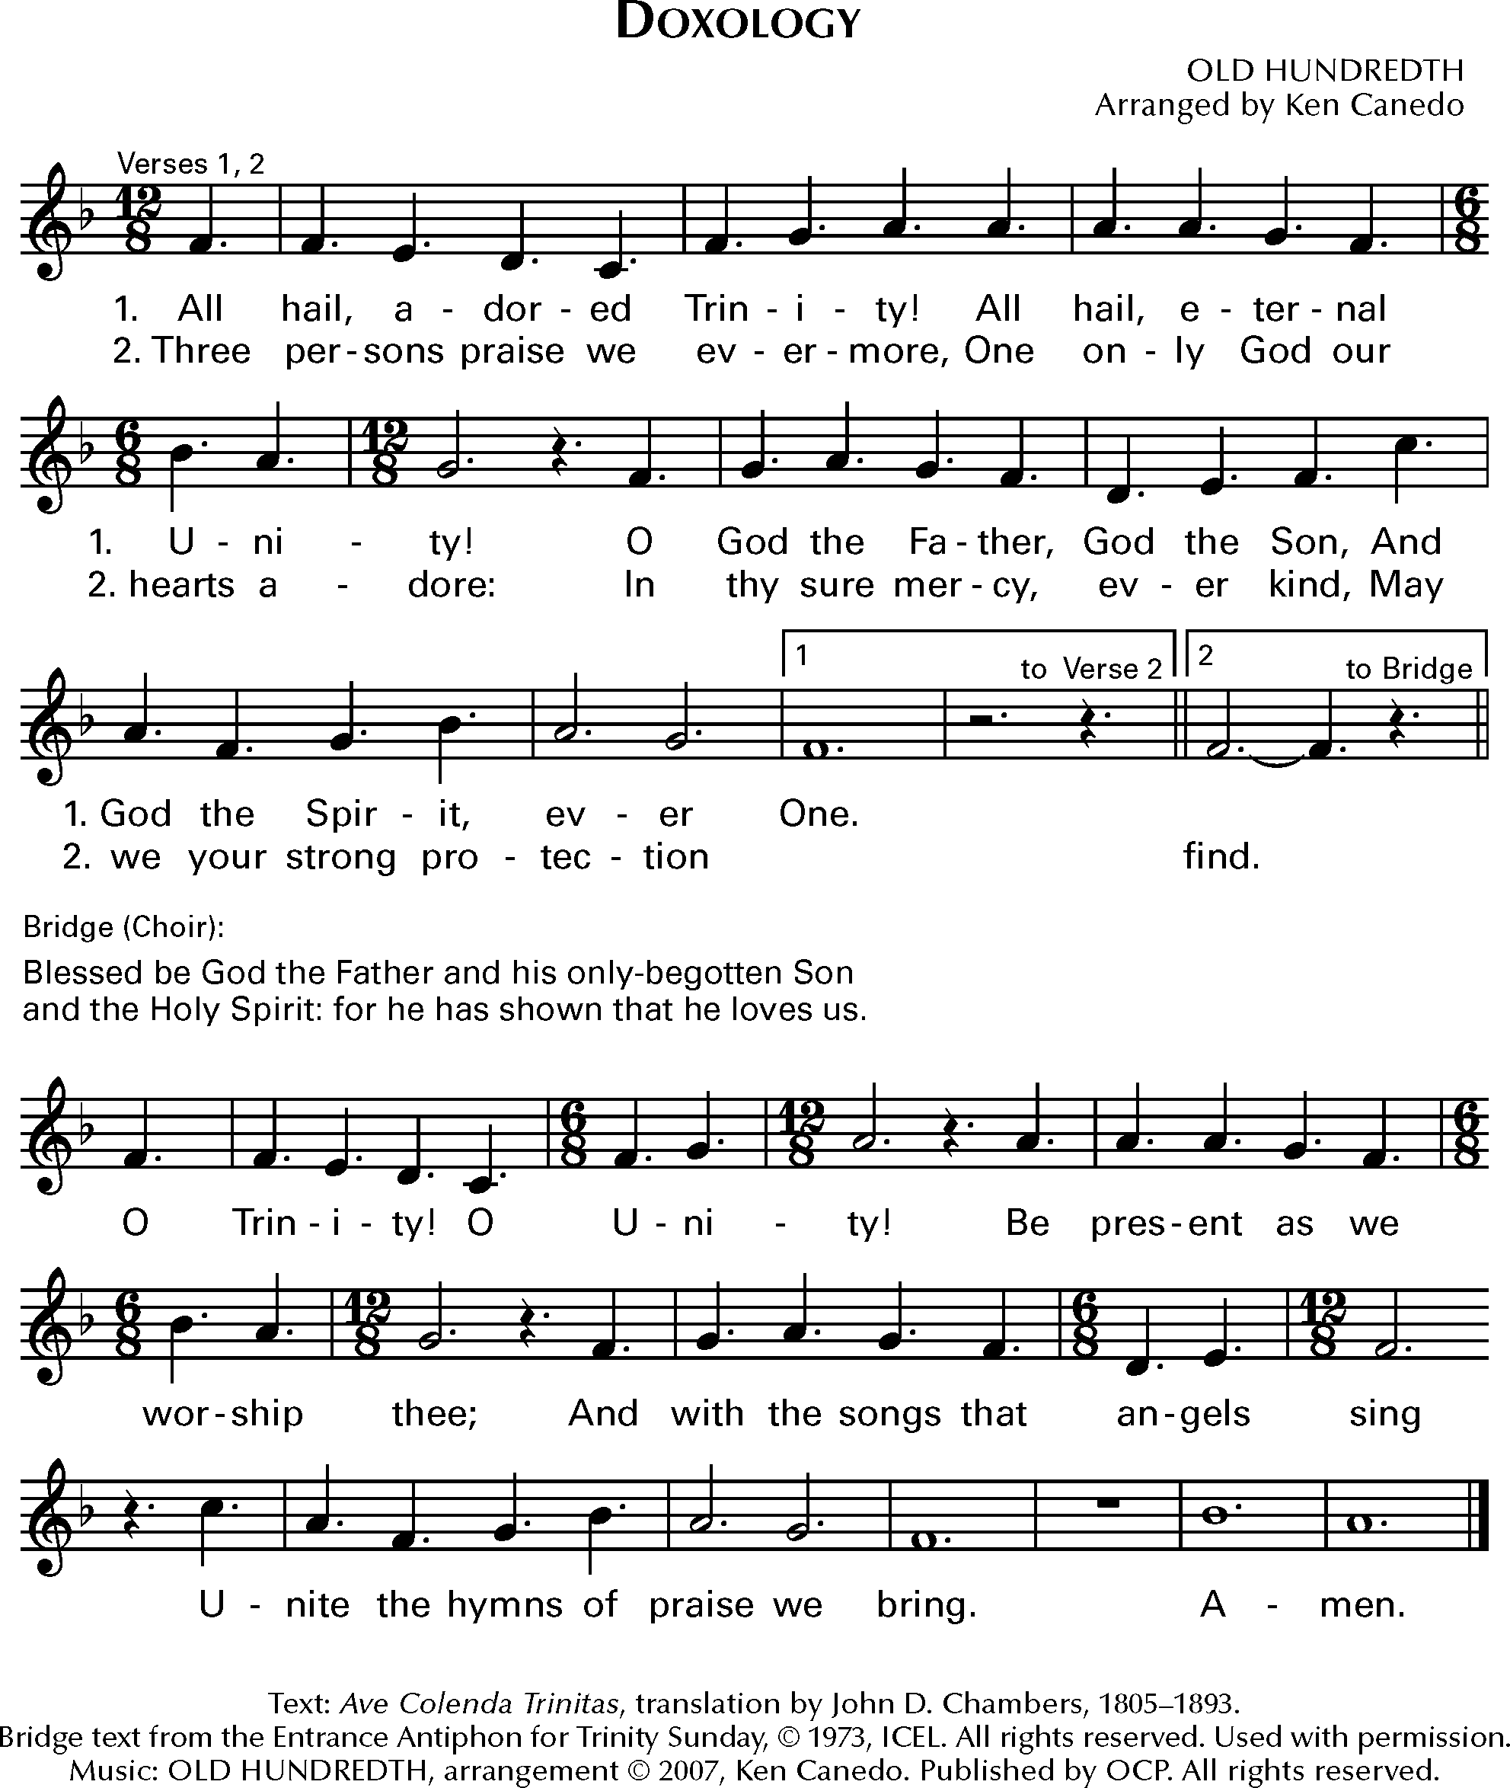

*Music: OLD HUNDREDTH*

The Eucharistic Prayers

*The Eucharistic Prayer, or Great Thanksgiving, is the prayer of the Church to invite Christ to be present in the elements of bread and wine. Now we come to the second act in the drama with the Liturgy of the Table. It is based on Jewish Fellowship meals, particularly the Passover observance. But this second half of the service is not communion in and of itself. It is the whole service, both acts of the drama, that make up the Eucharist.*

Eucharistic Prayer A: The Book of Common Prayer

*Presider* God is with you. *or* The Lord be with you.

*People***And also with you.**

*Presider* Lift up your hearts.

*People***We lift them to the Lord.**

*Presider* Let us give thanks to the Lord our God.

*People***It is right to give thanks and praise.**

*Then, facing the Holy Table, the Presider proceeds.*

*Presider* It is right, and a good and joyful thing, always and everywhere to give thanks to you, Almighty God, Creator of heaven and earth.

*Here a Proper Preface is sung or said on all Sundays, and on other occasions as appointed.*

*Presider* Therefore we praise you, joining our voices with Angels and Archangels and with all the company of heaven, who for ever sing this hymn to proclaim the glory of your Name:

Spoken: Holy, holy, holy

**Holy, holy, holy Lord, God of power and might,**

**heaven and earth are full of your glory. Hosanna in the highest.**

**Blessed is the one who comes in the name of the Lord. Hosanna in the highest.**

Sung: Holy, holy, holy Based on Hymn 56 Hymnal 1982

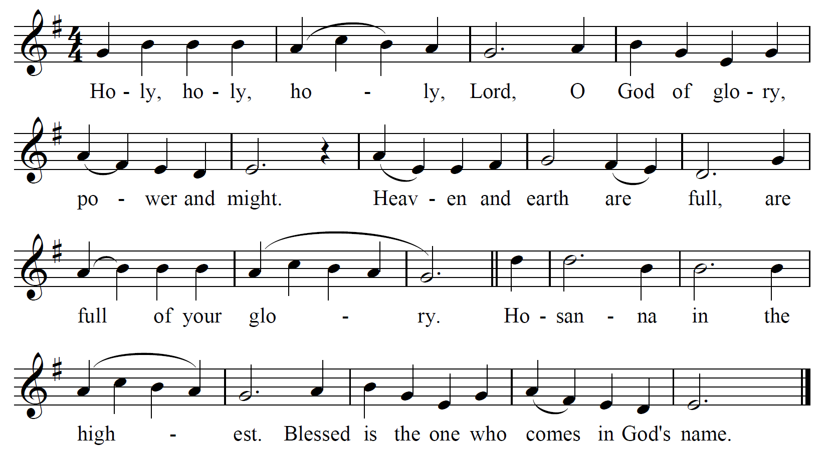

*Presider* Holy and gracious God: In your infinite love you made us for yourself; and, when we had fallen into sin and become subject to evil and death, you, in your mercy, sent Jesus Christ, your only and eternal Son, to share our human nature, to live and die as one of us, to reconcile us to you, the God and maker of all.

*Presider* Jesus stretched out his arms upon the cross, and offered himself in obedience to your will, a perfect sacrifice for the whole world.

*Presider* On the night he was handed over to suffering and death, our Savior Jesus Christ took bread; and when he had given thanks to you, he broke it, and gave it to his disciples, and said, “Take, eat: This is my Body, which is given for you. Do this for the remembrance of me.”

*Presider* After supper Jesus took the cup of wine; and when he had given thanks, he gave it to them, and said, “Drink this, all of you: This is my Blood of the new Covenant, which is shed for you and for many for the forgiveness of sins. Whenever you drink it, do this for the remembrance of me.”

*Presider* Therefore we proclaim the mystery of faith:

*People* **Christ has died. Christ is risen. Christ will come again.**

*Presider* We celebrate the memorial of our redemption, Almighty God, in this sacrifice of praise and thanksgiving. Recalling Christ’s death, resurrection, and ascension, we offer you these gifts.

*Presider* Sanctify them by your Holy Spirit to be for your people the Body and Blood of your Son, the holy food and drink of new and unending life in Christ. Sanctify us also that we may faithfully receive this holy Sacrament, and serve you in unity, constancy, and peace; and at the last day bring us with all your saints into the joy of your eternal kingdom.

*Presider* All this we ask through Jesus Christ our Savior. By Christ, and with Christ, and in Christ, in the unity of the Holy Spirit all honor and glory is yours, Almighty God, now and for ever. **AMEN.**

Eucharistic Prayer for Advent

*Presider* God is with you. *or* The Lord be with you.

*People***And also with you.**

*Presider* Lift up your hearts.

*People***We lift them to the Lord.**

*Presider* Let us give thanks to the Lord our God.

*People***It is right to give thanks and praise.**

*Then, facing the Holy Table, the Presider proceeds.*

*Presider* Blessed be your name, Lord God of time and eternity, for you have come to your people and set them free. You have spoken through the mouth of holy prophets and remembered your covenant of old. You have prepared the way of our salvation by raising up a mighty Savior from the house of your servant David.

*Presider* Your Son Jesus took upon himself on the cross the cost of our sin, and through him you revealed the fullness of your promise of mercy. In his resurrection you gave us knowledge of salvation by forgiveness of our sins that we might serve you without fear in holiness and righteousness all our days.

*Presider* And so we gladly thank you, joining with the company of angels and archangels and all the host of heaven in their unending hymn.

Spoken: Holy, holy, holy

**Holy, holy, holy Lord, God of power and might,**

**heaven and earth are full of your glory.**

**Hosanna in the highest.**

**Blessed is the one who comes in the name of the Lord.**

**Hosanna in the highest.**

Sung: Holy, holy, holy Based on Hymn 56 Hymnal 1982

**

*Presider* God of the future and the past, you promised that all flesh shall see your salvation: show us the salvation you bring through the flesh and blood of your only Son. As your prophets heralded his saving glory, sanctify your church for his promised coming. Send your Holy Spirit upon this bread and this cup that they may be for us the body and blood of Christ our Lord;

*Presider* Who, at supper with his disciples, took bread, gave you thanks, broke the bread, and gave it to them, saying, “Take, eat: this is my body which is given for you; do this in remembrance of me.”

*Presider* After supper he took the cup. Again he gave you thanks, and gave it to his disciples, saying, “Drink this, all of you: this is my blood of the new covenant, which is shed for you and for many for the forgiveness of sins. Do this, as often as you drink it, in remembrance of me.”

*Presider* Great is the mystery of faith.

*People***Christ has died; Christ is risen; Christ will come again.**

*Presider* Refining Spirit, you burn away all that does not endure your presence. Reveal your mercy in the very crucible of your love. Protect your sons and daughters who are facing a crucible of trial or temptation or testing, and amid the suffering of your children reveal you eternal grace.

*Presider* Refine and strengthen the hope of you church through every adversity and every danger. Set the hearts of your people on fire to seek your justice and share your mercy; until your dawn from on high breaks upon us, and on the day of your coming we stand clothed in the righteousness of the Son,

*Presider* Through Christ, and with Christ, and in Christ, in the unity of the Holy Spirit all honor and glory are yours Almighty God, now and forever. **AMEN.**

The Lord’s Prayer (Traditional)

*The Lord’s Prayer follows in either traditional or contemporary language. The link between our daily bread and the spiritual food we receive in the Eucharist is an ancient connection. In the Lord’s Prayer we ask for daily bread, meaning the things we need to get through each day. But as a part of that, the bread also symbolizes God’s presence.*

*Presider* As our Savior has taught us, we are bold to pray.

*People* **Our Father, who art in heaven, hallowed be thy name. Thy Kingdom come, thy will be done, on earth as it is in heaven. Give us this day our daily bread. And forgive us our trespasses, as we forgive those who trespass against us. And lead us not into temptation, but deliver us from evil. For thine is the kingdom, the power and the glory, for ever and ever. Amen.**

The Lord’s Prayer (Contemporary)

*Presider* Let us pray in the way that our Savior has taught us.

*People* **Our Father in heaven, hallowed be your name, your kingdom come, your will be done, on earth as in heaven. Give us today our daily bread. Forgive us our sins as we forgive those who sin against us. Lead us not into temptation but deliver us from evil. For the kingdom, the power, and the glory are yours now and for ever. Amen.**

The Breaking of the Bread

*The Presider breaks the consecrated bread in view of the assembly.*

*Presider* Christ our Passover is sacrificed for us.

*People* **Therefore let us keep the feast.**



Invitation to Communion

*We partake in the Eucharist and are spiritually nourished, but it is not for our benefit alone. Communion enables us to return to the world with renewed vigor for proclaiming the Gospel in our words and in our lives. In the Eucharist, Christ’s presence both nourishes us and challenges us.*

*Presider* The gifts of God for the people of God. *Then may be added:* Take them in remembrance that Christ died for you, and feed on him in your hearts by faith, with thanksgiving.

*Or*

*The Presider may add*

*Presider* These are God’s holy gifts, for you, God’s holy people. *Then may be added:* So come to this table you who have been here often and you who have not been here in a long time. You who have tried to follow Jesus and you who have failed. You who are full of faith and full of doubt. Come, it is Christ himself who invites you to meet him here.

Sharing the Sacred Meal

*This is Christ’s table and all are welcome and all are fed. All the baptized are invited to partake in the sacred meal. Please follow the movement to the altar.*

Communion Hymns:

*Hymns, anthems, or instrumental music may be played.*

The Great Silence

*Once all have received communion and the Holy Table has been cleared, the community observes a moment of silent reflection and prayer. The silence is begun and ended with the sound of a bell.*

*Presider* Jesus said to his disciples, “Come away to a quiet place and rest for a while.” Therefore, let us now rest in Christ’s presence in the silence.

*A prolonged silence is kept. At a signal from the Presider, the silence is broken.*

Post Communion Prayer

*After the Silence the Presider invites the congregation to stand and pray saying:*

*Presider* God is with you.

*People* **And also with you.**

*Presider* Together, let us pray.

*People* **Eternal God, for whom we await, you have fed us with the bread of heaven and the cup of salvation: keep us ever watchful, that we may be ready to stand before the Son of God, Jesus Christ our Lord. Amen.**

The Blessing

*The Presider blesses the people as a reminder of God’s extravagant love and invites us to go into the world to be God’s blessing.*

Closing Song

*We begin and end our time of worship by praising God through song and prayer.*

Dismissal

*As the celebration ends, we are charged to “Go in Peace to love and serve the Lord.” The Eucharist is therefore not an exclusive gathering that separates us from the world, but a challenge to reach out beyond our own church to the world around us.*

*Deacon* Our worship is ended. Our service in the world begins. Go into the world to love what God loves. Go in Peace to love and serve the Lord.

*People* **Thanks be to God.**



Please return your bulletin for reuse next week.

**Thank you for worshiping with us today.**

**We hope to see you again soon**

**as we offer Christ’s unfenced love to the world.**

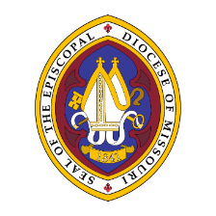

**The Episcopal Diocese of Missouri Land Acknowledgement**

In humility, we recognize and acknowledge that we in the Diocese of Missouri worship and live on the traditional ancestral lands of the Osage Nation, the Illiniwek/Peoria Tribe, the O-Gah-Pah (Quapaw) Tribe, the Otoe-Missouria Tribe, and other First Peoples. We recognize our mutual dependence upon and benefit from this land; we proclaim our solidarity with and our debt to the Peoples who first claimed and improved this land as their home. We acknowledge our complicity in the process of colonization that dispossessed the First Peoples from their ancestral lands. We affirm our commitment to stand with indigenous communities today and henceforth as they seek justice and resist continued threats to their sovereignty and humanity.

We are also cognizant that the history of The Episcopal Church is intertwined with the history of colonialism and slavery in the United States. More than four centuries ago, the first Africans were brought to the Americas and enslaved. Two centuries ago, enslaved and indigenous persons contributed to the exploration of this state by Lewis and Clark. Our state’s history is entangled with both the Missouri Compromise making this state officially a slave state, and the cases of Scott v. Emerson that petitioned for Dred and Harriet Scott’s emancipation. We acknowledge the tragic legacy of slavery in our diocese, and the blood, sweat, and tears of enslaved people that soak the earth beneath our feet in Missouri. This legacy persists today as we continue to work towards racial justice, equity, liberation, and community, here in Missouri and across The Episcopal Church.