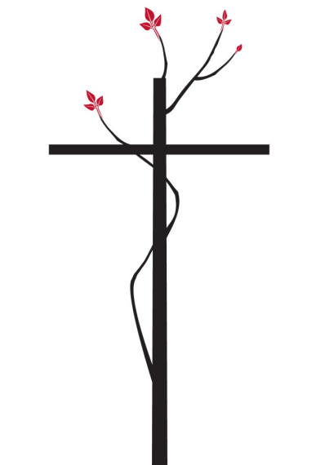

Liturgical Resources
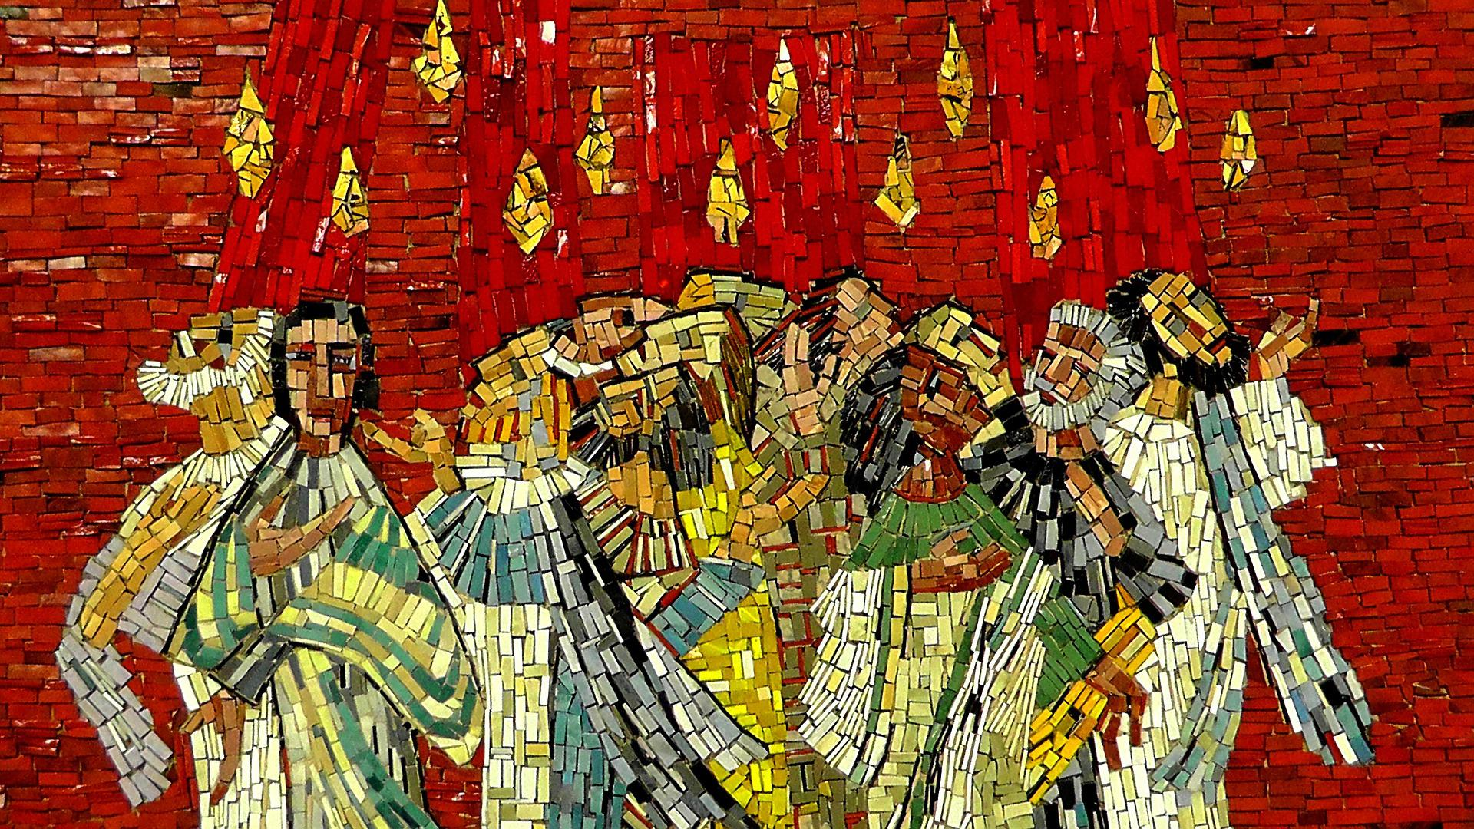
for the Day of Pentecost

Introduction
Pentecost (from the Greek pentekoste, ‘fiftieth’ of fifty days of celebration) has its roots in the Jewish Feast of Weeks, which was completed on the fiftieth day after Passover. On the fiftieth day of Easter, God sends his Holy Spirit to empower the Church to perform the mission which the risen Christ has entrusted to it; and he inaugurates the messianic community of perfect communication. Pentecost celebrates both the Holy Spirit and the Christian Church. It was originally the crown and completion of the Easter season; only later, in the medieval West, did it become a new festival season of its own.

After the Easter Vigil, the time of Pentecost was a preferred occasion for baptism in early Christian centuries, and the services of Pentecost also reflect this baptismal theme. Christ’s disciples are born again of water and the spirit. There is some evidence that the ascension was first celebrated on the fiftieth day of Easter, but it was soon moved to the fortieth day in faithfulness to Luke’s chronology. Ascension and Pentecost are closely linked. The risen Lord is no longer present to the Church in the body of his flesh; the Church is now to be the new body of Christ, filled with his life through the gift of the Spirit.

Concerning the Service.
The Day of Pentecost is among the “High, Holy Days” of the Church. On this day, we celebrate the coming of the Holy Spirit to enliven the first followers of Jesus. It is also a time to renew our Baptismal Vows while dwelling in the presence of God’s Holy Spirit.

It is recommended that the congregation gather in the same space where the New Fire was kindled at the Easter Vigil or gather in the customary place of worship with the Gathering Rite taking place at the entrance to the worship space closest to the Font. The liturgy begins with an Exhortation rather than a hymn.

The Day of Pentecost is listed among the days set aside for Holy Baptism. In the event there are no baptisms, the community of faith should renew their Baptismal Vows.

Particular care should be taken to involve a wide cross-section of the community in the voices present in the liturgy.

Gathering of the Community

The Exhortation (Long Form)
Presider Dear people of God, we are formed as God’s holy people from the primal elements of water and fire; the waters of baptism and the fire of the Holy Spirit. In the beginning, God spoke the creation into being by the Word. The Breath of God swept through all things, bringing life and wholeness. In the fullness of time, God created humanity in the Divine image and breathed the breath of life into earthen vessels. God’s Spirit engulfed the disciples gathered in the upper room, inspiring them to preach the gospel to the ends of the earth. The Eternal Spirit, our ending and our beginning, our Guide and Inspiration, continually comes to us, a holy flame of unknowable power, the Fire that fills our soul, consuming us, driving us and renewing us, calling us, commissioning us and empowering us, leading us ever onward. The Holy Spirit calls us to paths we could never imagine, ways we never sought, lives filled and lived in the joy of divine grace even in the face of evil: suffering, pain, and death. We invoke the presence of the Holy Spirit to be our guide, our hope, and our joy. Praying that Almighty God who has led the people of Israel empowered Sara and Abraham, Jacob and Leah, Miriam and Moses, Mary and Joseph, will lead us now. Come, Holy Spirit, come.

Presider In this sacred space we gather as did the first followers of Jesus, awaiting the coming of the Holy Spirit. We bring our whole selves, our joys and sorrows, our hopes and fears, our longings and losses, that God’s transforming fire may consume us and make us holy and whole.
People Come to us, Holy Spirit!

Presider In the quiet times of peace, in the anguished eternities of grief.
People Come to us, Holy Spirit!
Presider In welling fountains of joy, in cold vistas of disbelief.
People Come to us, Holy Spirit!
The liturgy continues with the Invocation of the Holy Spirit.

Or

The Exhortation (Short Form)
Presider Dear people of God, we gather in this sacred space, as the first followers of Jesus gathered, awaiting the coming of the Holy Spirit. We bring our whole selves, our joys, and sorrows, our hopes and fears, our longings and losses, that God’s transforming spirit may consume us and make us holy and whole.
People Come Holy Spirit, come fill us with love.
The liturgy continues with the Invocation of the Holy Spirit.

The Invocation of the Holy Spirit
Come Holy Spirit: Water
Water is poured into the font.
Reader In the beginning God created the heavens and the earth. The earth was without form and void, and darkness was upon the face of the deep, and the Spirit of God was moving over the face of the waters. (Gen. 1: 1-2)
People The voice of the Lord is upon the waters; the God of glory thunders; the Lord, upon many waters. (Psalm 29: 3)

A hymn, chant, instrumental music, or Taize canticle may be sung between each action.

Come Holy Spirit: Wind
Wind chimes and bells may be rung.
Reader The wind blows where it chooses, and you hear the sound of it, but you do not know where it comes from or where it goes. So it is with everyone who is born of the Spirit. (John 3: 8)
People The voice of the Lord causes the oaks to whirl, and strips the forest bare; and in God's temple all cry, "Glory!" (Psalm 29:9)

A hymn, chant, instrumental music, or Taize canticle may be sung between each action.

Come Holy Spirit: Earth
Soil for a Community or Good News Garden may be brought forward.
Reader When you send forth your Spirit all living things are created; and you renew the face of the earth. (Psalm 104:30)
People The earth is the Lord's and all that is in it, the world and those who live in it. (Psalm 24:1)

A hymn, chant, instrumental music, or Taize canticle may be sung between each action.

Come Holy Spirit: Flame
A burning flame or candle may be carried to the altar.
Reader I baptize with you water, but one more powerful than I is coming who will baptize you with the Holy Spirit and with fire. (Luke 3:16)
People The voice of the Lord flashes forth flames of fire. The voice of the Lord shakes the wilderness; the Lord shakes the wilderness of Kadesh. (Psalm 29: 7-8)

A hymn, chant, instrumental music, or Taize canticle may be sung between each action.
The Blessing of Fire & Water
Presider God is with you.
People And also with you.
Presider Let us give thanks to the Lord our God.
People It is right to give thanks and praise.
Presider Elohay Mishpat*, your Spirit moved over the waters of creation, and kindled the flame of hope at Pentecost.
People Come Holy Spirit, come fill us with life.

Presider In Christ, you are the purifying flame of justice, you drive away the darkness of this world that we may, with pure minds, come to you, the Light that never fails. Bless this fire, and grant that it may enflame our minds, our hearts and souls with a passion for justice.
People Come, Holy Spirit, come as a refining fire.

Presider In the waters of rebirth, you renew us and by the power of your life-giving Spirit. Ever cleanse and sanctify your people. In these waters we are buried and raised with Christ our Savior. Bless, we pray you, this water for the service of your holy Church; and grant that it may be a sign of the cleansing and refreshment of your heavenly grace.
People Come, Holy Spirit, come wash us with grace.

Presider You are the burning flame of justice and the cooling waters of salvation; enflame us, fill us and use us and in Jesus call us to new life in you. To Christ, to you, and to the Holy Spirit, be all honor and glory now and for ever. Amen.
*Elohay Mishpat is the Aramaic word for “God of Justice” from Isaiah 30:18)

Opening Hymn

Opening Acclamation
Presider Blessed be the God of all Creation
People Whose Spirit renews the face of the earth.

or

Presider Come Holy Spirt, our souls inspire.
People And fill us with celestial fire!

Presider There is one Body and one Spirit;
People There is one hope in God’s call to us;
Presider One Lord, One Faith, One Baptism;
People One God and Creator of all.

Presider God is with you.
People And also with you.
Presider Let us pray.
The Presider continues with the Collect of the Day.

An interactive Reading from the Acts of the Apostles
This is an interactive reading. Please join in with any language you may choose.
Reader When the day of Pentecost came the disciples were met in one room. Suddenly they heard a sound like a powerful wind filling the house in which they sat. And there appeared above them what seemed like tongues of fire. They were filled with the Holy Spirit. And by some miraculous act they began to speak to each other in foreign tongues, proclaiming the wonders of God in every language.
Choose a language and speak loudly together.
Repeat three times.
(English) The spirit is here! As Jesus promised! Alleluia!
(Spanish) ¡El espíritu está aquí! ¡Como prometió Jesús! ¡Aleluya!
(French) L’esprit est là, comme Jésus l’avait promis! Alléluia!
(German) Der Heilige Geist ist da! Als Jesus versprochen hat! Halleluja!
(Zulu) Umoya ongcwele ufikile! njengoba sithenjiswe nguYesu! Alleluya!
(Dutch) De geest is hier! Zoals Jezus beloofde! Halleluja!
(Welch) Mae ysbryd yma! Fel yr addawyd Iesu! Haleliwia!
(Hindi) Aatma yahaan hai! Jaisa ki yeeshu ne vaada kiya tha! Alleluiya!
(Swahili) Roho iko hapa! Kama Yesu alivyoahidi! Aleluya!
(Tamil) Āvi iṅkē irukkiṟatu! Iyēcu vākkuṟuti aḷittapaṭi! Allēlūyā!

Other languages may be added as reflected in the community of faith.

Reader Now in Jerusalem at that time were gathered people of devout faith from many corners of the earth. Witnessing the disciples, they were astonished saying,

Skeptic Aren’t these people simple folk from Galilee? How is it possible for them to be speaking to us all in our own language?

Reader Some were dismissive,

Skeptic These people are drunk, they are not full of new words, but new wine.

Reader Hearing this, Peter came forward with the disciples,

Peter People of Judea, listen to me. We are not drunk but filled with the Holy Spirit. Remember the words of the prophet Joel as he spoke the word of God.

Joel “In the days to come I will pour out my spirit upon humankind. Your sons and your daughters shall prophesy, your young shall see visions, your elders dream dreams and even the lowly will be filled with the spirit. Before the great day of the Lord’s coming, the sun will be turned into darkness and the moon blood red. All who call on the Lord’s name will be saved.”

Peter Alleluia! Alleluia! The spirit of the Lord is upon us.
All Alleluia! Alleluia! The spirit of the Lord is upon us.

The Prayers of the People
Presider We pray for God to fill us with the Holy Spirit.

Leader Generous God, we thank you for the power of your Holy Spirit. We ask that we may be strengthened to serve you better. Come Holy Spirit,
People Renew your people.

Leader We thank you for the wisdom of your Holy Spirit. We ask you to make us wise to understand your will. Come Holy Spirit,
People Renew your people.

Leader We thank you for the peace of your Holy Spirit. We ask you to keep us confident of your love wherever you call us. Come Holy Spirit,
People Renew your people.

Leader We thank you for the healing of your Holy Spirit. We ask you to bring reconciliation and wholeness where there is division, sickness and sorrow. We pray especially for those we name: (list the sick) Are there others? Come Holy Spirit,
People Renew your people.

Leader We thank you for the gifts of your Holy Spirit. We ask you to equip us for the work which you have given us. Come Holy Spirit,
People Renew your people.

Leader We thank you for the fruit of your Holy Spirit. We ask you to reveal in our lives the love of Jesus. Come Holy Spirit,
People Renew your people.

Leader We thank you for the breath of your Holy Spirit, given us by the risen Lord. We ask you to keep the whole Church, living and departed, in the joy of eternal life. Come Holy Spirit,
People Renew your people.

Presider Generous God, you sent your Holy Spirit upon your Messiah at the river Jordan, and upon the disciples in the upper room: in your mercy fill us with your Spirit, hear our prayer, and make us one in heart and mind to serve you with joy for ever. Amen.

Post Communion Prayer
After all have received communion the Presider says
Presider God is with you.
People And also with you.
Presider Let us pray.
People Faithful God, who fulfilled the promises of Easter by sending us your Holy Spirit and opening to every race, people and nation the way of life eternal: open our lips by your Spirit, that every tongue may tell of your glory; through Jesus Christ our Lord. Amen.

The Blessing
The Presider blesses the people.
Presider May the Spirit, who hovered over the waters when the world was created, breathe into you the life she gives. May the Spirit, who overshadowed Mary the Godbearer when the eternal Son came among us, make you joyful in the service of the Lord.
May the Spirit, who set the Church on fire upon the Day of Pentecost, bring the world alive with the love of the risen Christ. And the blessing of God almighty…

